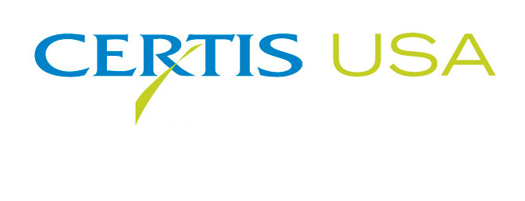
Jeremy Adamson Joins Certis USA as Fungicide Product Manager

Jeremy Adamson has joined the biopesticide company Certis USA as Fungicide Product Manager. Adamson will direct and guide the U.S. marketing strategies for the company’s more than 10 fungicide brands. He will work in parallel with the Certis USA sales team to optimize product positioning, leverage competitive advantage and build customer loyalty.
Adamson reports to Jim Black, Certis USA Director of Business Development, who said, “We’re pleased to welcome Jeremy to the Certis USA team. He will hit the ground running, supporting our rapid growth and many new product introductions. Jeremy has an excellent mix of experience and knowledge in agriculture that will be of immediate benefit to us and ultimately our customers.”
Adamson came to Certis USA from DowDupont where he handled many roles in sales, new market development and program management. Previously, he worked for Crop Production Services in ag distribution as a plant health and nutrition specialist. Jeremy holds a B.S. degree in Ag Economics from Purdue University. He serves as the public relations chair for MANRRS.
Headquartered in Columbia, Maryland, Certis USA is a leading manufacturer and distributor of a broad line of biopesticide products for specialty agricultural and horticultural markets and the home and garden market. Certis USA products provide valuable solutions by meeting the challenges faced by today’s growers who are seeking sustainable alternatives, resistant pest management and harvest solutions, and low pesticide residues for market flexibility and export accessibility. For more information about Certis USA or its products, please visit www.certisusa.com.
#
Media Contact:
Felicia Gillham, Gillham & Associates Marketing Communications
619-482-8820; Cell: 619-341-3054; fgillham@gillham-associates.com

