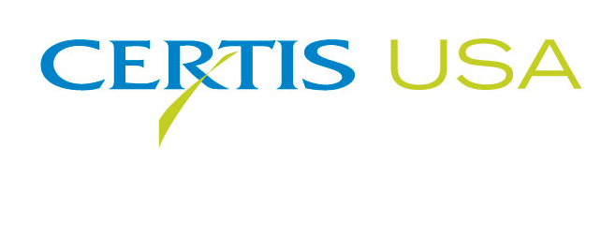
“Certis for Citrus” Program Helps Fund Fight Against Citrus Greening (HLB)

BONITA SPRINGS, Florida – JUNE 13, 2018 – The biopesticide company, Certis USA, presented the non-profit Citrus Research and Development Foundation, Inc. (CRDF) with a check for $20,000 to help fund research projects in an effort to find a cure for Huanglongbing (HLB; citrus greening) at the CRDF annual meeting which took place at the Hyatt Regency Coconut Point Resort and Spa. The CRDF has oversight responsibility for HLB research and development efforts. HLB is one of the world’s most serious citrus diseases for which there is no current cure. Several states or portions of states, such as California, Florida, Georgia, Louisiana, Texas, South Carolina and the territories of Puerto Rico and the U.S. Virgin Islands have established both plant quarantines and Asian citrus psyllid restrictions to stop the spread of citrus greening. For more information about HLB/citrus greening click here.

“Under the Certis for Citrus program, Certis USA makes a donation to CRDF based on
every pound of Kocide® 3000 or Kocide® 2000 copper fungicide purchased by a Florida citrus grower from June 1, 2017 to May 31, 2018,” said Joe Craig, Certis USA Regional Manager-Florida Gulf. “Florida citrus growers have been longtime users and supporters of Kocide. Certis USA wants to show our appreciation and support the fight against HLB.”

John Arthington, Ph.D., CRDF interim chief operating officer, said, “CRDF appreciates that Certis continues to show its support for the HLB fight and to contribute towards the financial support that is so important to the success of the foundation. Proceeds from this program will be invested directly into moving solutions to the field.”

Headquartered in Columbia, Maryland, Certis USA is a leading manufacturer of biopesticide products for agricultural, horticultural and home and garden markets. Certis USA products provide valuable solutions by meeting the challenges faced by today’s growers who are seeking sustainable alternatives, resistant pest management and harvest solutions, and low pesticide residues for market flexibility and export accessibility. For more information about Certis USA or its products visit www.CertisUSA.com.
# # #

Cutline
Joe Craig, (center) Certis USA Regional Manager-Florida Gulf, presents Jackie Burns, Ph. D., UF/IFAS Dean for Research and Director of the Florida Agricultural Experiment Station (left) and John Arthington, Ph.D., interim chief operating officer of the Citrus Research and Development Foundation, Inc. (CRDF) (right), a check for $20,000 on behalf of the Certis for Citrus program. Under the program, Certis USA makes a donation to CRDF based on every pound of Kocide® 3000 or Kocide® 2000 copper fungicide purchased by a Florida citrus grower from June 1, 2017 to May 31, 2018.

Contact:
Rick Purnell, Gillham & Associates Marketing Communications
760-464-0035 • Cell: 760-799-5578

