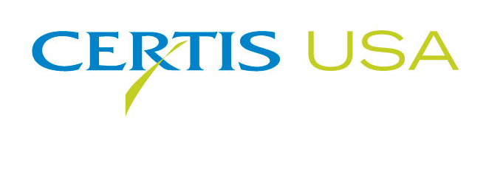

Certis USA Acquires LAM International

COLUMBIA, Maryland, JUNE 20, 2017 — The biopesticide company Certis USA acquires 100 percent of the shares of Butte, Montana-based LAM International. LAM International is a developer and manufacturer of several leading bioinsecticide products, including Botanigard® and Mycotrol®, and has a pipeline of newly registered products and others currently under registration and development. LAM International also has a state-of-the-art solid fermentation production facility that complements the Certis USA liquid fermentation production facility in Wasco, California. LAM International continues to operate as a subsidiary of Certis USA. Luis A. Mazariegos, Ph.D., founder and CEO of LAM International, becomes a consultant for Certis USA.

Dr. Mazariegos said, “After 12 years of leading the LAM International team, it was the right moment to find a company that we felt shared our vision and could take our line of biological products to the next level. This acquisition by Certis USA, with its line of biological products, marketing knowledge, liquid fermentation expertise and outstanding team of executives will make Certis USA a world leader in the biopesticide arena.”

Jow-Lih Su, Ph.D., CEO of Certis USA, said, “The addition of the LAM solid fermentation production facility significantly expands Certis USA’s capabilities for biological product development. Having both solid and liquid fermentation technology platforms allows us to commercialize more new and innovative biological pest control products worldwide.”

Headquartered in Columbia, Maryland, Certis USA is a leading manufacturer and distributor of a broad line of biopesticide products for specialty agricultural and horticultural markets and the home and garden market. Certis USA products provide valuable solutions by meeting the challenges faced by today’s growers who are seeking sustainable alternatives, resistant pest management and harvest solutions, and low pesticide residues for market flexibility and export accessibility. For more information about Certis USA or its products visit www.CertisUSA.com.

-30-
Media Contact:
Felicia Gillham
Gillham & Associates Marketing Communications
619-482-8820; Cell: 619-341-3054

