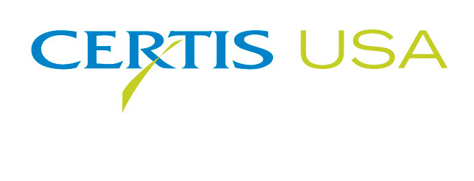

Mike Allan joins Certis USA as Vice President, North America

COLUMBIA, Maryland, July 5, 2018 — Mike Allan joins Certis USA as Vice President, North America. In his position, Allan will lead Certis USA’s business in North America.
Tim Damico, Executive Vice President of Certis USA, said, “Our rapid growth in recent years has reached a point where we need more resources. Mike brings his comprehensive operational and marketing experience to Certis USA to help us take full advantage of the growing biopesticide markets in North America.”
Allan previously served as Vice President, Biorationals, and President, North America at Isagro USA. He also served in various roles at Arysta/Tomen, including Global Business Development Manager and Product Manager Fumigants/Fungicides.
Headquartered in Columbia, Maryland, Certis USA is a leading manufacturer and distributor of a broad line of biopesticide products for specialty agricultural and horticultural markets and the home and garden market. Certis USA products provide valuable solutions by meeting the challenges faced by today’s growers who are seeking sustainable alternatives, resistant pest management and harvest solutions, and low pesticide residues for market flexibility and export accessibility. For more information about Certis USA or its products, please visit www.certisusa.com.
#
Media Contact:
Felicia Gillham, Gillham & Associates Marketing Communications
619-482-8820; Cell: 619-341-3054; fgillham@gillham-associates.com

