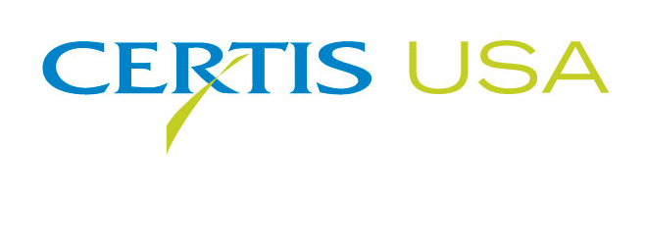

Rendition®, a New PAA in the Agricultural Market

COLUMBIA, MD—July 8, 2014—Certis USA introduces Rendition®, a broad spectrum bactericide, fungicide and disinfectant, that contains a high concentration of PAA (peroxyacetic acid) with a proprietary surfactant for superior coverage. PAA is a proven control measure for treating Alternaria, Botrytis (gray mold), mildews, Fusarium and Rhizoctonia diseases, for eliminating algae and for disinfecting farm workspaces. With its high percentage (5.24%) of PAA, Rendition is an economical selection for growers who need bacterial and fungicidal control when raising tomatoes, peppers, grapes, cherries, apples, potatoes and other crops.

Jeremy Briscoe, Certis USA Specialty Ag Business Manager, said Rendition fits well within the Certis USA product line. “Rendition can be used many different ways to solve many different problems fruit and vegetable growers come across,” he said. “Rendition offers more flexibility at better economics to the distributors and the end users since the product label provides for multiple uses. One product can fit all the needs where PAA is used on the farm or in the packing house.”

Rendition may be used to cure and prevent bacteria, fungi and algae. It can be applied as a seed bed treatment, soil drench, foliar treatments, applied through irrigation systems, or used for postharvest treatments, such as on potatoes. Rendition may be applied up to and including the day of harvest. Because it is residue exempt, it is an export friendly product.

Tim Damico, Executive Vice President, NAFTA for Certis USA, said, “Rendition factors into our strategic position as being the number one provider of biopesticide products in the U.S. Certis USA provides almost 30 different biopesticide products, and the product line continues to expand yearly. This is the 14th new product that Certis USA has added in the last five years leading to unprecedented growth of the company.

Headquartered in Columbia, MD, Certis USA is a leading manufacturer and distributor of a broad line of biopesticide products for specialty agricultural and horticultural markets and the home and garden market. Certis USA products provide valuable solutions by meeting the challenges faced by today’s growers who are seeking sustainable alternatives, resistant pest management and harvest solutions, and low pesticide residues for market flexibility and export accessibility. For more information about Certis USA or its products visit www.CertisUSA.com.

-30-
Media Contact:
Felicia Gillham
Gillham & Associates Marketing Communications
Cell: 619-341-3054 (PST)

