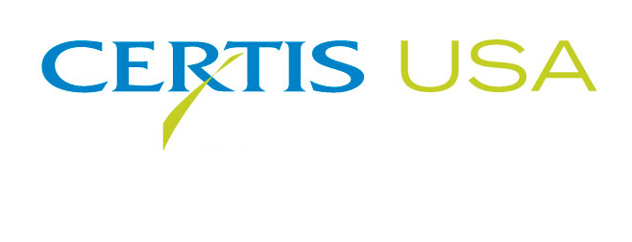

Art McSwain Joins Certis USA as Regional Manager

COLUMBIA, Maryland, July 17, 2018 — Certis USA announces its hiring of Art McSwain as Regional Manager. He will be responsible for the sales and marketing of the company’s biopesticide products in Kentucky, North Carolina, South Carolina, Tennessee and southern Virginia. McSwain replaces Gabe Diaz-Saavedra who became the Certis USA Home and Garden Account Manager.
Scott Peterson, Eastern Regional Sales Director for Certis USA, said, “Art is a great addition to the sales team. He brings new supplier and grower relationships along with a deep understanding of the pecan, tobacco and biostimulant markets. With the growing interest in biopesticides, Art will be instrumental in finding their fit in the crops in his territory.”
McSwain previously served as Account Manager-Southeast for Sipcam Agro USA. In his 21-years in agricultural sales, McSwain has also worked for McSwain Marketing, Tristate/TLC and Sharda International.
McSwain holds a B.A. degree in Business Administration from the Georgia College and State University, Milledgeville, GA. He is a member of the Southern Crop Protection Association, Georgia Pecan Growers Association, Georgia Fruit & Vegetable Growers Association and the Georgia Plant Food Educational Society. McSwain will work from his office in Kathleen, GA, where he lives with his wife, Ashley, and their two daughters.
Headquartered in Columbia, Maryland, Certis USA is a leading manufacturer and distributor of a broad line of biopesticide products for specialty agricultural and horticultural markets and the home and garden market. Certis USA products provide valuable solutions by meeting the challenges faced by today’s growers who are seeking sustainable alternatives, resistant pest management and harvest solutions, and low pesticide residues for market flexibility and export accessibility. For more information about Certis USA or its products, please visit www.certisusa.com.
#
Media Contact:
Felicia Gillham, Gillham & Associates Marketing Communications
619-482-8820; Cell: 619-341-3054; fgillham@gillham-associates.com

