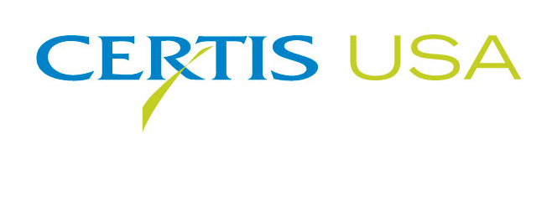

Heather Driskill Named Logistics and Customer Service Representative For Certis USA
Unprecedented Growth Requires Additional Resources

COLUMBIA, MD—August 15, 2014—Heather Driskill joins Certis USA as Logistics and Customer Service Representative. She is responsible for providing customer service, handling shipping and receiving of orders, order entry and working with the company’s national sales team.

Driskill reports to Rob Marceron, Logistics and Customer Service Manager for Certis USA. Marceron said, “Heather has an extensive background in shipping and receiving and inventory control. Also her customer support background will add greatly to our customer service department. For many years our customer service interface was exclusively provided by Brenda Van Leeuwen. But the rapid expansion of the Certis USA business warrants the addition of a highly competent and experienced customer service representative. We now have a great ‘one-two team,’ and we’re looking forward to Heather’s contributions.”

Driskill most recently served as Warehouse Supervisor for the Delsey Luggage Inc. location in Hanover, MD. Prior to her work for Delsey, Driskill worked in customer service for a number of national retail businesses.

Headquartered in Columbia, MD, Certis USA is a leading manufacturer and distributor of a broad line of biopesticide products for specialty agricultural and horticultural markets and the home and garden market. Certis USA products provide valuable solutions by meeting the challenges faced by today’s growers who are seeking sustainable alternatives, resistant pest management and harvest solutions, and low pesticide residues for market flexibility and export accessibility. For more information about Certis USA or its products visit www.CertisUSA.com.
-30-
Media Contact:
Felicia Gillham
Gillham & Associates Marketing Communications
619-482-8820; Fax: 619-482-8825; Cell: 619-341-3054 (PDT)

