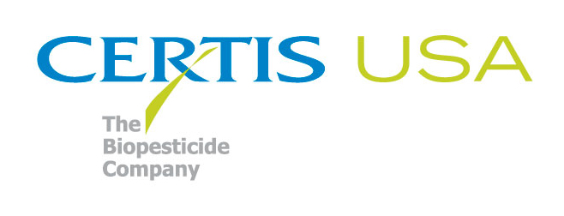

Joe Lebow Joins Certis USA
As Northern California Regional Sales Manager

COLUMBIA, MD—September 5, 2012—Joe Lebow brings 12-plus years of experience in California specialty agriculture to his new position with Certis USA as Northern California Regional Sales Manager. Lebow is responsible for the sales and marketing of the Certis USA line of biopesticide products into the vine, tree, fruit and vegetable crop markets in the northern San Joaquin and Sacramento valleys.

Jeremy Briscoe, Certis USA Specialty Ag Business Manager, said Lebow is a welcome addition to the Certis USA sales team and the timing is critical. “Joe is responsible for introducing our newest product, a biofungicide, to these northern markets. He needs to hit the ground running, and I’m confident he’ll do just that.”

Previously Lebow was Southwest Division Marketing Manager for Crop Production Services (Bakersfield, CA office). In addition, Lebow has worked in the retail/field level. He started his career as an in-house Pest Control Adviser (PCA) for Sun Pacific, a large specialty fruit operation in California’s Central Valley.

Lebow holds a B.S. degree in Plant Science from California State University-Fresno. He is a licensed California PCA and an active member of the California Association of Pest Control Advisers (CAPCA). Lebow will work from his office in Yuba City, CA.

Headquartered in Columbia, MD, Certis USA is a leading manufacturer and distributor of the largest line of biopesticide products for specialty agricultural, horticultural and home and garden markets. Certis USA products include insecticides, insect growth regulators, fungicides, herbicides and nematicides. Its website is located at www.certisusa.com.

-30-
Media Contact:
Felicia Gillham
Gillham & Associates Marketing Communications
619-482-8820; Fax: 619-482-8825; Cell: 619-341-3054 (PDT)

