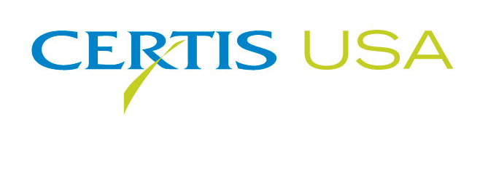

Scott Peterson Joins Certis USA to Oversee
The Biopesticide Company’s Eastern Agricultural Sales

COLUMBIA, Maryland—September 26, 2016— Scott Peterson joins Certis USA as Eastern Regional Sales Director to manage the biopesticide company’s sales activities in territories east of the Rocky Mountains.

Peterson’s position at Certis USA is a reflection of rapid sales growth experienced by the company in recent years that led to the re-alignment of the sales functions. Jeremy Briscoe, a longtime member of Certis USA’s management team, becomes Western Regional Sales Director and will manage the sales activities for the sales territories west of the Rocky Mountains.

Tim Damico, Certis USA Executive VP, NAFTA, said, “With Scott and Jeremy, we have an excellent team in place that will help us to handle the growth of the company and an expanding product line. We welcome Scott. He has proven experience in sales management and in growing new sales territories. Plus, Scott is highly knowledgeable of biological plant protection products and has successfully introduced a number of biopesticide products.”

An active member of the Biopesticide Industry Alliance (BPIA), Peterson was recently named BPIA Volunteer of the Year, the first person honored for the position in the history of the organization.

Peterson comes to Certis USA from SipcamRotam LLC (previously SipcamAdvan) of Durham, NC, where he served as National Sales Manager—Agriculture. Peterson holds a B.S. in Biology from Bethel University in St. Paul, MN. He will maintain an office in Decorah, IA.

Headquartered in Columbia, Maryland, Certis USA is a leading manufacturer and distributor of a broad line of biopesticide products for specialty agricultural and horticultural markets and the home and garden market. Certis USA products provide valuable solutions by meeting the challenges faced by today’s growers who are seeking sustainable alternatives, resistant pest management and harvest solutions, and low pesticide residues for market flexibility and export accessibility. For more information about Certis USA or its products visit www.CertisUSA.com.

-30-
Media Contact:
Felicia Gillham
Gillham & Associates Marketing Communications
619-482-8820; Cell: 619-341-3054

