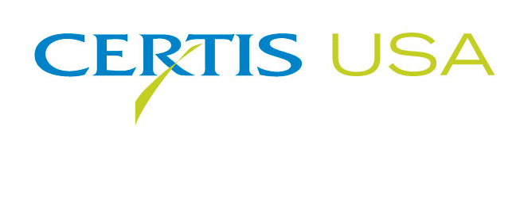

The Biopesticide Company Certis USA Introduces
Carb-O-NatorTM Foliar Fungicide for Crops and Greenhouse, Nursery Use

COLUMBIA, Md.—October 3, 2016—The biopesticide company, Certis USA, introduces Carb-O-NatorTM, a broad spectrum foliar fungicide that works on contact to control powdery mildew, Alternaria, Anthracnose, Botrytis, Septoria leaf spot and other diseases. Carb-O-Nator is registered for use on agricultural crops, terrestrial and ornamental, greenhouse and nursery plants and turf. Its active ingredient, potassium bicarbonate, is well-known for its proven efficacy against plant disease coupled with its high level of safety to workers, bees, wildlife and the environment. Because it works on contact, Carb-O-Nator is an ideal selection for use in disease resistance management programs. Carb-O-Nator has a reentry interval (REI) of four hours, a zero-day pre-harvest interval and is residue exempt, making it a highly flexible fungicide to use. It is NOP (USDA’s National Organics Program) compliant and OMRI® listed.

Tim Damico, Certis USA Executive VP, NAFTA, said, “We’ve been looking for an effective curative fungicide to add to our offering, and Carb-O-Nator fit the need and our product line. Certis USA has built the most diverse line of biopesticide products in the U.S. and the addition of Carb-O-Nator to our line was a logical choice. Carb-O-Nator offers simple, yet effective foliar disease control.”

The Carb-O-Nator formulation contains 85% potassium bicarbonate by weight. Certis USA recently developed a new proprietary formulation which exhibits superior dispersing and spreading properties that eliminates the need to use a spreader sticker in the mixing tank. Through a combination of osmotic pressure, pH and the activity of carbonate and bicarbonate ions, Carb-O-Nator quickly eradicates foliar diseases. Carb-O-Nator is registered for use on acorn squash, almond, apple, apricot, cantaloupe, cherry, chicory, melons, cucumber, endive, escarole, grape, honeydew, lettuce, muskmelon, peach, pear, pepper, pistachio, plum, prune, pumpkin, radicchio, rose, spinach, strawberry, summer squash, tomato, walnut, watermelon, winter squash and zucchini.

Headquartered in Columbia, Maryland, Certis USA is a leading manufacturer and distributor of a broad line of biopesticide products for specialty agricultural and horticultural markets and the home and garden market. Certis USA products provide valuable solutions by meeting the challenges faced by today’s growers who are seeking sustainable alternatives, resistant pest management and harvest solutions, and low pesticide residues for market flexibility and export accessibility. For more information about Certis USA or its products visit www.CertisUSA.com.

-30-
Media Contact:
Felicia Gillham
Gillham & Associates Marketing Communications
619-482-8820; Cell: 619-341-3054

