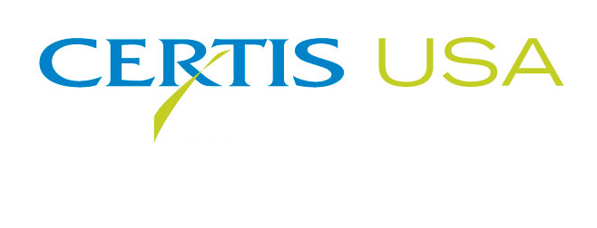
Certis USA Completes New Azadirachtin Production Facility
To Meet Growing Demand for Neem-Based Biopesticides

COLUMBIA, Maryland, October 4, 2018 — Certis USA has completed construction and start-up of a new azadirachtin formulation and packaging facility located in its factory in Wasco, California. The state-of-the-art system allows the company to produce the highest quality biopesticides and expands its capacity for its neem seed-based bioinsecticide: Neemix® 4.5 insect growth regulator. Neemix 4.5 is widely used worldwide by organic and conventional growers of vegetables, tree fruit and nuts, grapes and many other specialty crops. Neemix 4.5 is OMRI® Listed and NOP approved.
The neem tree (Azadirachta indica), a native of India, has been known for centuries to hold pesticidal properties. Twenty-five years ago, Certis USA pioneered the commercialization of neem based biopesticides. Today Certis USA established a vertically integrated in-house production system for its neem biopesticides, starting from its joint-venture company in India that performs seed sourcing, cleaning, extraction and processing, to its dedicated neem oil and azadirachtin purification, formulation and packaging facility in its Wasco California factory.
Dr. Jacob Eyal, Certis USA Vice President, said, “For products coming from nature like neem biopesticides, it is important that we have control and traceability of our products from seed to processing to formulation to packaging. We take these steps to ensure the quality and purity of our products.”
Neemix 4.5 features many benefits that growers are seeking to be successful in today’s marketplace. Neemix 4.5 is OMRI listed, residue exempt with a 4-hour reentry interval (REI), 0-day preharvest interval (PHI) and has a unique mode of action that is effective on a wide range of pests, including aphids, leafminers, whiteflies, thrips, mites and nematodes. Neemix 4.5 works as an insect growth regulator that controls the immature stages of pests before they become reproducing adults. Neemix 4.5 also reduces damage by repelling and deterring feeding of all stages of the insects, including adults.
Headquartered in Columbia, Maryland, Certis USA is a leading manufacturer and distributor of a broad line of biopesticide products for specialty agricultural and horticultural markets and the home and garden market. Certis USA products provide valuable solutions by meeting the challenges faced by today’s growers who are seeking sustainable alternatives, resistant pest management and harvest solutions, as well as low pesticide residues for market flexibility and export accessibility. For more information about Certis USA or its products, please visit www.certisusa.com.
#
Media Contact:
Felicia Gillham, Gillham & Associates Marketing Communications
619-482-8820; Cell: 619-341-3054; fgillham@gillham-associates.com

