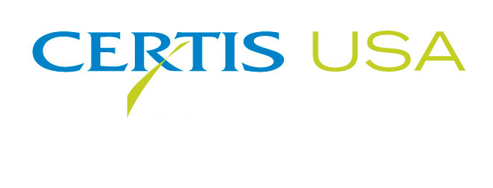
BoteGHATM Mycoinsecticide Launches
As LAM International Expands Its Solid Fermentation Capacity

COLUMBIA, Maryland, October 9, 2018 — Certis USA announces the launch of BoteGHATM mycoinsecticide for control of a broad spectrum of insect pests, including whiteflies, aphids and thrips on outdoor-grown vegetables, fruit, berries, tree nuts and other crops. The active ingredient of BoteGHA is a naturally occurring entomopathogenic fungus (Beauveria bassiana GHA strain) that causes a lethal infection of the target pest. Spores of the fungus germinate on contact with target insects or mites penetrating and then proliferating to kill the host from within. This nontoxic mode of action presents low risk to applicators and handlers and is considered safe on beneficial species and the environment compared to many other insecticides. BoteGHA is exempt from residue tolerance with no preharvest interval (PHI) requirements or Maximum Residue Limits (MRLs) and carries the minimum allowed restricted entry interval (REI) of 4 hours.

In support of the BoteGHA launch, LAM International, the manufacturer of BoteGHA and a wholly owned subsidiary of Certis USA, has embarked on a major investment to expand its solid fermentation production capacity at its Butte, Montana facility.

Jacob Eyal, Executive Vice President of Certis USA, said, “This investment will not only support the growth of our Beauveria product sales, but also the development and commercialization of our other new biopesticide products in the R&D pipeline.”

The project is expected to be completed in 2019. LAM and Certis USA are among the largest biopesticide solid fermentation producers in the U.S.

Headquartered in Columbia, Maryland, Certis USA is a leading manufacturer and distributor of a broad line of biopesticide products for specialty agricultural and horticultural markets and the home and garden market. Certis USA products provide valuable solutions by meeting the challenges faced by today’s growers who are seeking sustainable alternatives, resistant pest management and harvest solutions, and low pesticide residues for market flexibility and export accessibility. For more information about Certis USA or its products, please visit www.certisusa.com.
#
Media Contact:
Felicia Gillham, Gillham & Associates Marketing Communications
619-482-8820; Cell: 619-341-3054; fgillham@gillham-associates.com

