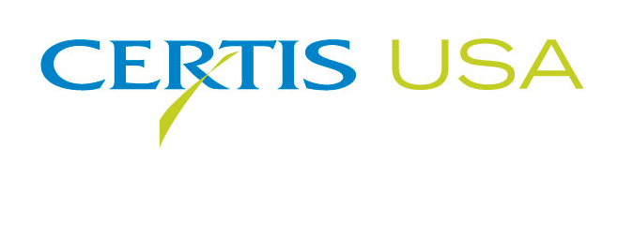
Jim Black Becomes Director of Business Development for Certis USA

COLUMBIA, Maryland—October 13, 2015—Certis USA, the biopesticide company, names Jim Black, formerly of Chemtura Corporation, to serve as its Director of Business Development. Black’s primary responsibilities are to lead new market and product development initiatives for Certis USA.

Black reports to Tim Damico, Certis USA’s Executive V.P. NAFTA. Damico said, “Certis USA has seen rapid growth over the past five years and has many new opportunities for the future. We are pleased to have Jim’s excellent array of skills, contacts and experience to lead our business development activities.”

For more than 30 years, Black has held senior level sales, marketing and business development positions for global agrichemical manufacturers. Most recently, Black was Global Strategic Business Unit Lead, Insecticides, Fungicides, Herbicides, PGRs and previously Director of Marketing, North America for Chemtura Corporation (now Arysta Lifescience). He has held positions with Entek Corporation (now DuPont), BASF Corporation and Dow Chemical Company.

Black holds an MBA degree (Magna Cum Laude) from Wilmington University, New Castle, Delaware, and a B.S. degree in Animal Science from Penn State University.

Headquartered in Columbia, Maryland, Certis USA is a leading manufacturer and distributor of a broad line of biopesticide products for specialty agricultural and horticultural markets and the home and garden market. Certis USA products provide valuable solutions by meeting the challenges faced by today’s growers who are seeking sustainable alternatives, resistant pest management and harvest solutions, and low pesticide residues for market flexibility and export accessibility. For more information about Certis USA or its products visit www.CertisUSA.com.

-30-
Media Contact:
Felicia Gillham
Gillham & Associates Marketing Communications
619-482-8820; Cell: 619-341-3054 (PST)

