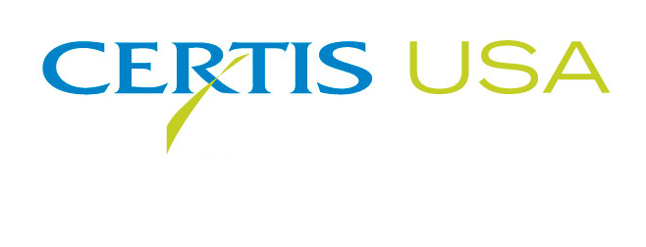
Mike Allan Takes the Helm for North American Business at Certis USA
As Tim Damico Retires

COLUMBIA, Maryland, Oct. 22, 2018 — Effective November 1, Mike Allan, Certis USA Vice President, North America, will assume the responsibilities for Certis USA’s North American business as Tim Damico, Certis USA Executive Vice President retires after 20 years with Certis USA and its predecessor company, Thermo Trilogy.
Jow-Lih Su, CEO and President of Certis USA, said, “As a core member of Certis USA’s management team for 20 years, Tim has built the company’s North American businesses from the U.S. and Mexico to Canada putting together a strong sales team and a leading biological/OMRI listed product portfolio. Tim also made significant contributions to the biopesticide industry by serving on the board of the Biological Products Industry Alliance (BPIA) and represented Certis USA and BPIA in various industry events. Tim’s efforts and those of other company team members, whose efforts he championed, led to Certis USA being named Member of the Year by BPIA.”
Damico said, “Being an integral part of Certis USA and the biopesticide industry has been an exhilarating and rewarding journey and personally one of the most fruitful experiences in my 40-year career in agricultural crop protection. I have all the confidence in Mike that he will continue to carry on the Certis USA legacy of being the leader in the biopesticide industry.”
Allan said, “That sets a high bar of excellence at Certis USA. I look forward to continuing Certis USA’s success.” Allan previously served as Vice President, Biorationals and President, North America at Isagro USA. He also served in various roles at Arysta/Tomen, including Global Business Development Manager and Product Manager Fumigants/Fungicides.
Headquartered in Columbia, Maryland, Certis USA is a leading manufacturer and distributor of a broad line of biopesticide products for specialty agricultural and horticultural markets and the home and garden market. Certis USA products provide valuable solutions by meeting the challenges faced by today’s growers who are seeking sustainable alternatives, resistant pest management and harvest solutions, and low pesticide residues for market flexibility and export accessibility. For more information about Certis USA or its products, please visit www.certisusa.com.

#
Media Contact:
Felicia Gillham, Gillham & Associates Marketing Communications
619-482-8820; Cell: 619-341-3054; fgillham@gillham-associates.com

