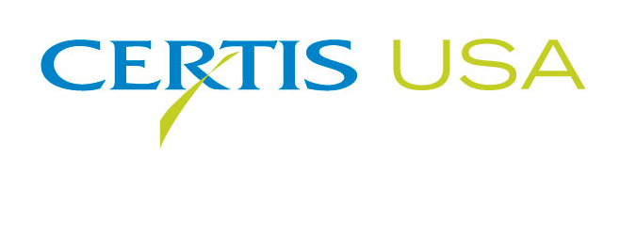
The Biopesticide Company Certis USA
Hires Curtis A. Nelson for Its Central California Agricultural Sales Position

COLUMBIA, Maryland, NOVEMBER 28, 2017 — Curtis A. Nelson brings extensive sales and marketing experience with him to Certis USA as Regional Manager-Central San Joaquin Valley of California. Nelson will be responsible for generating sales and support for Certis USA’s extensive line of biopesticide products used by the state’s vegetable, fruit, tree, vine and potato growers.

Jeremy Briscoe, Western Regional Sales Manager for Certis USA, said, “Curtis will be an ideal addition to the team. He knows the markets, and he knows the growers and their needs. He’ll be an excellent educator for them on how to fit our products into their current resistance management and IPM programs and their harvest export plans for both conventional and organic production.”

Nelson served most recently as Regional Sales Manager for Marrone Bio Innnovations. He’s worked for a number of other crop protection companies, including Western Farm Service, ADAMA, Kleen Globe, Inc. and AgraQuest, as well as irrigation equipment companies serving the specialty agriculture California market.

Nelson is a Member of the Board for the Association of Applied Insect Ecologists (AAIE) and holds PCA, QAL and CDL licenses in California. Nelson will work from his office in Dos Palos, CA.

Headquartered in Columbia, Maryland, Certis USA is a leading manufacturer and distributor of a broad line of biopesticide products for specialty agricultural and horticultural markets and the home and garden market. Certis USA products provide valuable solutions by meeting the challenges faced by today’s growers who are seeking sustainable alternatives, resistant pest management and harvest solutions, and low pesticide residues for market flexibility and export accessibility. For more information about Certis USA or its products visit www.CertisUSA.com.

-30-

Media Contact:
Felicia Gillham
Gillham & Associates Marketing Communications
619-482-8820; Cell: 619-341-3054 (PST)

