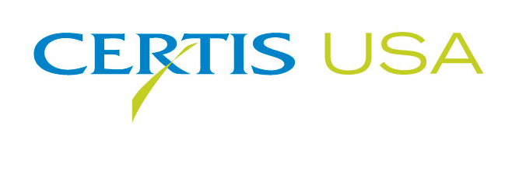

Anne Webster and John Wood Fill New Sales Territories
For Fast-Growing Biopesticide Company Certis USA

COLUMBIA, MD—December 2, 2014—Due to double digit growth each year in the last five, Certis USA established two new sales territories and announces new hires to fill the positions created by the demand for biopesticides. Anne Webster joins Certis USA as Regional Sales Manager-Great Lakes and John Wood is named Regional Sales Manager-CA South Central Valley. In their respective territories, Webster and Wood will be responsible for the sales and marketing of the company’s line of biopesticide products into the fruit and vegetable markets. A new third-party warehouse relationship has been established in Lima, OH to service the Great Lakes Region.

Webster comes to Certis USA with extensive experience in agricultural business, most recently as Recruiting Consultant at Ag1 Source. Webster previously served in sales capacities for Northwest Ag Products, Chemtura, Becker-Underwood and United Phosphorus Inc. She is a graduate of Western Michigan University with a B.S. degree in Agriculture and a minor in Agribusiness. A licensed commercial applicator, Webster is also a certified CCA. She works from her office in Paw Paw, MI to cover the following state territories: Illinois, Indiana, Michigan, Ohio and Wisconsin.

Wood will cover sales for Certis USA in California’s southern San Joaquin Valley. He previously served as Regional Sales Manager for AgriQuest Inc./Bayer CropScience-Biologics. Wood has also worked for Miller Chemical and Fertilizer Corp. and Gowan Company. He is a managing partner of a family farm and management operation in Baton Rouge, LA. He holds a B.S. degree in Ag Business Management from Cal Poly-San Luis Obispo and is a licensed PCA. Wood operates from his office in Bakersfield, CA.

Wood and Webster report directly to Jeremy Briscoe, Certis USA Specialty Ag Business Manager. Briscoe said, “The demand for biopesticides has grown exponentially over the last five years, which has put Certis USA in the hot seat. We have the largest product line of biocontrols on the market. The ag chemical and biopesticide experience that Anne and John have will be put to quick work in their new sales territories. We need them, and we’re glad they’ve joined Certis USA.”

Headquartered in Columbia, MD, Certis USA is a leading manufacturer and distributor of a broad line of biopesticide products for specialty agricultural and horticultural markets and the home and garden market. Certis USA products provide valuable solutions by meeting the challenges faced by today’s growers who are seeking sustainable alternatives, resistant pest management and harvest solutions, and low pesticide residues for market flexibility and export accessibility. For more information about Certis USA or its products visit www.CertisUSA.com.
-30-
Media Contact:
Felicia Gillham
Gillham & Associates Marketing Communications
619-482-8820; Fax: 619-482-8825; Cell: 619-341-3054 (PDT)

