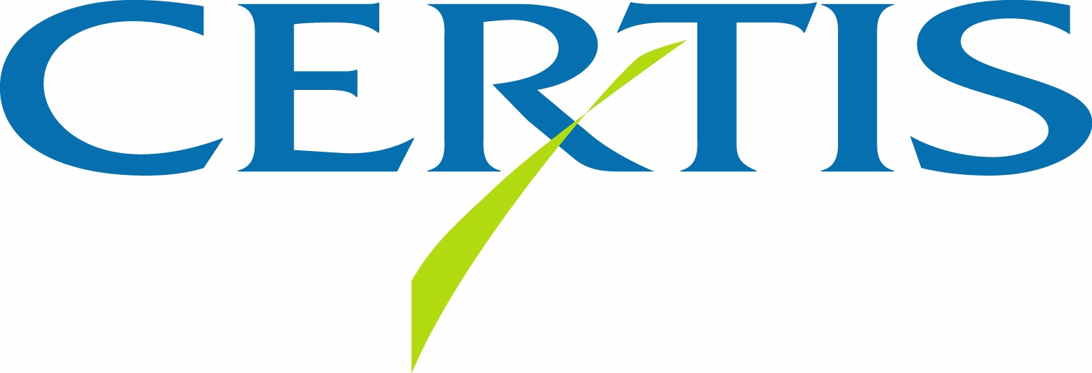

Certis USA Signs Global License Agreement for Bacillus mycoides Isolate BmJ.
Will Commercialize New Plant Disease Control Technologies.

COLUMBIA, MD—December 8, 2011—Certis USA has entered into a global license agreement with Montana State University-Bozeman and Montana BioAgriculture Inc. of Missoula, MT to develop and commercialize new plant disease control technologies based on Bacillus mycoides isolate BmJ.

BmJ is a naturally occurring, nonpathogenic bacterium that triggers a plant's immune response to pathogenic fungi, bacteria and viruses resulting in systemic acquired resistance (SAR) to diseases. BmJ does this by a mechanism very similar to that of chemical SAR activators, but with equal or better disease control for longer periods and with lower risk of phytotoxicity. While some microbial biofungicides have been reported to also have moderate activity as SAR activators, BmJ is unique in that it works entirely as a microbial SAR activator with no direct effect on the plant pathogen itself. These characteristics make BmJ a valuable tool for use in fungicide resistance management programs.

Montana State University (MSU) has patented methods for inducing SAR in plants by applying
BmJ-based control agents, and related patents are pending. The technology has been under development by MSU and Montana BioAgriculture, and the collaboration has proven the efficacy of BmJ against Cercospora leaf spot in sugar beets, white mold and early blight in potatoes, and several other crop diseases. Certis USA plans to commercialize this technology worldwide in an expanded range of crops and diseases.

For more information about Certis USA or its products, call 1-800-250-5024 or visit www.CertisUSA.com.

Headquartered in Columbia, MD, Certis USA is a leading manufacturer and distributor of the largest line of biopesticide products for specialty agricultural and horticultural markets. Certis USA product brands include its granulovirus products CYD-X® codling moth virus, Gemstar® corn earworm virus, and Spod-X® beet armyworm virus; as well as Agree®, Crymax®, Deliver® and Javelin® Bt bioinsecticides; Azatin®, Neemazad® and Neemix® botanical insect growth regulators; Trilogy® botanical fungicide/miticide; SoilGard® microbial fungicide; MeloCon® bionematicide; Basamid® granular soil fumigant; SCREEN Duo™ heat stress management for plants; DES-X™ insecticidal soap concentrate; Cueva™ liquid copper fungicide concentrate; SeduceTM insecticidal bait; Final-SanTM-O herbicidal concentrate; Sluggo® slug and snail bait (Eastern markets only) and Bug-N-Sluggo® insect, slug and snail bait; and now PFR-97TM insecticidal fungus.
-30-
Media Contact:
Felicia Gillham
Gillham & Associates Marketing Communications
619-482-8820; Fax: 619-482-8825; Cell: 619-341-3054 (PDT)

