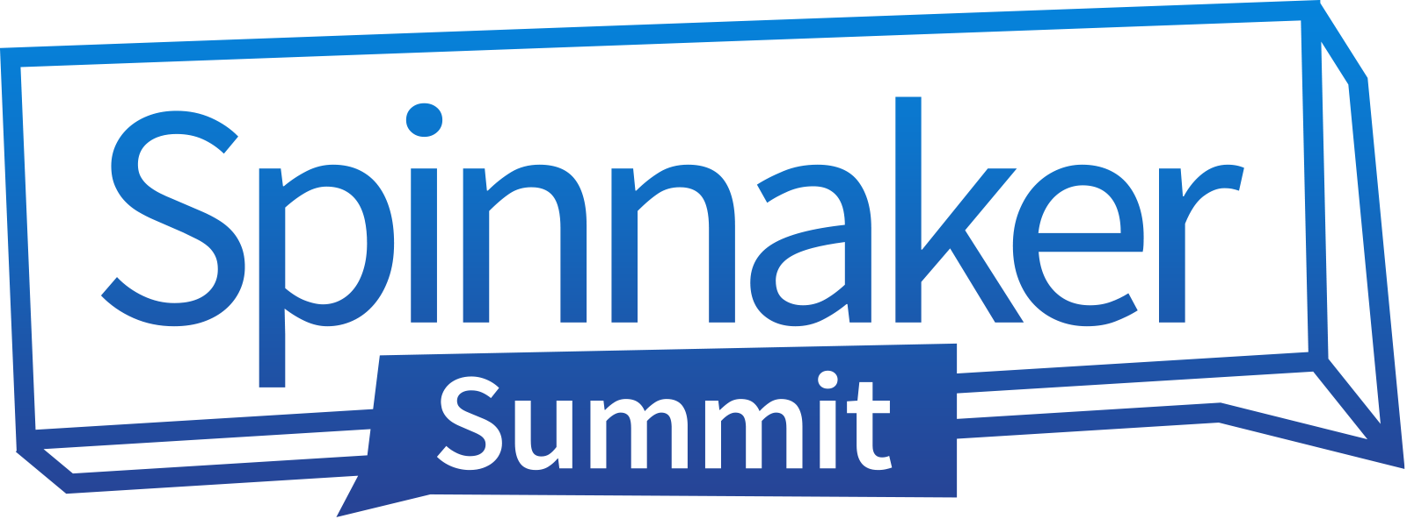

Dear {Name},

I’d like to attend Spinnaker Summit 2019 taking place November 15-17, 2019, in San Diego, California. I’ve researched several open source software conferences and this is the conference for uniting Spinnaker users together with open source software evangelists and technologists to advance the development efforts of the Spinnaker continuous delivery (CD) platform.

Over 1,000 of the most talented individuals from the open source community gather together for this event making it a great place to network with open source software developers and practitioners, CD innovators and influencers, along with acquiring insights and best practices from the Continuous Delivery Foundation (CDF) founding project members.

Here is some data from Spinnaker Summit 2018 to give you an idea of who attends:

• Technology innovators, influencers, and solution providers represent the majority of attendees with 22% from computer industry, 20% from Internet technologies, and 16% from IT services.

• Key technology strategists, adopters, and influencers representing all functional areas and departments: engineers, technical leads, developers, architects, along with C-level executives.

• Many of today’s top enterprises including: Netflix, Google, Adobe, Redbox, SAP, GoPro, Pluralsight, Apple, VMware, Linux, Salesforce, and Amazon.

To get a feel for what the conference is all about, check out this [**highlight reel**](https://www.spinnakersummit.com/2018) from Seattle in 2018.

Here’s how I envision my attendance at Spinnaker Summit 2019 strengthening our company:

• Adopt open source software and continuous delivery development best practices and insights to accelerate our software releases securely and reliably.

• Get hands-on Spinnaker product experience and create a roadmap for implementing a continuous delivery strategy within our development environment to enhance our software development life cycle processes.

• Learn firsthand from leading enterprises how they benefited from using the Spinnaker platform to ensure we achieve successes with the technology adoption and accelerate our go-to-market efforts.

You can learn more about the conference [**here**](https://www.spinnakersummit.com/) and view last year’s keynotes and other videos [**here**](https://www.youtube.com/watch?v=nK9XBSJvKE8&list=PL4yLrwUObNksZ8svJWu5HOHT3e_dpa5Ih).

If I register before September 1st, the fee is only USD $495.00. Included in the registration fee is access to all keynotes and sessions, technical training workshops, sponsor showcase, opportunity to meet the Spinnaker core team, all meals, and other evening networking events.

I would be happy to write a post-conference report and share with other members of the team what I’ve learned and how we can implement this continuous delivery platform into our business strategy.

Thanks,

{Your Name}