The Blast Furnace

Sixth Cohort
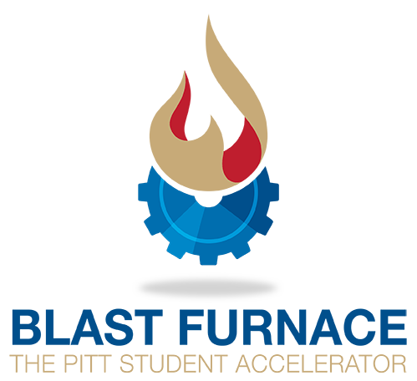

Along with the
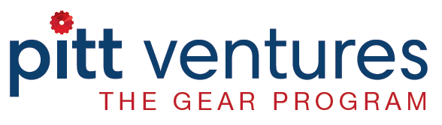

Monday Peer Participation Class &

Wednesday Entrepreneurial Speaker Series

Basic Agenda:
Monday (9 sessions):
(Soft Drinks Provided; Teams prep before session)
Starts at 5PM until 7PM
Brief presentation by Teaching Team followed by
Individual team updates / exercises / Q&A

Wednesday (8 sessions):
(Pizza/Sandwiches/Soft Drinks Provided)
Start time 5PM
Speakers between 5 and 6:30PM
Social/Network 6:30PM

Website for All Info: http://go.innovation.pitt.edu/bfinfo

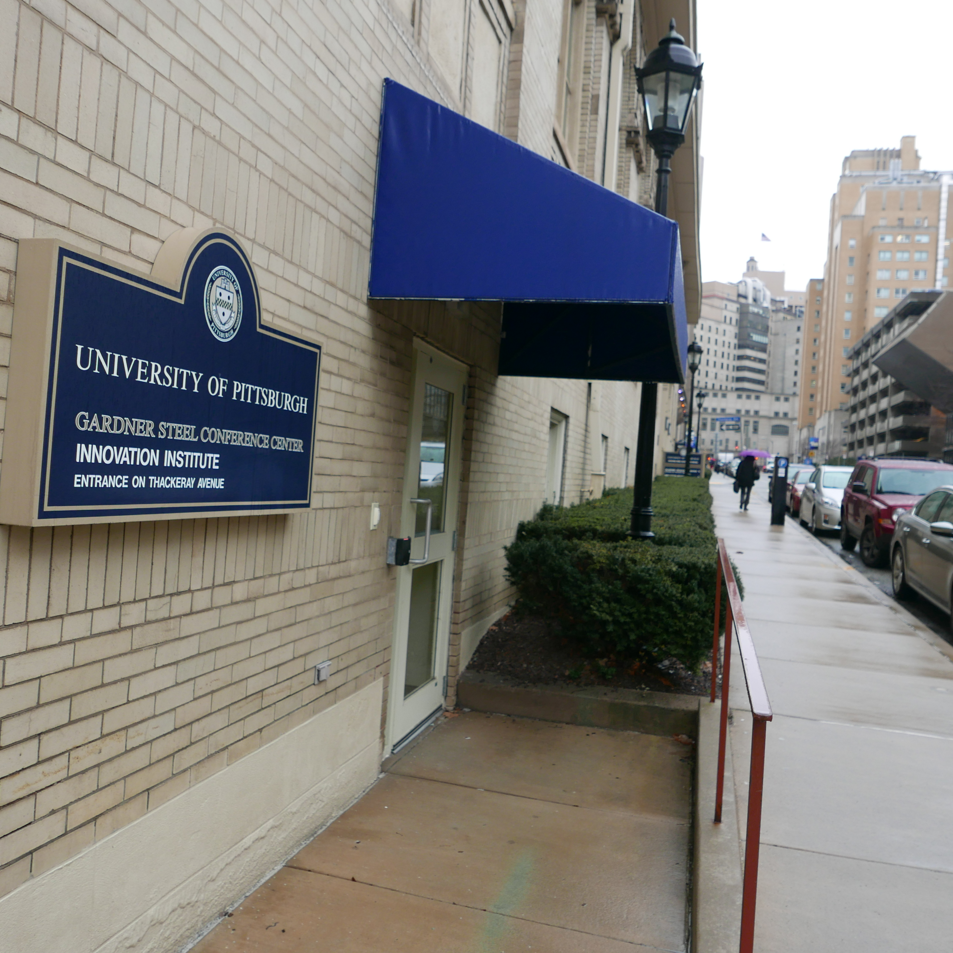
Blast Furnace Location

All Monday events are in the Blast Furnace Workspace are at G50 Gardner Steel Conference Center
http://www.tour.pitt.edu/tour/gardner-steel-conference-center?viewmap

Enter on O’Hara Street, under blue awning, door closest to Soldiers & Sailors Memorial
Address: 4042 O’Hara Street, Pittsburgh, PA, 15213

Wednesday Entrepreneurial Speaker Series Sessions are in Barco Law Building, Room 111 (The session Nov 2 will be in Barco, Room 107)

Blast Furnace Overview
The Blast Furnace is organized around a series of workshops designed to move an innovation closer to commercialization. Blast Furnace teams will interact with potential customers, partners, and competitors as they apply workshop learning and validate business hypotheses to determine the commercial readiness of their idea.
The Blast Furnace provides teams with access to EIR’s (Entrepreneur in Residence) who are experienced at starting and running businesses. They are the teaching team and comprise a wide breadth of backgrounds.
The culmination of all the hard work the teams devote to the Blast Furnace is a Demo Day where each team presents a pitch to judges for cash prizes.
Blast Furnace Cohort 5 Schedule – October, November, June 2017
Week 1 | Monday October 2 – Class  Creating Customer Value  - Introductions and program overview  - Value proposition and customer benefits | Wednesday October 4 – Speaker Series  Creating Customer-Driven Offerings  - Proper customer discovery (CD)  - Examples of failed CD
Week 2 | SPECIAL DAY TUESDAY October 10 – Class  The Business Plan  - Business Model Canvas (BMC) overview  - Relating BMC to product and customers | Wednesday October 11 – Speaker Series  A Framework for Building Your Company  - Who wants what you have to sell?  - How/what do customers buy today?
Saturday October 14 - Mentor Mixer 8:30-11am – William Pitt Union Kurtzman Room

Week 3 | Monday October 16 – Class  Your Market and Who Is Trying to Steal It?  - Qualifying the market  - Identifying competition | Wednesday October 18  Innovation Showcase  Come! Register: http://go.innovation.pitt.edu/showcase_science_2017_register
Week 4 | Monday October 23 – Class  Your Market and Who Is Trying to Steal It?  - Qualifying the market  - Identifying competition | Wednesday October 25 – Speaker Series  You Have More Competitors than You Know  - How do customer solve problems today?  - How could customers solve problems today?
Week 5 | Monday October 30 – Class  Interviewing Basics  - Gathering potential customer data | Wed. Nov. 1 & Thur. Nov. 2 – Speaker Series  NOVEMBER 2 Meet in Room 107 in Barco Building!  Business Fundamentals – Part 1 (Wednesday)  - VC funding – how does it work?  - Accounting for startups  - What is involved in leading a startup?  Business Fundamentals – Part 2 (Thursday)  - Legal issues for newly created companies  - Insurance issues in startups
Week 6 | Monday November 6 – Class  Idea Refinement  - Does your idea speak to the customer  - Design Team Logo (jpeg or png format) & 3-4 sentence summary of your business for the Blast Furnace Website  - Past Examples here: pittblastfurance.com | Wednesday November 8 – Speaker Series  Next Steps for Your Startup – Life After BF  - Local groups to assist your startup  - Moving your idea toward commercialization
Week 7 | Monday November 13 – Class  Product Refinement  - Does the product solve the problem | Wednesday November 15 – Speaker Series  Design, Build and Market Your Product  - Product design/prototyping/development  - How to market your product/service  - Fill out form on: http://go.innovation.pitt.edu/bfinfo  - Produce a one-page PDF marketing document to showcase your business
SKIP | NO BLAST FURNACE SESSIONS NOVEMBER 20 and 22
Week 8 | Monday November 27 – Class  Storytelling  - Effective business communication | Wednesday November 29 – Speaker Series  Building a Powerful Narrative  - Impactful storyline structure  - What must your audience remember?
Week 9 | Monday December 4 – Class  Demo Day Prep  (If you are nervous, practice your pitch in the Lower Lounge on off hours by yourself in the WPU! It helps!) | Thursday December 7  DEMO DAY - 5PM William Pitt Union, Lower Lounge  $ Cash prizes to 1, 2, & 3rd place!

Blast Furnace Structure
The Blast Furnace is a 9-week non-credit program focused on teaching students 3 core entrepreneurial skills:
- Critical assessment of idea viability;
- Identifying key drivers of value for users; and
- Validating a product by interviewing potential customers.

Blast Furnace sessions occur twice a week – Monday’s (5-7pm) and Wednesdays (5-7pm).
- Monday sessions are facilitated by Pitt EIR’s who have decades of experience running companies. These sessions focus on the practical aspects of developing your team’s business.
- Wednesday sessions are topical with guest speakers who have unique entrepreneurship experiences to share. Collectively these speakers have over a century of running successful businesses totaling over a billion dollars.

The Blast Furnace is a peer participation program –learn by doing and giving feedback to others. The peer feedback is so vital you are expected to attend all Mon and Wed sessions.

On-Line Tools: Teams are expected to join the Blast Furnace Slack team. This is the primary way the teaching team will distribute additional information, take questions between sessions and support the teams.

Blast Furnace Central Website: http://go.innovation.pitt.edu/bfinfo

EIR Mentoring: Teams are expected to engage with EIRs & mentors who have been selected specifically to work with the Blast Furnace. They are available by appointment, by email, virtual meeting and via Slack.

Blast Furnace Cohort 6 Videos and Readings
Participants are expected to watch the highly engaging Steve Blank “How to Build a Startup” videos at www.udacity.com (IC 100). For those people who want to get the maximum out of the Blast Furnace, we also recommend readings from:
- The Startup Owner’s Manual by Steve Blank and Bob Dorf
- Business Model Generation by Alexander Osterwalder and Yves Pigneur
 | Required Videos (Steve Blank at udacity.com) | Recommended Readings (optional)
Week 1 | Lecture 0; Before You Get Started (10:28)  Lecture 1; What We Now Know (20:34)  Lecture 1.5A: Business Models (12:17)  Lecture 1.5B: Business Models (31:34) | Startup Owner’s Manual  pages 1 - 50  Business Model Generation  pages 14 - 49
Week 2 | Lecture 2: Value Proposition (31:34)  Lecture 3: Customer Segments (43:28)  Lecture 5: Customer Relationships (34:32) | Startup Owner’s Manual  Pages 85 - 97 Pages 112 - 125  Pages 203 - 221 Pages 260 - 266  Pages 180 - 188 Pages 260 - 269  Pages 438 - 456  Business Model Generation  Pages 146 - 150 Pages 161 - 168  Pages 200 - 211
Week 3 | Lecture 6: Revenue Model (33:22) | Startup Owner’s Manual  Pages 176 - 179 Pages 257 - 270  Pages 429 - 459
Week 5 | Lecture 7: Partners (33:22)  Lecture 8: Resources, Activities, Costs (28:23) | Startup Owner’s Manual  Pages 169 - 175 Pages 180 - 188
Week 6 | Lecture 4: Channels (19:06) | Business Model Generation  Pages 126 - 168 Pages 296 - 351

