Customer Pricing Import Guide

Importing from Excel
Instead of updating individual records one at a time, AdvancePro allows you to add or update information about your customers, products and vendors in a batch by importing from Microsoft Excel. Customer specific pricing for specific products can be imported as well.

Import Schemas
Download the following schema to prepare your data for importing into AdvancePro:

Customer Pricing Import Schema.xls

RULES TO FOLLOW WHEN IMPORTING A SPREADSHEET:
- The first sheet must be named “Sheet1”. Notice that there is no space between ‘Sheet’ and ‘1’.
- No other sheets should exist except for ‘Sheet1’.
- Make sure to save the file as an ‘.XLS’ file.
- Format everything to ‘Text’ format.

Importing Customer Pricing
Before proceeding with your customer pricing import, you may wish to download and review ‘Sample Customer Pricing Import Schema.xls’

- Fill out the ‘Customer Pricing Import Schema’ with your information and save it as a .xls file in your ‘C’ Drive.
  - Your headers should be SKU, ProdName, Customer Numbers as in the example
Note: The Excel document must be saved as a .xls file
Note: Account numbers need to have been created for the accounts you wish to create special pricing for.
Note: Prices are imported in the default system currency only.

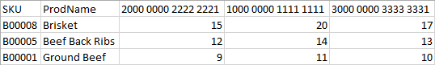

- In your start menu, open Microsoft SQL Server 2005 > Configuration Tools > SQL Server Surface Area Configuration Tools.
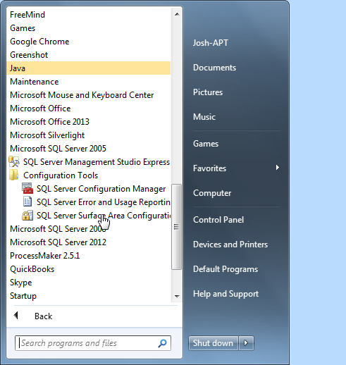
- Select ‘Surface Area Configuration for Features’. 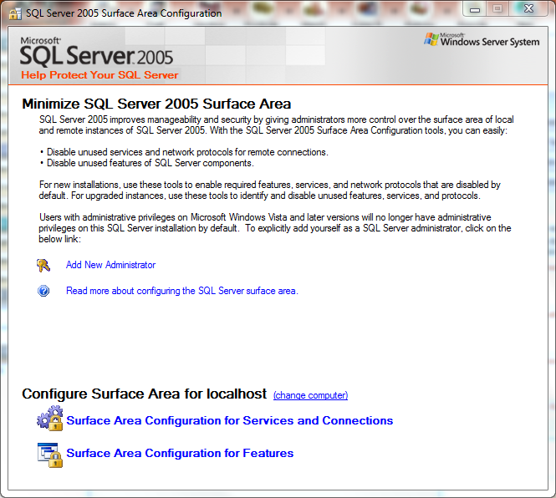
- Select ‘Ad Hoc Remote Queries’ and make sure it is enabled. 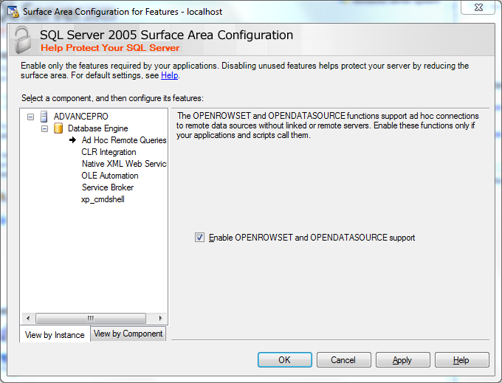

- Now that the system setup has been properly setup, we can go ahead with our pricing import.
  - Click “Admin” to bring up the Admin panel.
  - Click “Utilities” to access the Utilities menu.
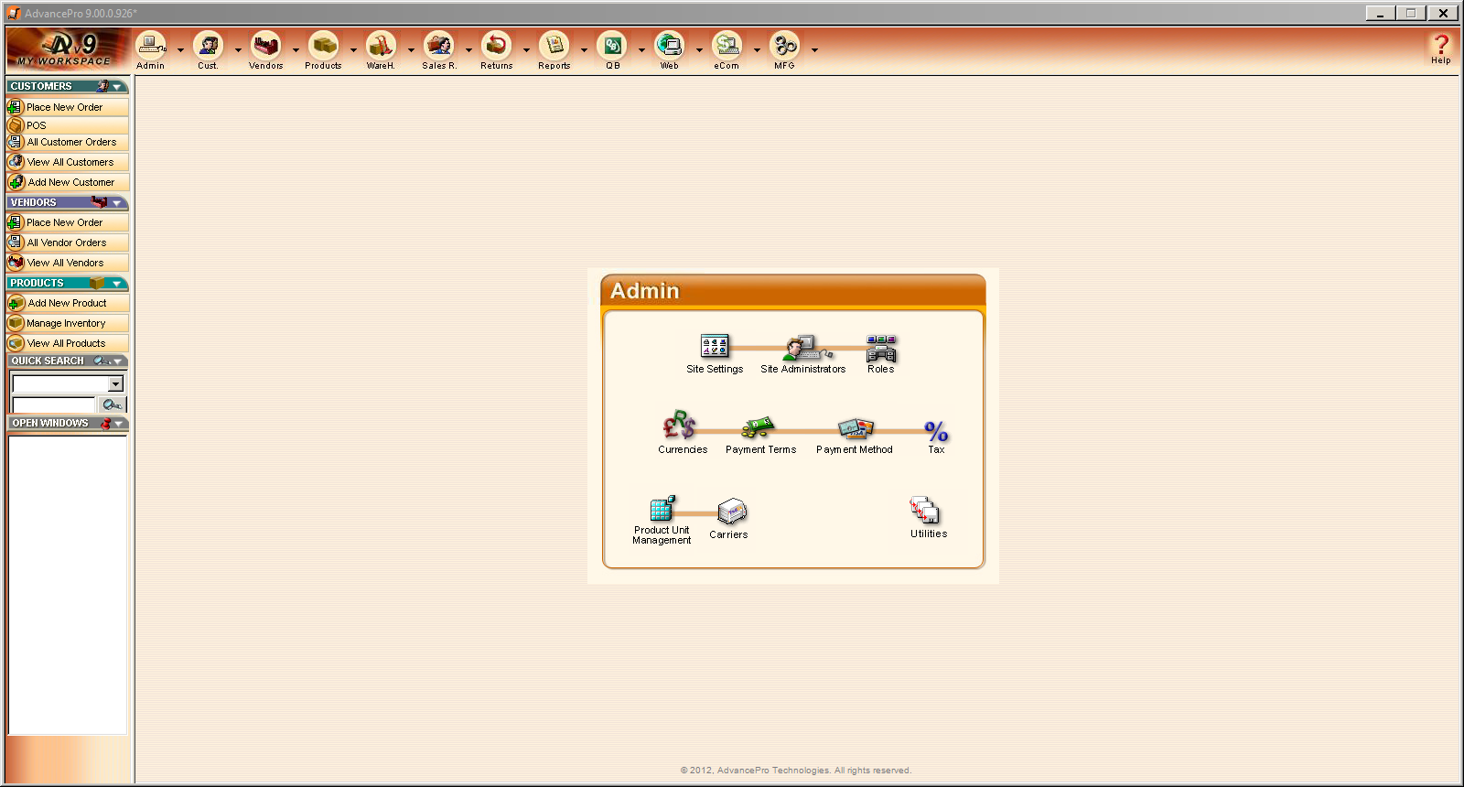

- Access the “Import Customer Pricing” screen
  - Click “Excel Import/Export”
  - Click the magnifying glass to search for your customer pricing file.
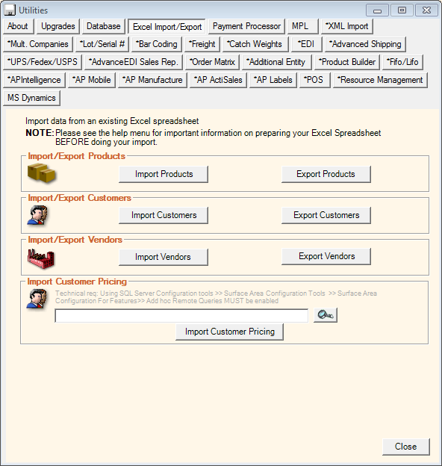

- Once you have found and selected your customer pricing file, click on “Import Customer Pricing.”
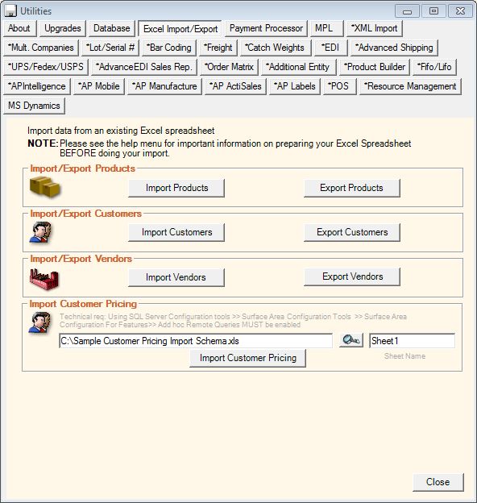

- AdvancePro will produce a report confirming that your pricing has been updated
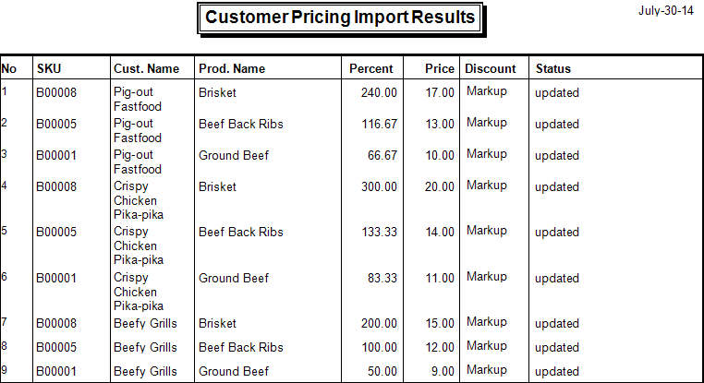
- For further help, visit the knowledge base.

