Partial Drop Shipment

Create a Customer order and mark it for dropship.
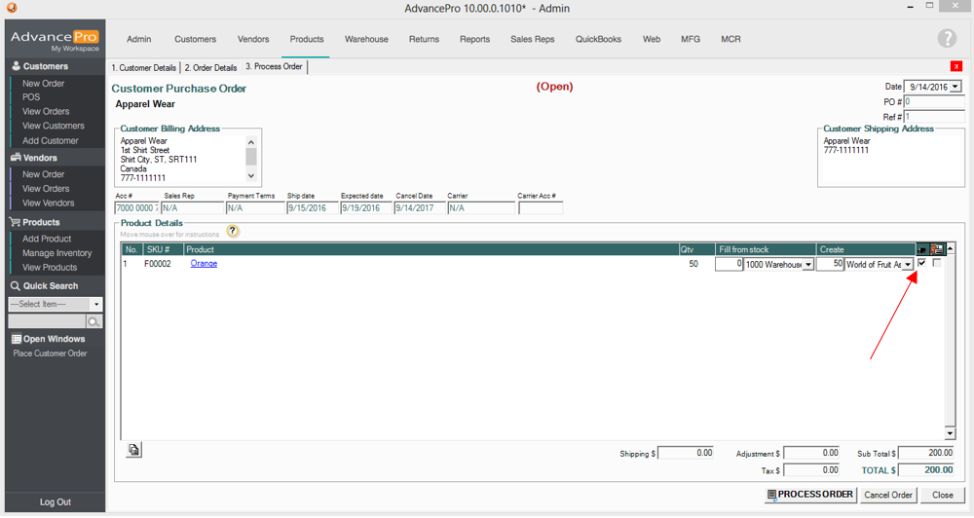
Process the Order. It will then create a Vendor order for the dropshipment.
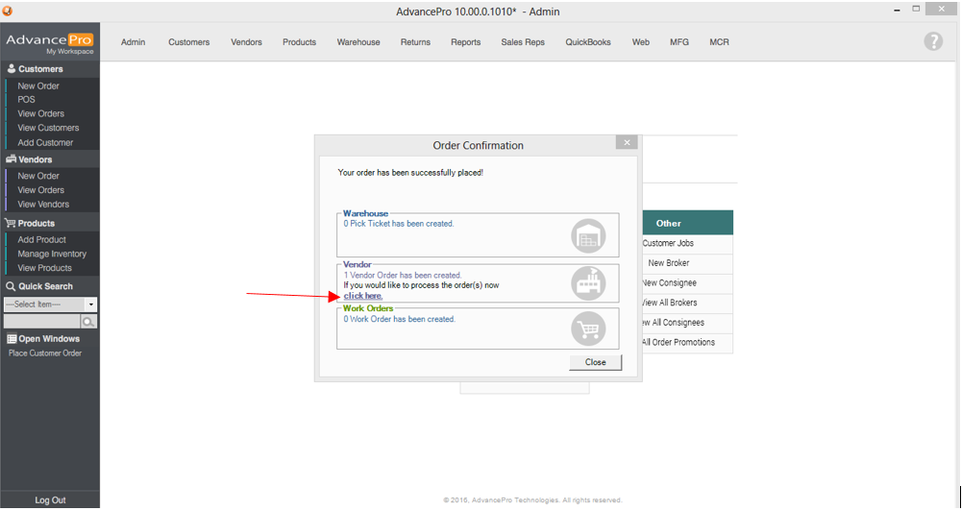

Place the Vendor order.
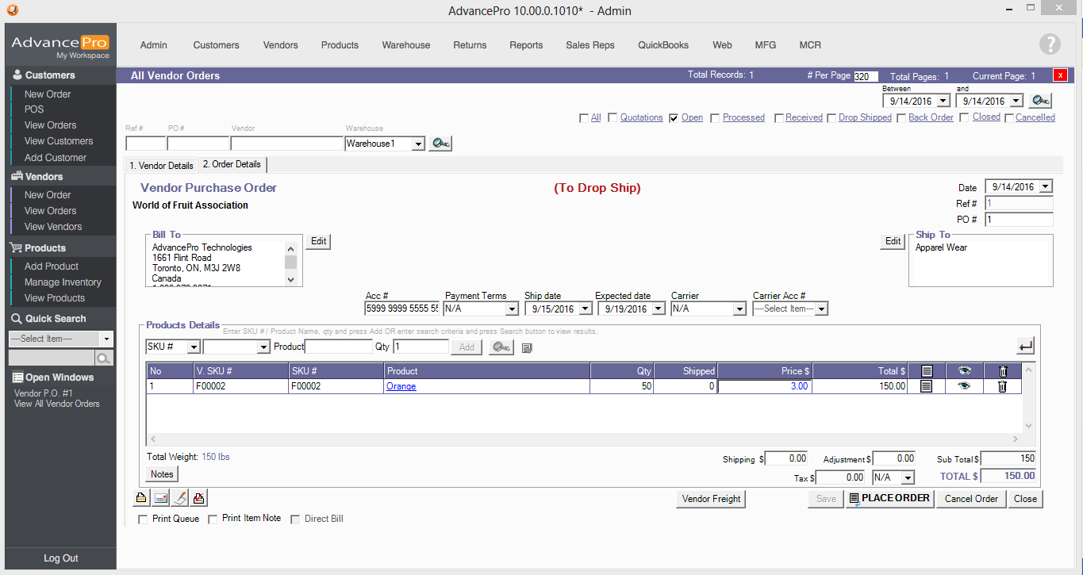

You will then see the order under “Drop Shipped”.
In this screen, you can then confirm the partial quantity of items that were sent by the vendor.
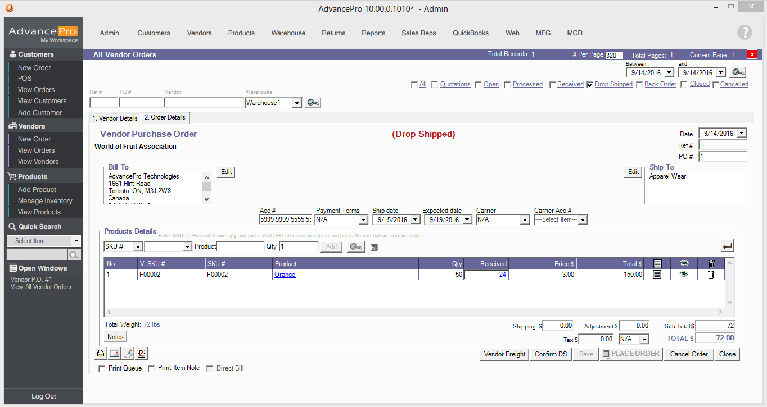

Click Confirm DS. You will then be asked to select if you want to partially confirm this order.
Select “YES” to receive partially and keep outstanding items pending future DS confirmation.
Click “NO“to receive partially and cancel the rest.
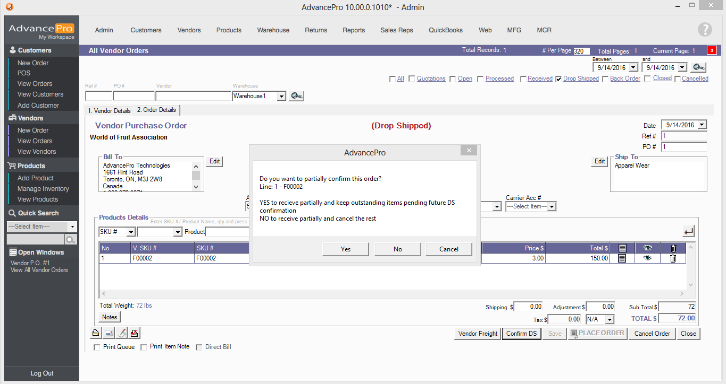
If you select “Yes”, the line item will be separated. One for the received quantity and the other is for the pending quantity to be received.
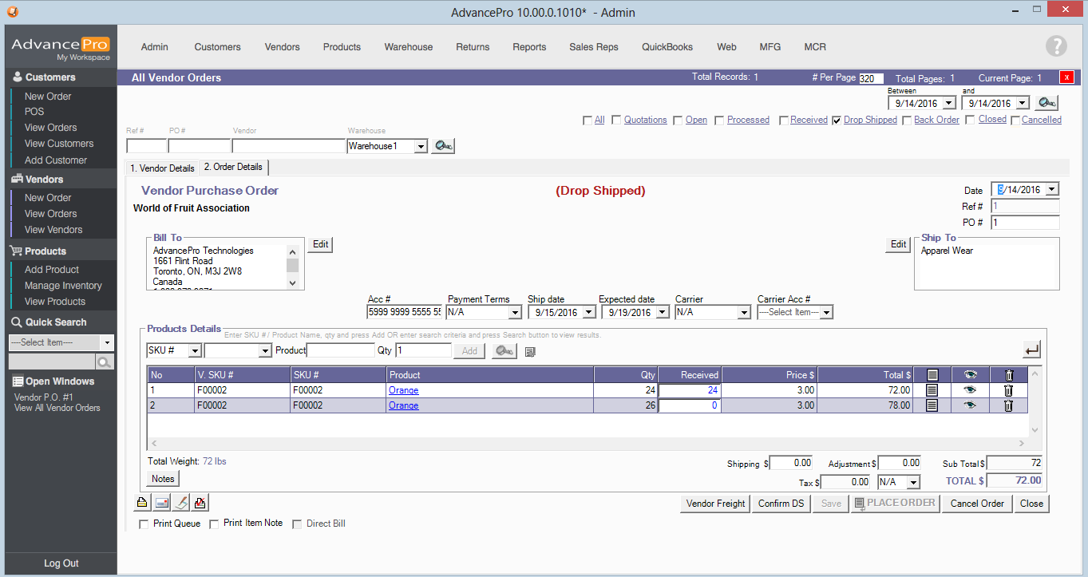

A Customer Invoice can now be created for the quantity that has been sent.
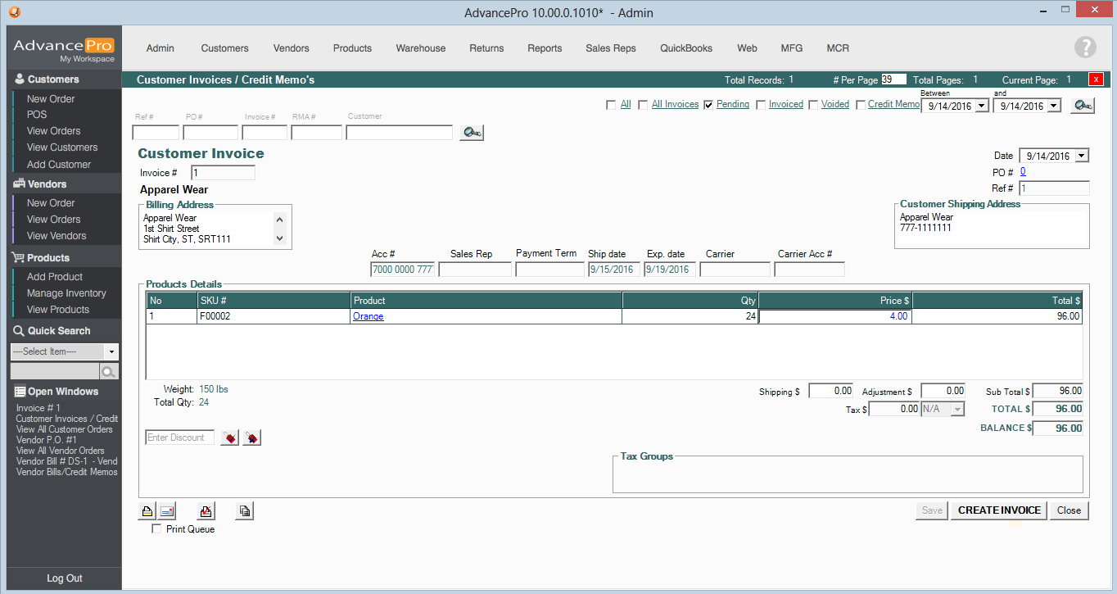
If you create the invoice now, it will create a new invoice when you receive the rest of the order.
If you wait until you receive the rest of the quantity before creating the invoice, it will just add the quantity in the existing pending invoice.

