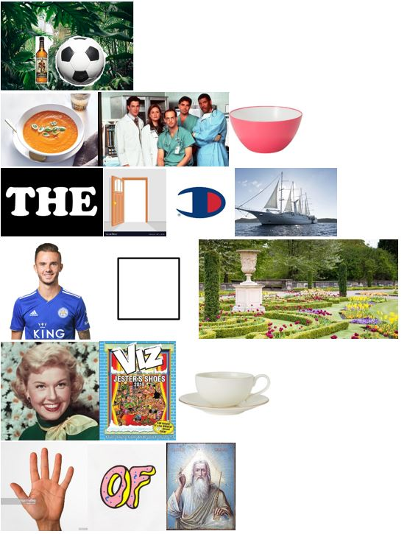

Say what you see answers from Switched On July 19:

1. Rumble in the jungle
2. Super Bowl
3. The Open Championship
4. Maddison Square Garden
5. Davis Cup
6. Hand of God