Yearbook Summer Assignment DUE: Friday, September 1st
Bennett

THERE IS A LOT OF INFORMATION IN THIS DOCUMENT AND YOUR FIRST GRADES IN YEARBOOK WILL BE BASED ON YOU CORRECTLY COMPLETING THESE SUMMER ASSIGNMENTS. READ EVERYTHING CAREFULLY.

THEN READ IT AGAIN. BEFORE YOU TURN IN YOUR ASSIGNMENT, READ IT AGAIN.

(*returning staffers, the assignment is different than last year, so read carefully too.)
Our coverage includes all the interesting stuff Saints are up to during the summer break.
- It is your first responsibility for the book to collect and document all this fun stuff so we can put it in the book.
- You should work on this ALL summer so you can turn in a variety of activities, people, places, and parts of the summer. We don’t just want photos from the week before school.

You must complete the following 2 (TWO) assignments. Read the details below for the requirements for each assignment. EVERYTHING you need to know is here (if it’s not, email me), but you may NOT come to school and say, “I didn’t know what I should do. That won’t cut it in yearbook.

Assignment 1:
Collect at least 8 (EIGHT) different summer photos for the yearbook, write captions for each one, and present them to the class. (Details and requirements below).

Assignment 2:
Create a sidebar or focus story on a summer topic. (Details and requirements below).

- This is your first grade of the year. Following standards is very important in yearbook.
- I will grade you on having each component of these assignments and bringing them as listed.
- Make sure you understand what I expect from you.
- Email me with any questions. If I do not hear from you, I will assume you understand the assignment.
- These assignments are DUE the SECOND day of school. If you do not work on them over the summer, you WILL NOT receive a good grade on these assignments.

FAILURE TO COMPLETE THESE ASSIGNMENTS MAY RESULT IN REMOVAL FROM THE CLASS.

Assignment 1:
WE WILL BE USING THESE PHOTOS IN THE YEARBOOK, SO MAKE THEM COUNT.
You can turn in photos taken by yourself or other photographers but be sure they meet the requirements.

  - You may NOT turn in more than one photo of yourself.
  - Do NOT turn in posed photos.
  - Do NOT turn in photos of people standing with their arms around each other looking at the camera. These are BORING! Get the action, tell the story.
  - Turn in photos of INTERLAKE students (other people are allowed in the photo as long as Interlake students are the focus.
  - Collect photos taken at high resolution.
  - Get original photos – DO NOT screen shot photos from Facebook, Instagram, SnapChat…
  - You may not turn in more than two photos of any one person.
  - You may not turn the same photo as another yearbook staffer – so collect lots of photos to avoid duplications.
  - If I’m not interested by your photo, it will be a ZERO.
Your assignment is DUE THE SECOND DAY OF SCHOOL, SEPTEMBER 1, 2017.
Here’s what you need to have:
- Photos
  - Bring Photos on a usb drive.
  - Photos should be saved as .jpg, .tff, or .png.
  - Name photo files by the subject and the name of the photographer (example: sailing smith.jpg)
    - you will lose points for photos that are not named as described above
  - DO NOT insert your photos into a word, powerpoint, or other file.
  - Make sure your file size is at least 300kb – smaller photo sizes may not receive credit. Check with Mrs. B. if you have any questions
  - Have at least 8 photos representing as many different people and activities as possible.
- Captions
  - Captions must be typed and saved on your thumb drive.
  - Captions must be accurate and include all required information (see list below)
  - Caption information must be clearly presented and proof read.
- Presentation
  - You will present your photos and captions to the class on Thursday, Sept 1. Be Ready!

PHOTO IDEAS

- Summer jobs
- Vacations
- Beach, lake, pool time
- Back to school shopping
- Summer sports
- Summer Camps
- Summer work outs/meetings of Interlake activities.

- If it’s summer and an Interlake student is involved – get photos!

Reach out to friends, friends of friends and people you don’t know to get photos. The more different people we can feature in the book, the better.

FOR EACH PHOTO – TYPE UP THE FOLLOWING CAPTION INFORMATION:
It is YOUR responsibility to track down this information.
- WHO – Names (first AND last) of everyone in the photo (even if they don’t go to Interlake).
- WHAT – What activity is going on? What is happening in the photo? What happened before, after?
- WHERE – Where is this? Be specific.
- WHEN – Date, time of day.
- WHY – What was the purpose of the event?
- HOW – How did people come to be at this event?
- PHOTOGRAPHER – Who took this photo?
- QUOTE – Extra Credit – Include an interesting quote from someone in the photo.

Use the examples below to help you write up your captions.
EXAMPLE 1

Who: T.C. Vu, Henry Haro, Teja Lingham, Lily Tang, Zein Charania, Katja Engetshwiler, and Laura Peder
What: As a group we decided to spend one of the hotter days of the summer at the beach, we just finished swimming and were resting on the grass drying off.
Where: This was at Chism Beach Park in Downtown Bellevue, WA.
When: Sometime in the middle of August, during the hottest time of day, 2-3pm.
Why: This was a get together with all of us that we had been trying to set up for a while, and we finally got it to happen, and to make it happen at a beach with everyone back from vacation made it that much better.
How: We had to try and find a day everyone was free after everyone was back from vacation, and we made it happen meeting up at Chism Beach Park to have a hot, fun day! Photographer: Sally Student
EXAMPLE 2

Photo 1 | Photo 2 | Photo 3
Senior basketball player Kaeleigh Randolph meets Coach Scott Marcum’s new baby boy Landon at Marcum’s house shortly after his birth. Landon Marcum was born on July 25th. Kaeleigh hopes that Landon will be the Girls Basketball good luck charm this season.  Photo by: Jimmy Junior | Sarah Williams (#25) gathers her club team this summer to give a powerful halftime talk to lead her team to victory during a tournament at Starfire in June. The team went on to win the tournament. “Everything came together for us to have a perfect victory that day,” said Sarah.  Photo by: Mr. Smith | Rachel Brous and Kaeleigh Randolph go to war in a water and nerf gun fight for a summer soccer practice on August 31st on the Interlake turf. Annika Granfors hides in the background trying to avoid the water attack The team calls it the first annual hunger games to get them prepared and excited for the season.  Photo by: Tanya Teen

Assignment 2:

All summer long there are interesting stories, trends and you guys are doing all sorts of fun stuff! We want to showcase all of that in the yearbook. This book is the story of your year, so trips, trends, summer fun, jobs, hikes, summer food… all of that is part of your story and it needs to be in the yearbook.

You will create a special interest story, a student profile, or a Q and A feature that we can run in the yearbook. Focus on a summer topic. Choose ONE of the following to turn in on September 1st with your summer photos.

- Special Interest Story
All sorts of interesting stuff happens over the summer. You could write about popular hikes, funny stories from summer jobs, a food trend, a social media trend, a big news event that everyone’s talking about, something that dominates the summer like Pokemon Go or the Ice Bucket Challenge. Be sure to get quotes from Interlake students for your story. If you don’t have photos to go with your story, include a plan for what photos you will include.
Your story should be 200-300 words, proofread, full of Interlake connections and quotes, and something that will interest Interlake students. Make sure the subject matter relates to summer – this will be in our summer section. So Q & A’s need to be on a summer topic. Include at least two photos (or a plan for your photos).

- Student Profile
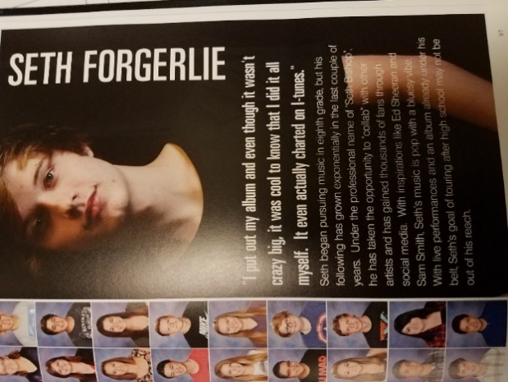
You go to school with lots of interesting people – people who compete internationally in roller skating, travel the world, volunteer all summer, own businesses, build things, have special talents…. There’s lots to celebrate about what your fellow students do. Be sure to include quotes from the student you are profiling as well as quotes about that student from other Interlake students. If you don’t have photos to go with your story, include a plan for what photos you will include.
Your story should be 200-300 words, proofread and include quotes from the profile student and other Interlake Students. Include at least two photos (or a plan for your photos).

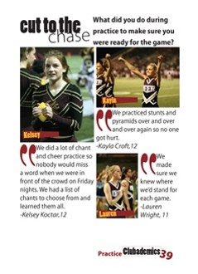
- Q and A Feature
Asking a question to many different students helps to tell a quick summer story. Make sure your question encourages people to tell a little story. Yes or no answers aren’t interesting. Always ask why to get people talking. Ask something specific about summer – What’s your favorite summer treat and why? What’s your Fourth of July tradition? What’s your summer soundtrack? … If you don’t have photos of each person who answered, include a plan to get those photos.
Your Q and A Feature should include a question, interesting answers from at least 6 people and photos of each person who answer (or a plan for your photos).

Rubric:

Use this rubric to make sure you have met all the requirements for the assignment. Be detail oriented and make sure you can check off Well Done for everything on the list.

WELL DONE: NEEDS WORK:

On time Late
Turned in correctly (right folder, right folder names) In wrong folder, folder name incorrect

Photos:
No more than one photo of self Multiple photos of self
No more than two photos of one person Many photos of one person
No duplicates with staff members Same photo(s) as other staff members
Interest and variety Posed, uninteresting
Interlake students Photos without any Interlake students
Saved as .jpg, .tff, .png Submitted in Word, PowerPoint, ect.
File name = subject and name of photographer File name has not been changed
Photos are at least 300kb Photos less than 300kb
8 photos ______ photos

Captions:
Who – first and last name Who – first and last name
What What
Where Where
When When
Why Why
How How
Photographer name Photographer name
Quote – Extra Credit Quote – Extra Credit

Special Interest Story:
200-300 words Fewer than 200 words
Proofread Errors
Connection to Interlake No connection to Interlake
Quotes No Quotes
Photos and/or photo plan No photos or plan

