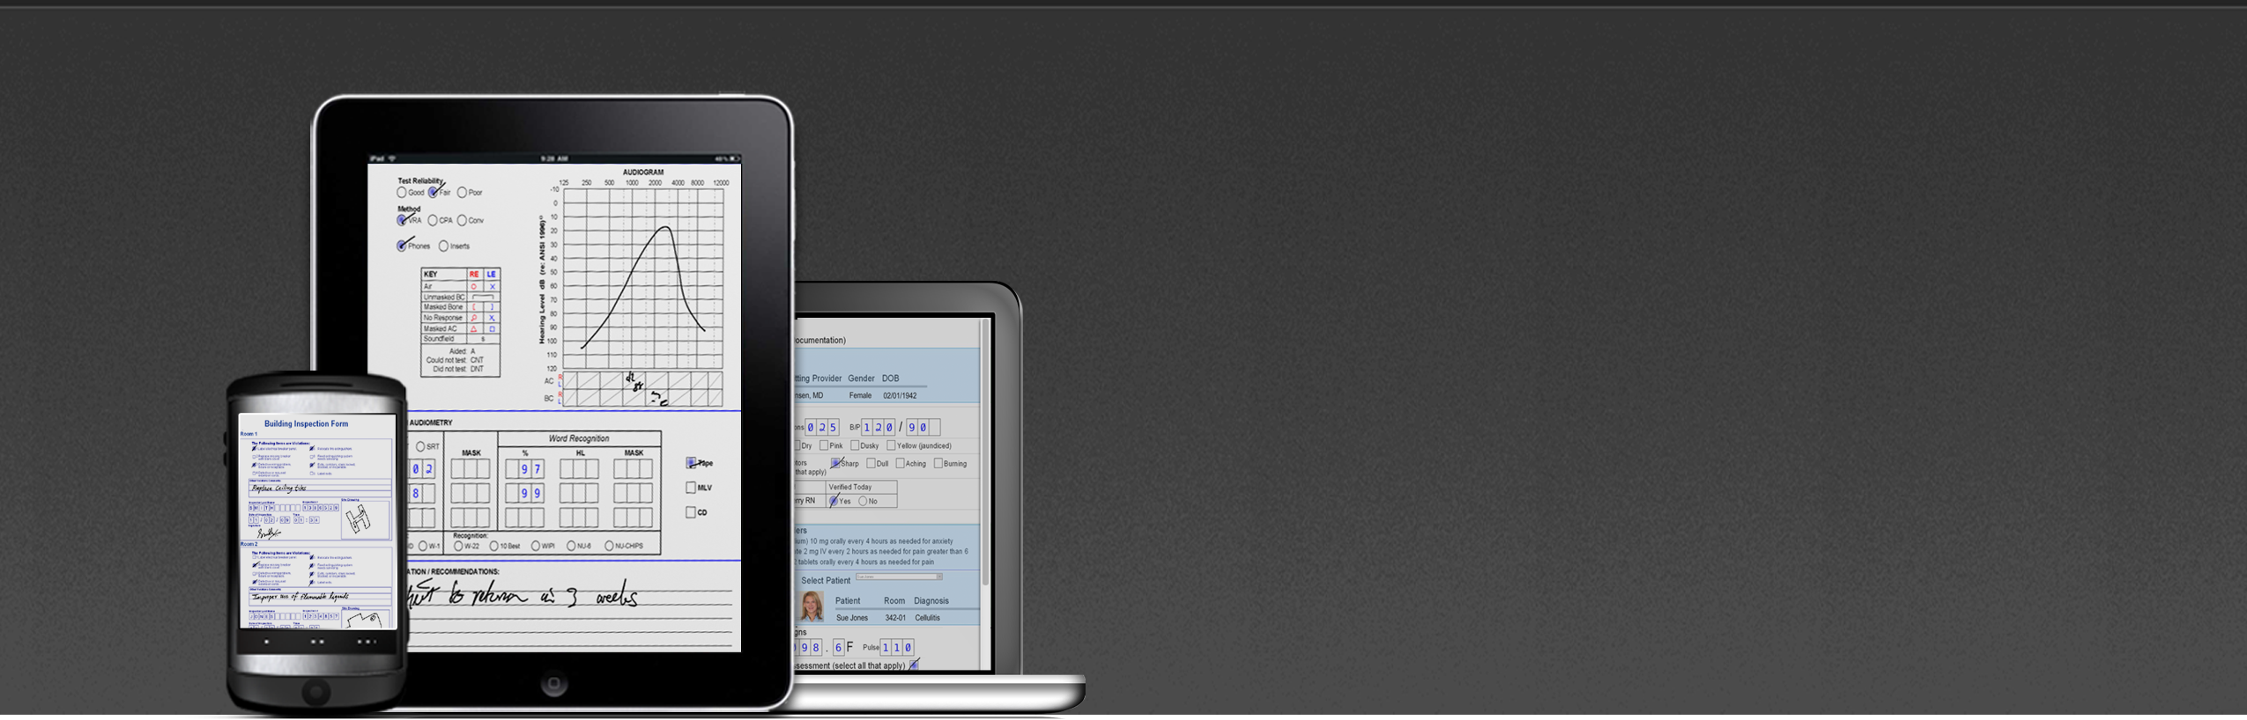

Mi-Forms Version 10 :
More usability, flexibility, platforms, and power.

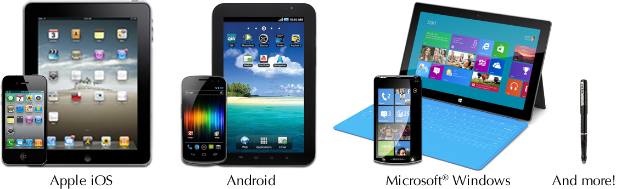
Mi-Forms Version 10 is a major evolution to the Mi-Forms platform; already one of the most flexible enterprise-class mobile data capture solutions available. V10 provides support for iPhone and Android phones while improving the functionality and user experience on iPad, Android and Windows tablets, and adds a variety of other features that leverage the power & flexibility of the Mi-Forms system—reaffirming Mi-Forms as the best solution for capturing any data, on any device and integrating that data anywhere!
Mi-Forms v10 features include:

Design
- Integrated syntax checking & highlighting JavaScript editor for iOS/Android scripting
- Improved form import from PDFs & other sources
Form Usability
- Paper-like forms on iPad/Android/Windows tablets
  - Pinch-zoom manipulation of forms on touch-devices
  - Finger swipes from page to page
  - Columnar forms on iPhone/Android phones
  - Collapsible form areas for more screen real estate
  - Region highlighting / hiding for guided form input
Capture
- Text fields, dates, checkboxes, images (camera and import), signature fields, grid fields
- Barcode scanning via camera or external scanner

Validate
- Instant form rules validation even while offline without coding or scripting
- Custom client-side rules in .NET & JavaScript
Communicate
- Web service access from forms
- Use the server to run .NET code from iOS/Android
Workflow
- Route forms for approval
- Active Directory support for iOS & Android devices
API
- JavaScript & .NET APIs allow for form customization at filling time

Mi-Forms V10 Product Features.
- = New in Version 10
Platform Support
Native Clients
- iPhone (v6.0+)
- Android Phone (v4.0+)
- iPad (iOS v6.0+)
- Android Tablet (v4.1+)
- Windows 8.1, 8, 7, XP
Web Browsers
- Internet Explorer 10+
- Chrome
- Safari
- Firefox
Server
- Windows Server 2012 / 2012 R2
- Windows Server 2008 R2
Industry-Leading Handwriting Recognition
- Combination of multiple handwriting recognition technologies for best recognition on the market: 98.5% accuracy for alpha characters, 99.5% for numeric characters
- Constrained print recognition with explicit control over legal character sets and lexica support
- Recognition of narrative handwriting with custom and standard lexica support
- Customizable handwriting recognition verification user interface
Voice Recognition
- Utilize operating system provided voice recognition services or integrate with 3rd party voice recognition services

Powerful Mi-Forms Designer
- Syntax highlighting & checking JavaScript editor for iOS/Android scripting
- WYSIWYG designer builds forms optimized for all devices
- Data palette based design allows creating forms from CDISC ODM, IBM Lotus Forms, ODBC, XML Schema & Intel Mobile Clinical Assistant
- Import forms via standard form conversion tool
- Point-and-click authoring of validation rules
- Built-in form test mode allows you to test form scripts and datapaths
- Spell checking
- Integration with Visual Studio
Rich Forms
- Paper-like formatted forms on iPad/Android/Windows tablets & web browsers
- Device appropriate form layout on iPhone/Android phones
- Improved touch support for Windows
- JavaScript API for iOS, Android & web forms
- Multiple pictures in a single image annotation field
- Highlight / hide portions of forms based on context (improved iOS/Android )
- Capture discrete data via checkboxes, picklists,
and multiple types of text fields
- Capture freeform ink for notes, signatures, and diagrams
- Audio annotations allow user to include audio recordings with other data
- Real-time display of validation rule status, with field navigation to assist the user in correcting validation rule violations
- Support for barcodes (camera & scanner) and RFID
- Support for GPS & geolocation
- Print forms at point-of-capture
- Full keyboard/mouse support
Flexible Data Exports
- XML
- CSV
- ODBC
- MSJet (Access)
- PDF, PNG, TIFF, JPG, BMP
- CDISC XML
- Microsoft Outlook
- Mi-Forms Session Files
- IBM Lotus Forms
Data Security
- Encrypted templates (improved )
- Encrypted sessions (improved )
- HTTPS communication
- Audit trails (date, time, user) for all captured data
- Session history
- Server audit trails (improved )
- Session security hashing
- Automatic background saving
.NET & JavaScript Scripting
- Use script language to perform complex data validation
- Comprehensive object model and rich event model allows control of all aspects of the user’s interaction with the form
- Designer includes syntax-highlighting editor and compiler (no Visual Studio license required)
- Debugging form script via VS.NET supported
- Scripting editor with auto-complete and real-time compilation of .NET code
- Scripting editor with syntax highlighting and checking for JavaScript code (no Visual Studio license required)

Powerful Component Architecture
- Mi-Forms Component can be licensed to bring the intuitive mobile form interface of Mi-Forms to your custom application
- .NET architecture for easy integration into applications
- Use the same object model in script code or external applications
- Automate form prefill / workflow through web services
Centralized Management
with Mi-Forms Server
- Paper-like & columnar formatted mobile web forms in browsers
- Integrate mobile web forms into your own
application
- Manage archived sessions via deletion interface
- Centralized authentication of users with standard security features
- Password strength enforcement
- Password expiration
- Account lockout
- Active Directory integration
- Centralized data export including custom exports
from script
- Queue-based workflow for users and groups
- Logic based on form contents
- Form locking
- Open web-services based communication over HTTP(S) for SDK built apps
- Administrative re-export of data
- Universally accessibly web-based interface
- Built on industry standard technologies
- Session archival and auditing
- History of every session
- Renderings of all pages in a form
- Customer activity reporting for transactional based solutions
- Session searching

