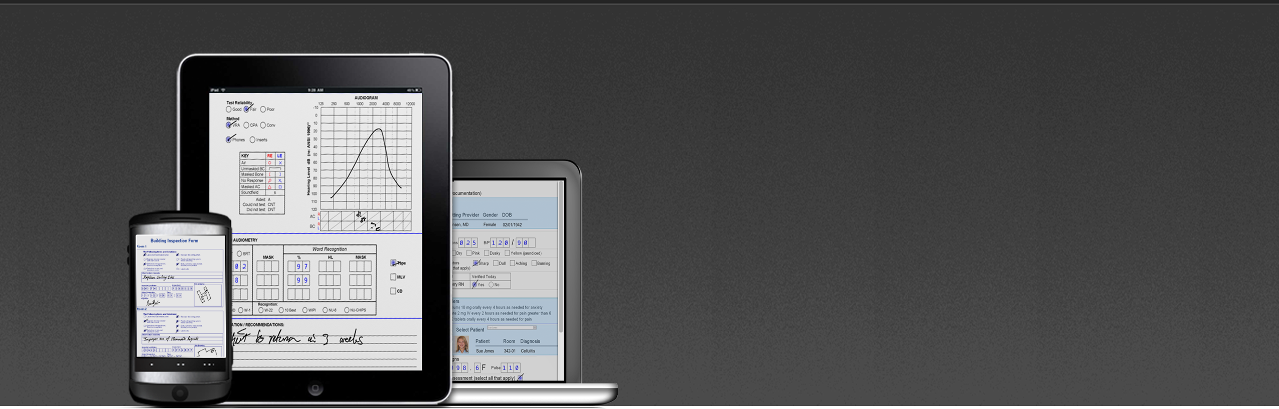

Mi-Forms: The most flexible
Enterprise-class mobile data
capture solution available.

Mi-Forms provides powerful & flexible mobile e-forms solutions that enable enterprises to eliminate their paper processes and streamline data collection. A Mi-Forms form is an electronic representation of a printed form, containing all of the normal handwritten fields found on paper forms, but also includes elements found only with electronic forms, such as picklists, barcodes, digital photos, audio files, GPS and user reference materials. Mi-Forms will streamline and eliminate extra steps and errors in your previous processes, making your systems more effective even when you are offline. And automating your data collection process makes information available in near real-time, giving you more speed in invoicing, trend analysis and summary reporting.
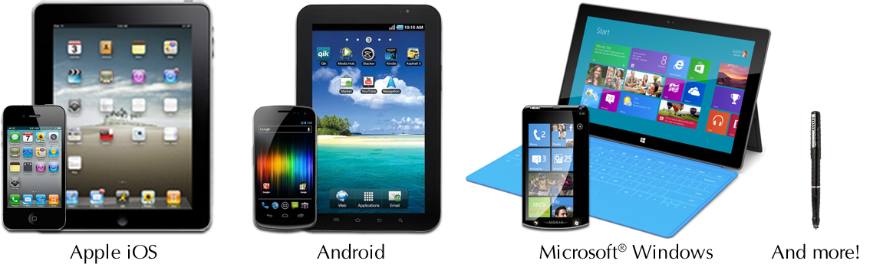
Mi-Forms features include:

- Business Rules: Business rules may be added to a form to enforce quality data collection. Such rules avoid missing data, flag potential errors or submission of bad data.
- Feedback: The form designer can specify real-time feedback during data collection. The feedback may occur when data is entered, calculations are performed or when business rules are violated.
- Datapaths: A Mi-Forms Datapath controls the export of data to an external database. Such exports can be simple file exports, like XML, CSV, or a variety of image file formats. In addition, a datapath can utilize ODBC to connect to a wide variety of DBMSes.
- Flexibility: Exports from the Mi-Forms platform can be integrated into almost any backend system and runs on a wide range of hardware including: Laptops, Desktops, iPads,
Android Slates, Tablet PCs, Anoto Digital Pens with paper, Virtual & On-premise Servers, Workstations and more!
- Enterprise Server: An enterprise-class administrative server for central management of users, forms & data flows, version control, audit trails and routing workflows.
The Mi-Forms System include:
- Mi-Forms Designer
- Mi-Forms Client
- Mi-Forms Server

Mi-Forms Designer: Easily create forms with deep functionality.

The Mi-Forms Designer is a versatile product that enables you to design custom forms for almost any process of your business. The intuitive graphical interface of the Mi-Forms Designer Software allows you to easily build forms that are just right for your enterprise and its customers and to deploy them on a variety of hardware platforms without extensive rework.
Mi-Forms Designer has three key components:
- WYSIWYG layout tool for form design
- Business rules and scripting language for data verification
- Extensive data path technology for communication to back end data bases and systems
Layout
Layout consists of a series of tasks that are accomplished through drop and drag technology and dialogs within Mi-Forms Designer Software. Much of this layout is performed using the toolbar, which allow for a wide variety of data types and data collection objects to be included in the form: alpha fields of various lengths; numeric fields; alphanumeric fields, check box groups; free form fields; as well as a variety of specialized fields such as social security number and a wealth of date and time fields The designer can include images to enhance the look of the form being created. It’s very easy to order, group, and align objects, giving the form a more professional look.
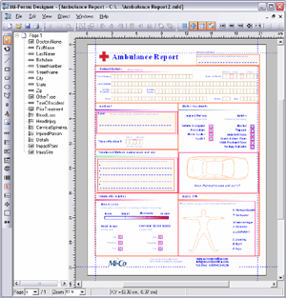
Business Rules
A form may require simple business rules such as required fields, cross-field validation rules (i.e., if gender is Male then question 5 must be greater than 8) or the most sophisticated business rules imaginable. With the Mi-Forms Designer, each of these types of rules can be built into the form during layout using the scripting language within the designer and the point and click authoring of validation rules.
Data Path Technology and Communication
The true power of Mi-Forms is its integration with existing enterprise applications. Data can be exported via ODBC, in XML files, or in comma-separated value (CSV) files. Images of forms and their ink can be exported in JPEG, GIF, TIFF, PNG, BMP, and PDF formats. Then for ultimate data flexibility, an external application can connect to the Mi-Forms Server’s back-end database via ODBC and pull exactly the data needed, including images of the ink for any given form element.
The Mi-Forms System allows for two-way communication between the form and any back end database that can be accessed through ODBC. With this technology, Mi-Forms allows for data fields to be dynamically filled from an enterprise’s existing database, for example an ERP, EMR, CRM, document management, content management or imaging system.

Mi-Forms Client: Intuitive and innovative data capture forms.

Whether implemented as a standalone application or as a client application with the Mi-Forms Server, the Mi-Forms Client provides everything that is needed to complete the other key steps in mobile data capture:
- Pre-fill
- Capture
- Verify and Validate
- Communicate
- Pre-fill: Pre-fill your forms with existing data.
Data from another source may be 'pulled' and used as pre-fill information into a form. This greatly reduces the amount of time spent capturing data, and also reduces possible errors incurred when users are withoutpre-filled data. Also, Mi-Forms enables captured data to be linked back to the original record source, if needed.
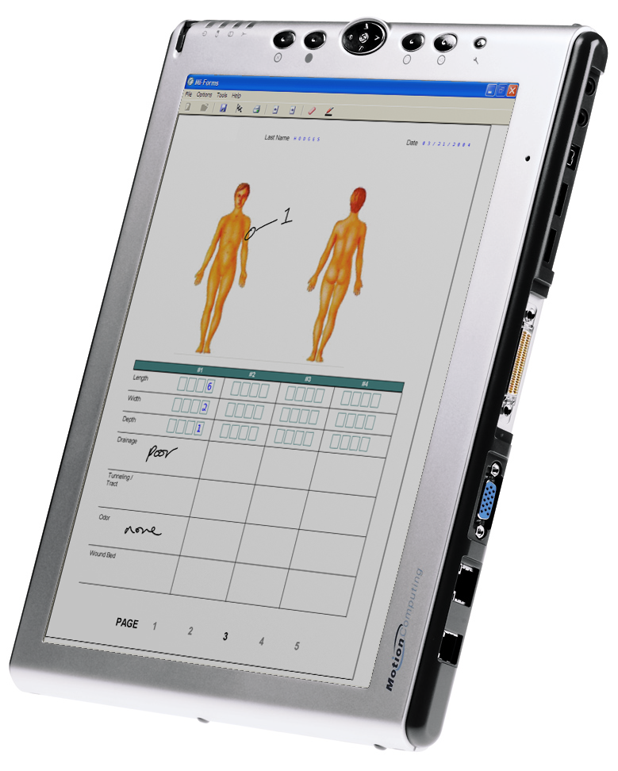
Capture: Capture new data using the Mi-Forms Client’s various tools for data capture. The Mi-Forms Client on a Tablet PC will convert handwriting into machine readable text as you write. Drawings, diagrams, and a number of other data sources may also be captured if needed (images, audio, barcodes, GPS, attachments of any files, etc).
The Mi-Forms Client also works perfectly well on Windows PC devices without handwriting capabilities. Users can simply use the keyboard and mouse to complete the forms instead of handwriting. Mi-Forms also supports Anoto-based digital pens from Logitech and Maxell. With digital pens, customers will fill in Anoto-based paper forms, dock the digital pen using your PC, and then allow Mi-Forms to capture and convert the ink into machine readable form.
Verify and Validate: The Mi-Forms Client allows customers to verify handwriting recognition results and validate data relationships (date / time evaluation, business rules, etc.) on their forms in real-time. On the Tablet PC, verification and validation checks are performed as the user is collecting data at the point of data collection, not later in the office while it is being manually processed. For digital pens, verification and validation checks can be performed on the PC when the pen is docked.
Communicate: Communicate and share your data with existing enterprise systems. Data may be sent directly from the Mi-Forms Client to a backend system, or from the Mi-Forms Client to the centralized Mi-Forms Server and then to other existing data repositories. Recognized data (text), ink, and form page background data may be exported via a variety of formats (CSV, XML, ODBC, MSJet, Outlook, variety of image formats, etc.) Data exports may also be customized for greater flexibility in exporting your data to your existing data system. In fact, the Mi-Forms Client offers a host of options to provide your enterprise with the flexibility to decide how your information is sent to a backend system for near real-time processing.

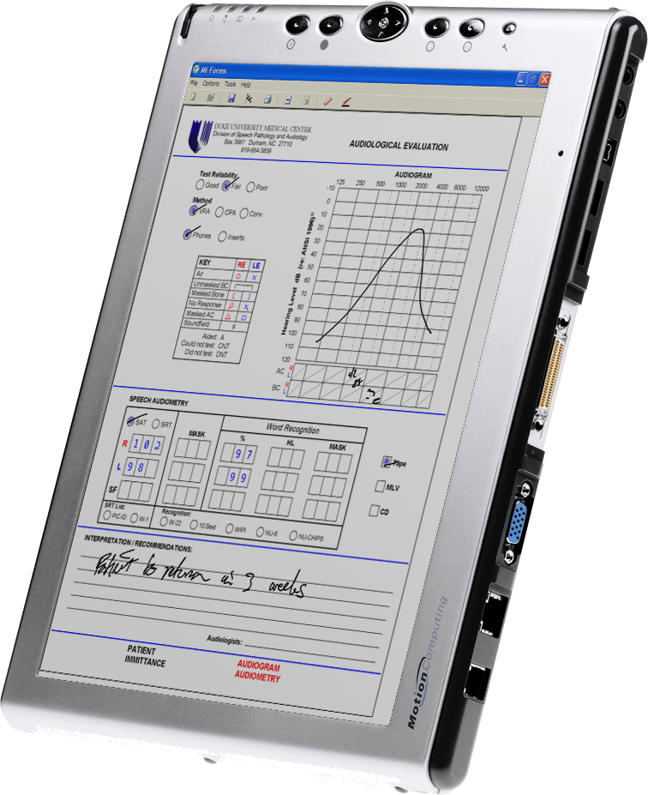

Mi-Forms Administrative Server: Accelerating business processes

The Mi-Forms Server is a powerful tool that allows your enterprise to control the flow of data, manage accounts and deliver new forms to your users. Some of the key functions of the Mi-Forms Server include:
Provision of HTML5 thin-clients & iPad/Android apps for touch-based form-filling or standard web-forms
- Management of users, passwords, groups and privileges
- Management of form and solution revisions
- Forms based workflow routing
- Centralized data export including custom data exports from script
- Server-side script code using same APIs and event model as client / component
Open web-services based communication over HTTP / HTTPS that can be integrated with Mi-Forms SDK built applications
- Active Directory Authentication
- Session/form search feature
- Clustering for performance and reliability
In addition, the administrator of the Server can control selected user functions such as access to the server to view, verify and edit data captured with the Mi-Forms Client Software. With the Mi-Forms Client connected to the Mi-Forms Administrative Server, your enterprise will have a complete end-to-end solution that streamlines slow, inefficient paper processes into a quick and efficient workflow.

Mi-Forms Standard Web-Forms Interface Mi-Forms Touch-based Mobile
