

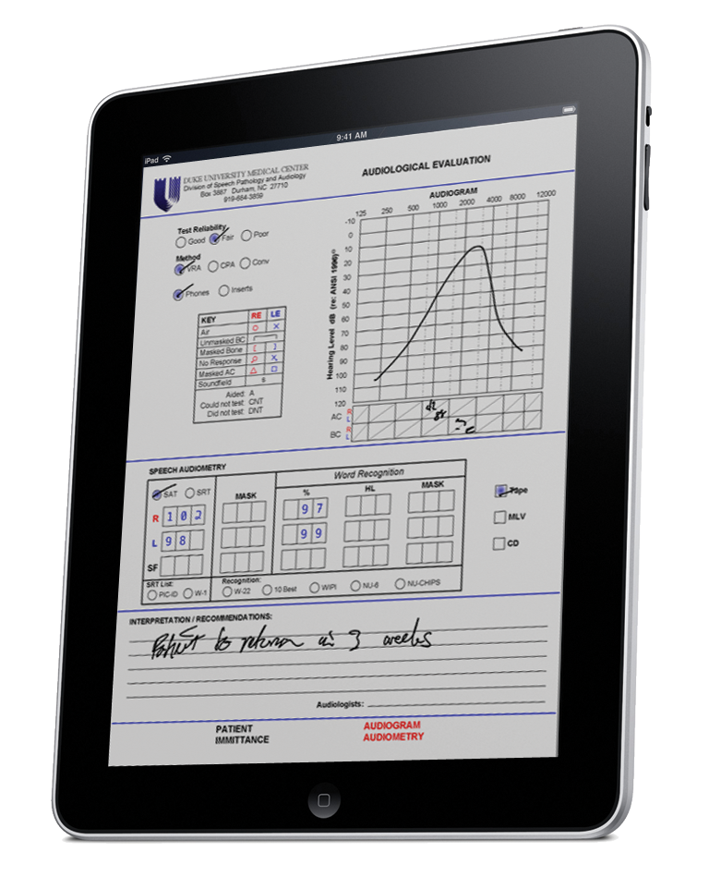
Mi-Forms for Oil & Gas Inspections

Mi-Forms provides flexible and powerful field inspection process automation capability. Mi-Forms mobile data collection solutions transform field and site inspection processes, providing strong efficiency and effectiveness benefits and improving availability of critical data for reporting and analysis. Mi-Forms technology can be used in applications such as well tending inspections, permitting, rig construction & maintenance inspections, quality assurance inspections and much more!

Mi-Forms features include:

Any Device: Mi-Forms works with the devices you want to use; iPads, Android tablets, and Microsoft Windows devices, PCs, Anoto Digital Pens with paper, Virtual & On-premise Servers, laptops, Workstations.
Online and offline: Unlike Web-only solutions, Mi-Forms works in remote field situations when a hot-spot is not available.
Workflow & Audit Trails: An enterprise-class administrative server for central management of users, forms & data flows, version control, audit trails and routing workflows.

"We looked at 2 other vendors but they were not close to what Mi-Co offered in terms of functionality.... the sales team was very knowledgeable and the product was simply the best available".
-Charles Schroeder,
IT Manager, Spectrasite

Mi-Forms for Oil & Gas Inspections

Touch Friendly: Mobile friendly checkboxes, drop down lists, toggles, switches and text field customization (dates, masks, validation) to make collection easy and reduce mistakes.
Speech Recognition & Capture: Hands-free e-Forms, speak naturally and SayItTM voice recognition & capture will fill in the fields for you.
Handwriting Interpretation: Write with a digital pen or your fingertip, and Mi-Forms will interpret your handwriting. An easy way to collect signatures and field notes.
Photo Capture and Inking: Add photos with mark-up and notes. Mi-Forms can even prompt the user for photo capture with workflow rules.
Barcode Scanning, GPS Tracking and RFID: Rich data capture comes standard and is easy to add to any template.
Your Business Rules: Business rules may be added to a form to enforce quality data collection. Such rules avoid missing data, flag potential errors or submission of bad data vastly boosting accuracy
Intelligent Feedback: The form designer can specify real-time feedback during data collection. The feedback may occur when data is entered, calculations are performed or when business rules are violated.
Flexible integrations: Send data directly to your line of business applications, databases, accounting accrual systems, document management systems and more — using web-services, flat-file exchange, APIs, SDKs and many other methods.

"Mi-Co has been supporting Tablet PC since its inception, their product integration and overall support of the platform proves that we have a vibrant ecosystem for partners to succeed. Mi-Co has recently met the requirements to become a Premier Tablet PC ISV Partner and we are thrilled to have them as one of our leaders in this space.”
- Frank Gocinksi, ISV Business Development and Evangelism Manager Microsoft Mobile Platforms Division.

