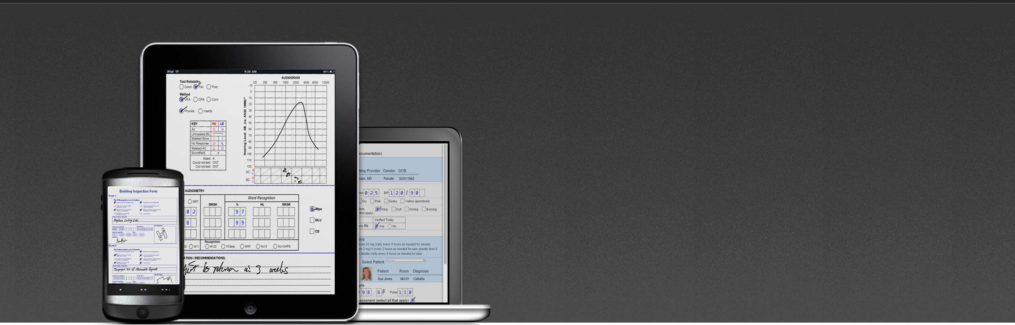

**Mi-Forms: The most flexible**

**Enterprise-class mobile data  
capture solution available.**

[](https://itunes.apple.com/us/app/id526845092?mt=8) [](https://play.google.com/store/apps/details?id=com.mico.miforms)

**Download our App on your Mobile Device.**

“Powerful & flexible mobile forms solutions for evolving enterprises.”

*Mi-Forms*

Increase workflow efficiency and **boost workforce productivity** through automating manuals processes and simplifying steps in the data collection process.

Streamline data collection and analysis by eliminating paper processes and gain a competitive edge.

Optimize and integrate through a digital form that can retain the look and accessibility of your old paper forms all while integrating modern digital elements and increase data accuracy

Customize it to your needs with our flexible, powerful Form Designer with customizable business rules, logic and our dual-language scripting interface.

Mi-Forms Solutions have produced results for customers such as:

Receive Intelligent Feedback with our Real-Time Reporting and Form Designer which can specify real-time feedback during data collection

Go offline with Mi-Forms and our robust offline data capture abilities, making it operable offline even in remote field areas and situations when a Wi-Fi hotspot is unavailable. Also includes SQLite replication to mobile devices

Mobile Field Inspection on Any Device – Smartphones, tablets and any devices such as: iPads, Android tablets, Microsoft Windows devices, PCs, Anoto Digital Pens with paper, Virtual/On-premise Servers, laptops, Workstations, etc. are compatible with Mi-Forms.







**Mi-Forms features:**

**Flexibility**

Any Device: Mi-Forms makes your Forms apps available with the devices you want to use; iPads, Android tablets, and Microsoft Windows devices, PCs, Anoto Digital Pens with paper, Virtual & On-premise Servers, laptops, Workstations.

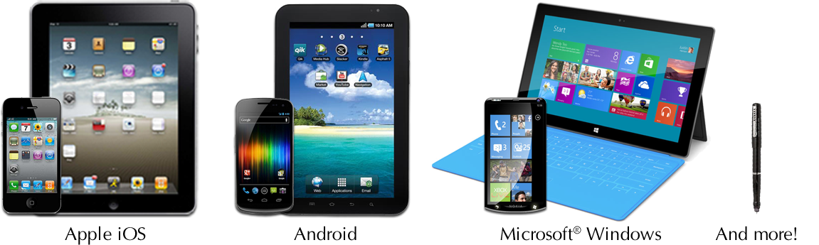

Export Flexibility: Exports from the Mi-Forms platform can be integrated into almost any backend system.

Online and Offline Capability: Unlike Web-only solutions, Mi-Forms works in remote field situations when a hot-spot is not available. Also features SQLite replication to mobile devices too!

Flexible Integrations: Send data directly to your line of business applications, databases, document management systems, GIS and more — using web-services, flat-file exchange, APIs, SDKs and many other methods. ESRI and Google Earth.

**Any Data:** Mi-Forms enables the capture of photos, barcodes, GPS coordinates, voice, and much more & interfaces with external handheld devices.

“With Mi-Forms, quickly and easily create enterprise-class mobile forms apps that can be used on any device, anywhere. Mi-Forms is the secure method for mobile inspections and data capture, and reports automatically to your company's existing database. Mi-Forms also comes packed with robust features such as our full offline and online data capture capabilities.”

Business Rules: Business rules can be added to enforce quality data collection and help to avoid missing data, flag potential errors or submission of bad data and help boost data collection accuracy with a simple, no-code rules editor

Intelligent Feedback: The form designer can specify real-time feedback during data collection. Feedback can occur as data is entered, during calculation of data, or when business rules are violated.

Datapaths: A Mi-Forms Datapath controls the export of data to an external database. A wide variety of export formats are supported such as: XML, CSV, and image file formats. Additionally, a Datapath can utilize ODBC to connect to a wide variety of Databases

OEM White-Label Rebranding Option: Mi-Co also offers the opportunity for Partners to rebrand our mobile-forms software platform which is backed by 15 years of technology and investment. With this option you can rebrand with your own logos, images and branding and resell in the marketplace.

**Manage**

“Streamline Business Processes with Mi-Forms: The Most Mature Solution based on 10 issued US Patents”

Enterprise Server: An enterprise-class administrative server for central management of users, forms & data flows, version control, audit trails and routing workflows.

Workflow & Audit Trails: An enterprise-class administrative server for central management of users, forms & data flows, version control, audit trails and routing workflows.

Integrate

**Mobile GIS Field Service:** Mi-Forms integrates with Mobile GIS Field Service Inspection tools to transform field and site inspection processes by improving availability of critical data for reporting and GIS analysis.

**User-Friendly**

Touch Friendly: Mobile friendly checkboxes, drop down lists, toggles, switches and text field customization (dates, masks, validation) to make collection easy and reduce mistakes.

Speech Recognition & Capture: Hands-free e-Forms, speak naturally and SayItTM voice recognition & capture will fill in the fields for you.

Handwriting Interpretation: Write with a digital pen or your fingertip, and Mi-Forms will interpret your handwriting. An easy way to collect signatures and GIS field notes.

**Photo Capture and Inking:** Add photos with mark-up and notes. Mi-Forms can even prompt the user for photo capture with workflow rules.

Barcode Scanning, GPS Tracking and RFID: Rich data capture comes standard and is easy to add to any template.

*The Mi-Forms System includes:*

Mi-Forms Designer

Mi-Forms Client

Mi-Forms Server

Mi-Forms SDK

Mi-Forms Designer has three key components:

Mi-Forms Designer: Easily create forms with deep functionality.

The Mi-Forms Designer provides versatility and accessibility that enables you to easily design and create custom forms for any process and business. The intuitive graphical interface of the Mi-Forms Designer Software enables you to build forms customized to your business enterprise and its customers as well as maintain usage and functionality. They can also be deployed over a wide variety of hardware platforms.

* 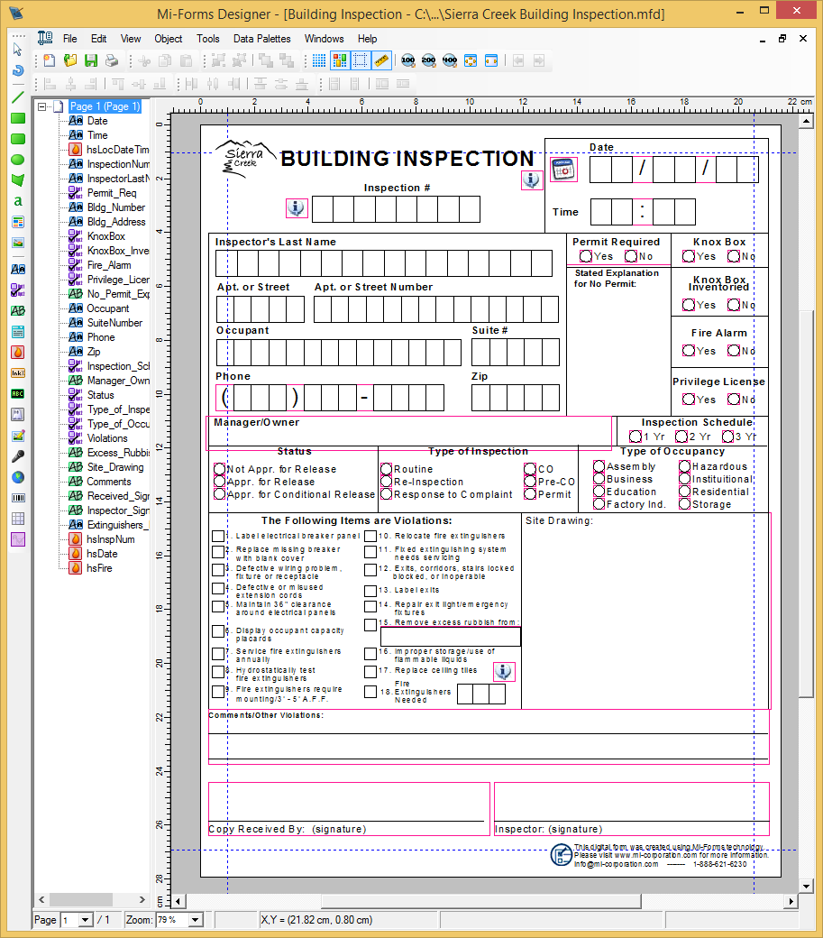WYSIWYG layout tool for form design
* Business rules and scripting language for data verification
* Extensive data path technology for communication to back end data bases and systems

**Layout**  
Through drag-and-drop technology, Layout in the Mi-Forms Designer Software makes it easy to order, group, align, and design your form. The layout toolbar includes a variety of data types and data collection objects to be included in the form: alpha fields of various lengths; numeric fields; alphanumeric fields, check box groups; free form fields; as well as a variety of specialized fields such as social security, date, time, etc. The designer also allows for images to be added enhance the look and customization of the form being created – giving it a professional, polished look.

Companion Product:  FormBridge for Mi-Forms

This feature creates a digitized layout from existing forms.  FormBridge automatically generates a Mi-Forms electronic layout from your paper layout based forms.  It converts from PDF, Word®, Excel®, QuarkXpress®, InDesign®, FormFlow®, paper sources and more to create fillable Mi-Forms to save time and reduce errors for quick and easy data and document conversion.

**Business Rules**  
From simple business rules such as required fields, cross-validation and value-range, etc., to the most complex business rules imaginable, the Mi-Forms Designer is equipped to handle them all. The Mi-Forms Designer allows for business rule creation through simple point-and-click authoring of validation rules to more customized rules that can be built into the form during the layout process via scripting language available in the designer.

**Data Path Technology and Communication**  
The true power of Mi-Forms lies in its ability to integrate with existing enterprise applications. Data can be exported via ODBC, in XML files, and CSV files. Form and ink images can also be exported as JPEG, GIF, TIFF, PNG, BMP, and PDF. For ultimate data flexibility, an external application can connect to the Mi-Forms Server’s back-end database via ODBC and then the needed data or form ink images for any given element.

[](https://youtu.be/VNrDUzIsYzc)The two-way communications system of Mi-Forms allows for ease of access between the form and any back end database that can be accessed through ODBC. With this technology, data fields in Mi-Forms can be filled dynamically from an enterprise’s existing database, such as an ERP, EMR, CMR, document management or imaging system.

Click the link to watch a short video on FormBridge!

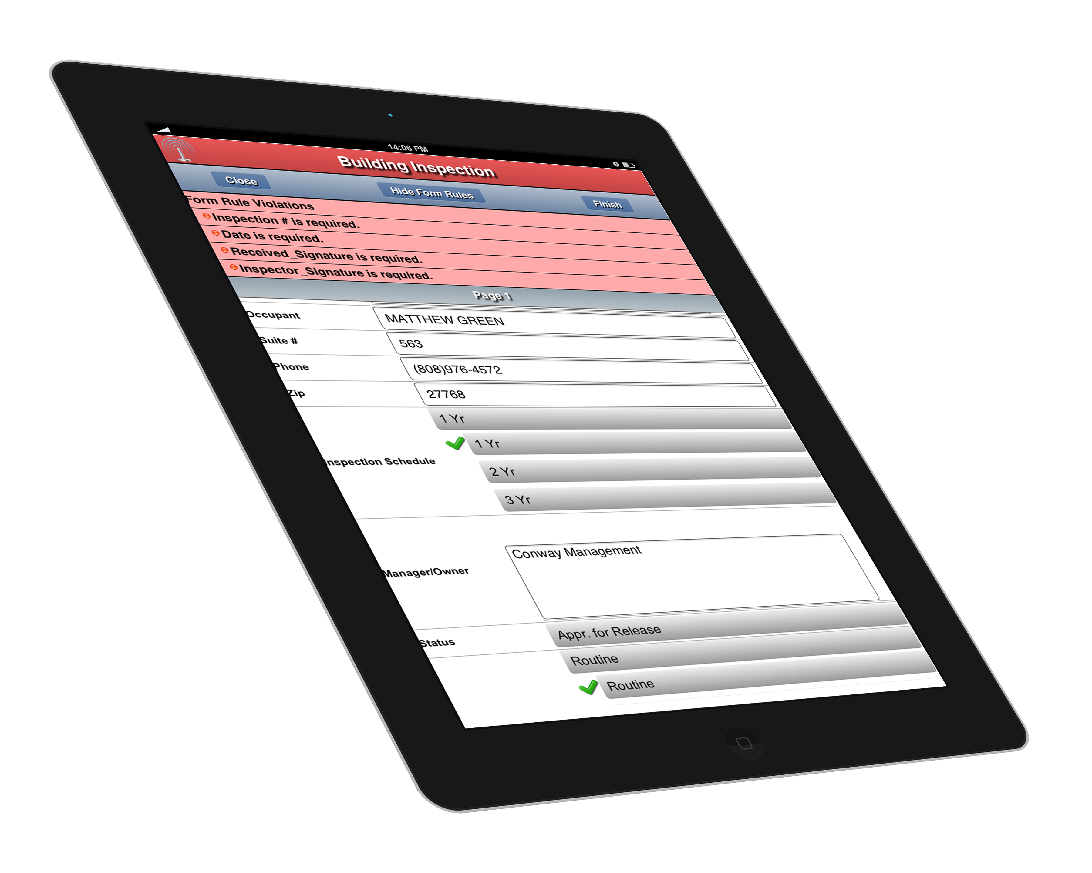**Pre-fill:** Pull data from another source and automatically pre-fill previous information into a form. This greatly reduces the amount of time spent capturing data, as well as limiting potential errors that may occur in lieu of pre-filled data. Mi-Forms also enables captured data to be linked back to the original record source, if needed.

Whether implemented as a standalone application or as a client application with the Mi-Forms Server, the Mi-Forms Client provides everything that is needed to complete key steps in mobile data capture:

|  |  |  |  |
| --- | --- | --- | --- |
| *Pre-fill* | *Capture* | *Verify and Validate* | *Communicate* |

Mi-Forms Client: Intuitive and innovative data capture forms.

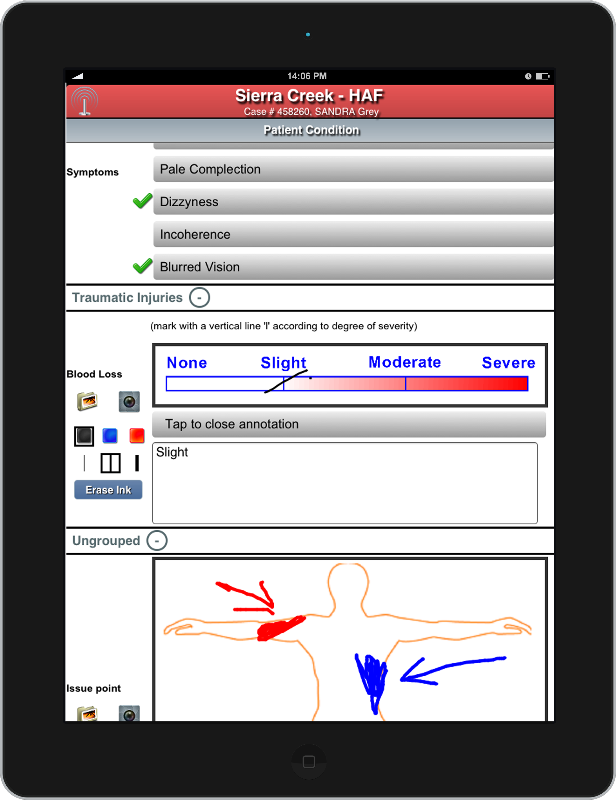**Capture:** Capture new data using the Mi-Forms Client’s various tools for data capture. The Mi-Forms Client on a windows PC converts handwriting into machine readable text as it is written. Drawings, diagrams, and a number of other data sources can also be captured (images, audio, barcodes, GPS, attachments of any files, etc.)

The Mi-Forms Client also works on Windows PC and mobile devices without handwriting function. Users can simply use the keyboard and mouse to complete the forms instead of handwriting. Mi-Forms also supports Anoto-based digital pens from Logitech and Maxell. With digital pens, customers will fill in Anoto-based paper forms, dock the digital pen using your PC, and then allow Mi-Forms to capture and convert the ink into machine readable form.

**Verify and Validate:** The Mi-Forms Client allows customers to verify handwriting recognition results and validate data relationships (date/time evaluation, business rules, etc.) on their forms in real-time. Verification and validation checks can be performed and reviewed as the user is collecting data at the point of data collection in real-time on your mobile device(s). For digital pens, verification and validation checks can be performed on the PC while the pen is docked.

**Communicate:** Communication and data sharing with your existing enterprise systems is also possible. Data can be sent directly from the Mi-Forms Client to a backend system, or from the Mi-Forms Client to the centralized Mi-Forms Server and then sent to other existing data repositories. Recognized data (text), ink, and form page background data may be exported via a variety of formats (CSV, XML, ODBC, MSJet, Outlook, variety of image formats, etc.) Data exports can also be customized for greater flexibility in exporting collected data to your existing data system. The Mi-Forms Client offers an array of options in providing your enterprise with the flexibility to decide where and how your information is sent to a backend system for near real-time processing.

**Provision of HTML5 thin-clients for touch-based form-filling or standard public-facing and authenticated web-forms**

The Mi-Forms Server is a powerful tool that allows your enterprise to control the flow of data, manage accounts and deliver new forms to your users. Some of the key functions of the Mi-Forms Server include:

**Mi-Forms Administrative Server: Accelerating business processes**

Management of users, passwords, groups and privileges

Management of form and solution revisions

Forms based workflow routing

Centralized data export including custom data exports from script

Server-side script code using same APIs and event model as client / component

Detailed audit trails on all events in a form’s life cycle

**Open web-services based communication over HTTP / HTTPS that can be integrated with Mi-Forms SDK built applications**

Active Directory Authentication

Session/form search feature

Clustering for performance, scalability and reliability

In addition, the administrator of the Server can control selected user functions such as: access to the server to view, verify and edit data captured with the Mi-Forms Client Software.

Mi-Forms Standard Web-Forms Interface Mi-Forms Touch-based Mobile Interface

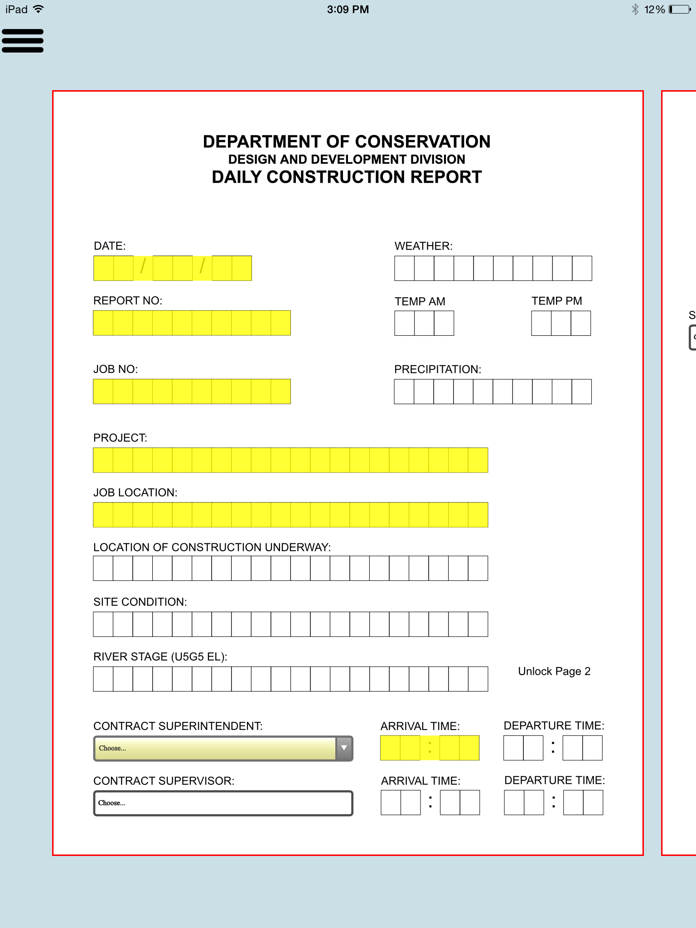

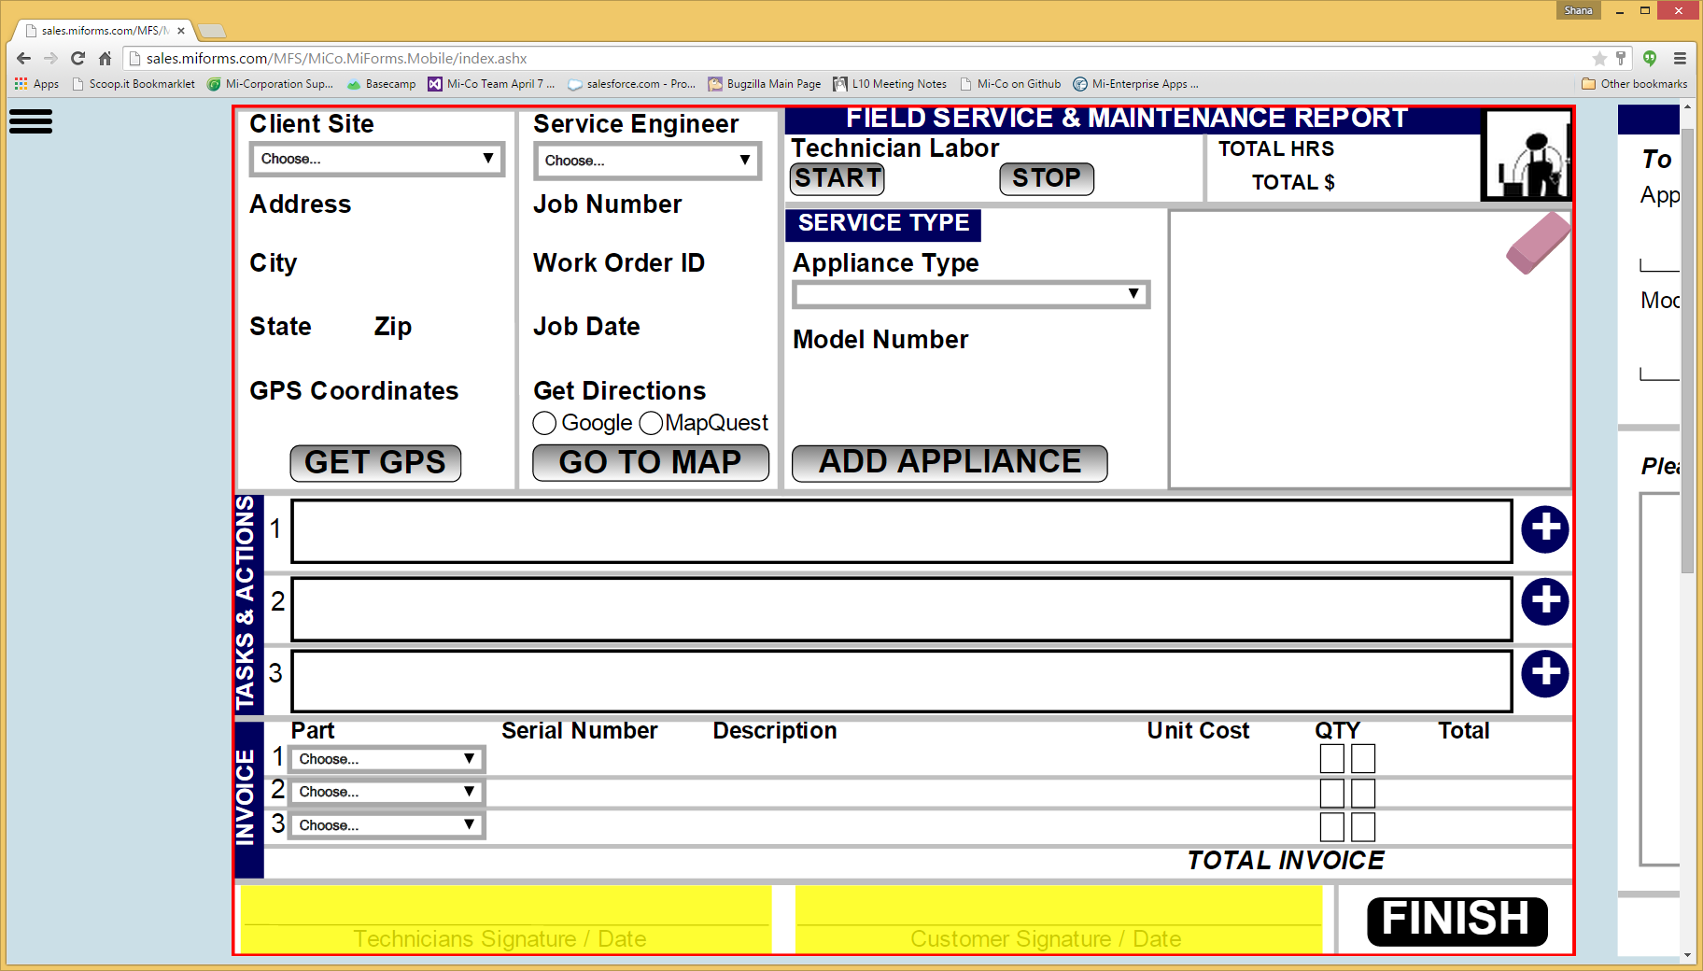

****Mi-Forms SDK: Integrate Mi-Forms' Mobile Data Capture Features Into Your Software and Applications****

Mi-Forms SDK is a **powerful development toolkit** that can integrate Mi-Forms' handwriting recognition and mobile data capture into your software and applications.

With Mi-Forms Client connected to the Mi-Forms Administrative Server, your enterprise can achieve a complete end-to-end solution that streamlines slow, inefficient paper processes and optimizes for a quick and efficient workflow process.

The system core is the Mi-Forms component. A rich forms-processing engine that can interpret any form built with the Mi-Forms Designer. This powerful component can provide user interfaces, manage data collection, process data in Mi-Forms format, as well as output data to other systems.

***What is Mi-Forms SDK?***

*Mi-Forms SDK is a .NET based SDK that bundles together Mi-Forms industry-leading handwriting recognition, natural user interface, and unified support for Digital Pens, Windows Tablets and Windows Servers. Mi-Forms SDK features a rich object model and an easy-to-use form designer. Solutions built using Mi-Forms SDK can be deployed either in rich client or smart client configurations*

**The Mi-Forms component can be used in the following ways:**

* Within a custom application
* In a Web-based application
* As a part of the Mi-Forms client
* Within a server solution to process Mi-Forms formatted data

****The benefits of SDK****

**Comprehensive**  
The Mi-Forms Software Development Kit provides enterprise class development environments that allow developers to lay out data capture forms with state-of-the-art form environments, easily integrate rich verification environments as well as create custom business rules in your application, and use Mi-Forms data path technology to automatically send and receive information to your product line’s databases and processes.

**Efficient**The forms based solutions developed in the Mi-Forms SDK can be used in multiple environments and across multiple platforms.

**Extensive**The development of any specialized requirement of your application can be easily incorporated due to integration with the Microsoft .Net framework.

**Support**The Mi-Forms SDK has been developed by technical staff that has over 40 years of experience in digital writing, mobile data capture, and handwriting recognition conversion. This expertise has been built into the SDK and this staff will support you every step of the way.