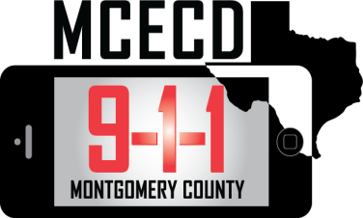

When Calling 9-1-1 for Help, Know the Phone You Own.

By: Andrea Wilson

9-1-1 may be the most important phone number you ever dial. In 2012, Montgomery County 9-1-1 received over 200,000 emergency calls. When reporting an emergency, it’s important to know how the type of phone you use can affect your call to 9-1-1. Many people have made the decision to eliminate their home phone in lieu of a cell phone or internet telephone service. Using a traditional landline to report an emergency provides the call center with the exact location, phone number and address. However, calls placed using cell phones and Internet telephone service or Voice over Internet Protocol (VoIP) appear to work like a traditional landline but pose challenges when answered by a 9-1-1 calltaker. Most calls placed by cellphones provide an approximate but not exact location and some may not arrive at the correct call center, resulting in the possibility of transferring the call. When using a cellphone be prepared to tell the calltaker information regarding your location. Callers using phones that access the internet should know the emergency calling features of their service provider. Remember to register your address with your provider and update your information if you move. If you’re using a VoIP adapter in order to use your phone while traveling, it is important to contact your service provider and report your destination. Updating your address or location with your service provider ensures that help is dispatched to the correct address. For all phones, calling 9-1-1 is for emergencies or potential emergencies only and should be used to report a threat to life or property. For all other calls, contact local police, sheriff or fire department by using the non-emergency number. Although text messaging is a common form of communication, Montgomery County 9-1-1 is not equipped to receive text messages. Voice calls to report emergencies is strongly encouraged.

