The Definitive Guide to Selling Better and Faster
It would be nice if you could make a single sale and have the revenue sustain your company forever. But in order to grow your organization, a steady stream of income is required.
When a company first starts out, there probably isn’t much of a sales process -- or team -- in place. The one or two sales hires target prospects, introduce them to your company, and close deals according to their own preferred methods.
However, as your business grows, sales leaders will need to implement a repeatable, scalable process to turn a trickle of income to a steady, predictable stream. With all salespeople using the same systems and playbooks and adhering to the same process, the sales organization becomes a well-oiled machine instead of a Frankenstein-esque contraption stuck together with duct tape.
What’s the secret to accelerating sales growth? While people and process usually precede systems, sales is somewhat of an exception. The right customer relationship management system (CRM) can actually help empower people and define process.
In this guide, learn how a CRM system can accelerate your business’ growth, bring in profitable, happy customers, and enable your sales team to sell better and faster.
Sell Better
Sales today is a far cry from what it was just 20 years ago. The advent of search and social media means sales is now more about research and careful customization than knocking on doors and “spray and pray.”

But different doesn’t always mean better. Even though changing times necessitate new approaches, some salespeople merely transfer their old methods to modern channels.
It’s not totally their fault. Change is hard, and sometimes, scary. But not to fear -- in this bold, new world of sales, the right CRM system can not only enable salespeople to update their practices, but also give them a competitive edge.
Contextualize Sales Outreach
When a sales rep receives an inbound lead or decides to target a specific company or decision maker, they don’t have to go into the initial outreach blind. Today, there’s a plethora of buyer information at sales reps’ fingertips. Before picking up the phone or writing a cold email, reps can research their buyers on:
- Search engines
- LinkedIn
- Facebook
- Twitter
- Blogs
- Company website
- Industry-specific sites
Just one problem. None of these virtual spaces gives the rep context on what the contact already knows about their company, or provides evidence of an existing relationship.
CRM to the rescue. A CRM that integrates with your marketing automation system gives sales reps a comprehensive picture of the prospect’s recent interactions with your company. And the value of this knowledge is hard to overestimate.
Let’s say a prospect downloaded an ebook on a specific industry trend yesterday. Armed with this insight, the sales rep can then customize their cold email to mention this trend, and offer their expertise. Since the topic is evidently top-of-mind for the prospect, the sales rep stands a much better chance of grabbing their attention with this email and receiving a response.
On the other hand, the sales rep would take a much different approach if the same contact checked out the product’s pricing page in the last hour. A demo or free trial is a much more appropriate and interesting offer in this case.
A tight bond between marketing automation and CRM enables sales reps to layer context onto their outreach. And this, in turn, helps their emails and calls to stand out amidst a sea of bland, generic pitches.
Make Sure Nothing Falls Through the Cracks
It’s rare to get a prospect’s attention on the very first outreach attempt. More often than not, a sales rep will need to reach out again, and again … and again.
Persistence is a virtue in sales. Most sales experts espouse making between six and 10 attempts before giving up on a prospect. Abandoning prospects too soon could leave money on the table.
But how can a sales rep keep all their assorted prospects and outreach attempts straight? Depending the number of leads a salesperson is working at any given time, trying to remember to call Company X on Tuesday, Organization Y on Friday, Business Z on Monday, and sending check-up emails on Thursday, Wednesday, and Saturday is all but impossible.
Wouldn’t it be nice if the CRM took this memory game off sales reps’ plates? With the right system, this isn’t just a pleasant dream -- it’s a reality.
Many modern CRMs include task modules that automatically alert sales reps of who to follow up with and when. Salespeople can simply set a reminder, and forget it.
When the time rolls around to reach out again, reps also benefit from having all prior contact attempts at their fingertips (HubSpot CRM automatically saves and logs voicemails and emails), as well as any buyer interactions that have taken place in the interim. With the right context at hand, salespeople can tailor their follow-ups based on what the buyer’s done and what’s already been said.
As outreach becomes more and more personalized, reps become more likely to receive a response, not less.
Prevent Disastrous Sales Derailments
It might seem like a good thing to close each and every single deal you’re working on during the last week of the month. You won’t just make quota -- you’ll absolutely crush it.
But this victory will likely be short-lived. With a totally empty pipeline, how will you hit your number the following month? Depending on the length of your sales cycle, you might not be able to close any deals. A devastating bust follows on the heels of your boom.
If you’re managing your deals with spreadsheets, it can be hard to grasp how close each is to closing and spot gaps in the funnel before it’s too late.
A CRM system can help salespeople avoid boom and bust cycles by visualizing their deal flow. Instead trying to infer meaningful knowledge from a sea of identical rows and columns, reps can immediately recognize stages in which they have too many opportunities -- or too few. With this knowledge, reps have an easier time balancing and prioritizing prospecting with working active leads.
Cement the Sales Process
The sales process first lives in a founder's or VP of sales' mind, and then on a piece of paper. But scaling the sales strategy through word of mouth and scattered documents isn't exactly effective. "To be the most useful, all that information has to be built into a system that [documents] the stages, the activities, and when you're supposed to do them," according to Brent Leary, partner at CRM Essentials.
Defining the sales stages in a CRM not only helps to firm up the process for your current team, but also has implications for future hires. "This makes it easy for people who have no idea what the sales process is when they get hired to hit a running start," Leary added.
The screenshot below shows how sales stages are visually defined in the HubSpot CRM, and how deals are moved between them.
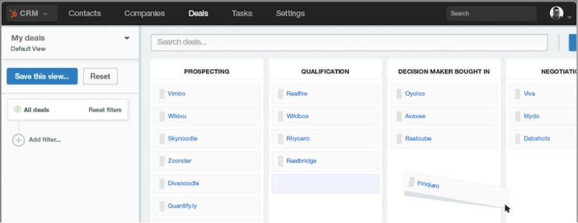
Sell Faster
As the last section demonstrated, CRM systems don’t just allows sales leaders and managers to keep tabs on their reps. The right CRM can also empower reps to sell more, better.
But what if I told you CRMs can also help reps sell faster? I wouldn’t blame you if you chuckled a bit. After all, “CRM” practically translates to “thing that slows me down” for most sales reps.
However, modern CRMs can actually quicken the sales process instead of bogging it down. Don’t believe me? Read on to learn how CRM can shave time off salespeople’s day-to-day, and facilitate a faster deal flow.
Eradicate Time-Consuming Data Entry
According to HubSpot’s State of Inbound Sales report, manual data entry is sales reps’ #1 problem with their CRM. Not exactly a surprising revelation.
A bit more eyebrow-raising is just how much non-sales activities eat into salespeople’s day. Docurated’s State of Sales Productivity study found that more than 50% of reps’ time is wasted searching for content, and working on CRM-related and administrative tasks. Yikes.
It goes without saying that this frustrates sellers, who would rather be connecting with prospects than doing administrative work. Therefore, it’s critical to streamline reps’ non-sales tasks as much as possible to maximize active selling time.
We’ve already established that the right CRM system provides both sales managers and reps with actionable insights, and benefits the entire sales organization. However, CRM is only as good as the data entered into it. And if data entry is 100% manual? Good luck getting accurate information.
In this instance, CRM is the problem, but it can also be the solution. Some CRMs today lessen the data entry burden on reps by automatically populating contact information from the web and marketing automation systems.
By using email productivity app Sidekick in conjunction with HubSpot CRM (both free), sales reps can live the dream of one-click prospecting. Simply by pushing the “add to HubSpot CRM” button, sales reps can auto-populate a new contact record directly from a company website. It just doesn’t get any easier than that.
Find Good Fit Prospects Fast
Most sales organizations get their leads from a combination of inbound and outbound efforts. The specific mix will vary depending on the team, but it’s rare to find a 100% outbound or 100% inbound organization.
Generating inbound leads is generally the responsibility of the Marketing team, but outbound efforts require a bit more elbow grease on behalf of Sales. Reps often use a combination of social media sites and search to find prospects that seemingly fit their company’s ideal customer persona.
This process works … but not as well as it could. Traditional prospecting takes time. Reps often have to hunt for each opportunity individually, and then do a fair amount of guesswork to classify a given company as a “good fit.”
However, prospecting features in certain CRM systems turn prospecting into less of a hunting expedition and more of a one-stop shop. For example, HubSpot CRM collects sales relevant information from across the web on a variety of companies, and then compiles data into a searchable database. Reps can then conduct custom searches based on specific criteria, and the system returns a comprehensive list of prospects that fit the requirements.
Prospecting = done.
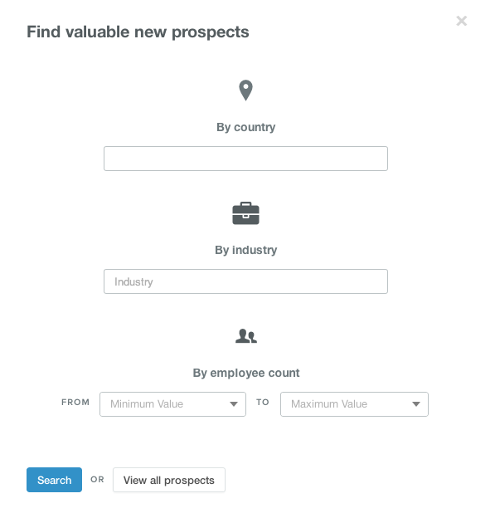
Prevent Reinventing the Wheel
Content isn’t just king in marketing -- its royal status extends to sales as well. Sending buyers relevant content throughout the sales process fosters trust between buyer and seller and positions the rep as a trusted advisor who is knowledgeable about the prospect’s business issues.
Keeping in mind the amount of time reps waste looking for content, CRMs that double as content repositories can help salespeople get the right content at the exact right moment. Need the latest demo deck? A newly-released case study? The most recent pricing sheet? No need to go searching elsewhere -- just grab it from the CRM and go.
And content isn’t just external-facing. What about the emails reps send day in and day out? While each and every single email should be customized to the specific recipient, smart reps save templates of their most successful messages for reuse down the line. Too bad this doesn’t save much time when they have to dig through their outbox every time they’d like to repurpose a template.
Not to fear -- CRM can help here as well. By allowing reps to save email templates directly in the system, reps can access their time-saving messages without even having to open a new tab.
Answer Questions in Record Time
Getting a straight answer to a prospect’s question when there's no single source of truth can be frustrating. Often, it's only after being bounced around colleagues and departments that a sales rep gets a response ... and then it might conflict with another version they heard along the way.
Implementing a CRM that everyone acknowledges is "the" source makes these situations a lot less likely. "CRM puts all the information about your customers and your product in one place, so you never have to say 'let me get back to you with that,'" said Marshall Lager, managing principal at Third Idea Consulting LLC.
CTA
Are you ready to sell better and faster with the help of a modern CRM system? HubSpot CRM contains all of the features referenced in this guide. The best part? It’s 100% free. Yes, you read that right. Free. $0.
Give the HubSpot CRM a spin today.
Like never before.

