Account Information Form
for Partner Revenue Share Payment

Please complete and return this Account Information Form to varcommissions@hubspot.com, as this is required in order to receive payment of Revenue Share under the HubSpot Partner Program Agreement. For Partners located in the U.S., payment is made by ACH. For Partners located outside of the U.S., payment is made by Wire. Please complete the section that applies to you.
For more information on payment requirements, please see section 4 of the HubSpot Partner Program Agreement available at: http://legal.hubspot.com/partner-program-agreement.

Partner Name:
Email Contact:

Partners located in U.S.
Bank Name
Account Number
Routing Number

Partners located outside of U.S.
Name on Account
Bank Name
Bank Address
Account Number
Swift (BIC) Code
IBAN
Sort Code/Branch Number/Routing Number
BSB (Australia Banks Only)

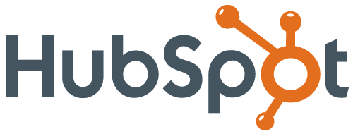
25 First Street, 2nd Floor ∙ Cambridge, MA 02141
P: 888.482.7768 ∙ F: 617.812.5820

