Social Sharing Kit for ISAGCA Members
Promotion for ISAGCA Blog, “Building a Resilient World: Practical Automation Cybersecurity”
---
The ISA Global Cybersecurity Alliance blog, “Building a Resilient World: Practical Automation Cybersecurity,” is a new, vendor-neutral resource for automation cybersecurity and related topics. You can find it at www.isa.org/isagcablog. We always welcome non-commercial, vendor-neutral article submissions from our members.
As a member of ISAGCA, your company may wish to share this blog, the product of our collective efforts, on social media. We’ve created a few sample posts across various platforms that you’re welcome to share if you’re interested in doing so. Please feel free to change the wording of these posts to fit your branding, or simply copy and paste. Don’t forget to tag the International Society of Automation in your posts and/or use the #ISAGCA hashtag!

1. Cybersecurity Blog to Watch
LinkedIn and Facebook: The International Society of Automation’s Global Cybersecurity Alliance, of which [Company Name] is a member, has launched a new blog, “Building a Resilient World: Practical Automation Cybersecurity.” It will feature thought leadership to start much-needed conversations and drive the field of automation cybersecurity forward. We invite you to follow along at www.isa.org/isagcablog. #ISAGCA
(continued next page)

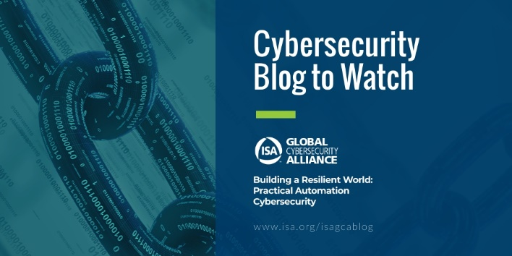
Twitter: The International Society of Automation’s Global Cybersecurity Alliance, of which we’re a member, has launched a new blog, “Building a Resilient World: Practical Automation Cybersecurity.” Many important conversations to come. Follow along at www.isa.org/isagcablog. #ISAGCA
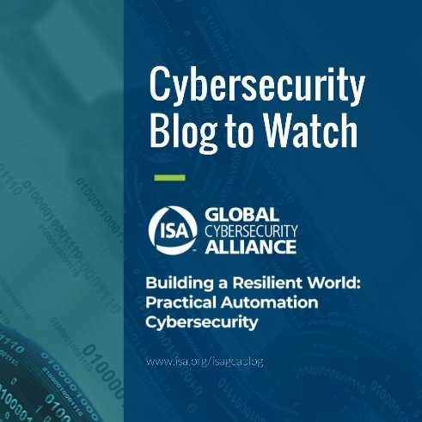
Instagram: The International Society of Automation’s Global Cybersecurity Alliance, of which [Company Name] is a member, has launched a new blog, “Building a Resilient World: Practical Automation Cybersecurity.” We invite you to follow along at www.isa.org/isagcablog. #ISAGCA

