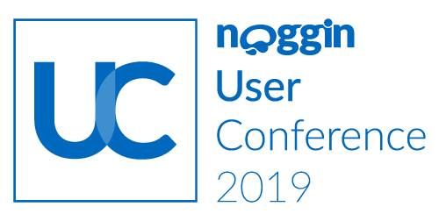
Subject: Approval to Attend the 2019 Noggin User Conference

Dear <insert boss’s name>,

I would like to attend the 2019 Noggin User Conference 2019 in Sydney, NSW Australia, September 12 – 13, 2019. This two-day event brings together countless users, partners, and customers of Noggin, in emergency management, environmental health and safety, security, business continuity, and crisis management across a dozen industry verticals. It’s the one event where attendees from any size or type of organization can find integrated safety and security thought-leadership sessions delivered by industry experts, discussing insights, best practices, and compliances, as well as Noggin success stories.

Here are more reasons I would like to attend and how our business can benefit from my being there:
- I’ll become more productive. I’ll get hands-on, in-depth software training, ideal for getting more out of our Noggin implementation and driving efficiencies in our Noggin system usage.
Also, executive decision makers at leading-edge firms like Woolworths and AGL Energy will be on hand to deliver keynotes sharing details of their successful implementations of the Noggin integrated safety and security platform. We can leverage those learnings to get more bang for our buck.
- I’ll learn from leading experts. Not just executive decision makers at top firms, panels of industry experts will be at the Noggin UC, too. They’ll be there discussing the state of play of in our industry, including trends, events, compliance drivers, etc.
- I’ll preview what’s happening next. Major forces are disrupting our industry. And it’s not always easy to keep up. That’s why it’s so important to get great insights into what’s happening next, like the next generation of integrated safety and security management technology, Noggin 2.0. In addition to full demos of the new platform, I’ll also learn more about the Noggin platform revamp and have access to module boot camps about setting up the industry and solution packs perfect for our situation.
- I’ll talk to peers and practitioners from around the world. Noggin UC attendees come from firms of all sizes, from all over the world. I’ll be able to exchange ideas and get solutions to the challenges our organization is facing, thanks to dedicated activities that facilitate meeting and collaborating with peers.
Again, I believe the Noggin UC is well worth the company investment. It’s the one conference where I can gain the latest skills, learn more about industry trends, and. get exposure to new products and technology.

If approved, I plan to attend sessions focused on <XXX>. I am seeking approval for the registration and travel expenditures.

If I register now, I’ll receive discounted rates. Here is a complete breakdown of the costs:

Conference Pass: $<XXX>
Airfare: $<XXX>
Hotel: $ <XXX> /night @ <XXX> nights
Transportation: $<XXX>
Meals: $<XXX>
Total Cost: $<XXX>

Complete information on the Noggin UC is available at https://www.noggin.io/2019uc.

Sincerely,
<Insert your name>

