Program logic
templates
By Grosvenor Public Sector Advisory

1. INTRODUCTION
A program logic is simply a graphical portrayal of your program theory that is succinct and easy to understand.
Your program logic can take the form of words, diagrams, tables, or a combination of all three. Program logics are often (but not always) captured in one page, and are typically divided into inputs, outputs and outcomes.
There are many different formats which you can use to help capture your program.
It’s important to remember that there is not right or wrong format. Look through the options below and use them as they are or adjust them to better meet your needs. The format isn’t as important as doing the critical thinking to develop a robust program logic.

What formats are there?
- Table based formats
- Process map formats
  - Outcomes hierarchy
  - Pipeline/results chain
  - Process map
- Picture based formats
  - Rich pictures
  - Place mats

Table based formats¹

Example 1
Critical  issues/gaps | Inputs/  resources | Outputs/  activities | Target  recipients | Short-term  outcomes | Outcomes  Medium-term  outcomes | Long-term  outcomes
What are the identified gaps or strategic issues that this initiative is responding to? | What are the identified gaps or strategic issues that this initiative is responding to? | What are the key activities to be undertaken? | Who is the target of the initiative? | What outcomes are sought in the immediate term? | What outcomes are sought in the medium term? | What are the long term/ultimate outcomes sought?

Example 2
Inputs |  | Outputs |  |  | Outcomes - Impact
 |  | Activities | Participation |  | Short | Medium | Long

¹W.K. Kellogg Foundation (1998)

Process map types

Outcomes hierarchy²
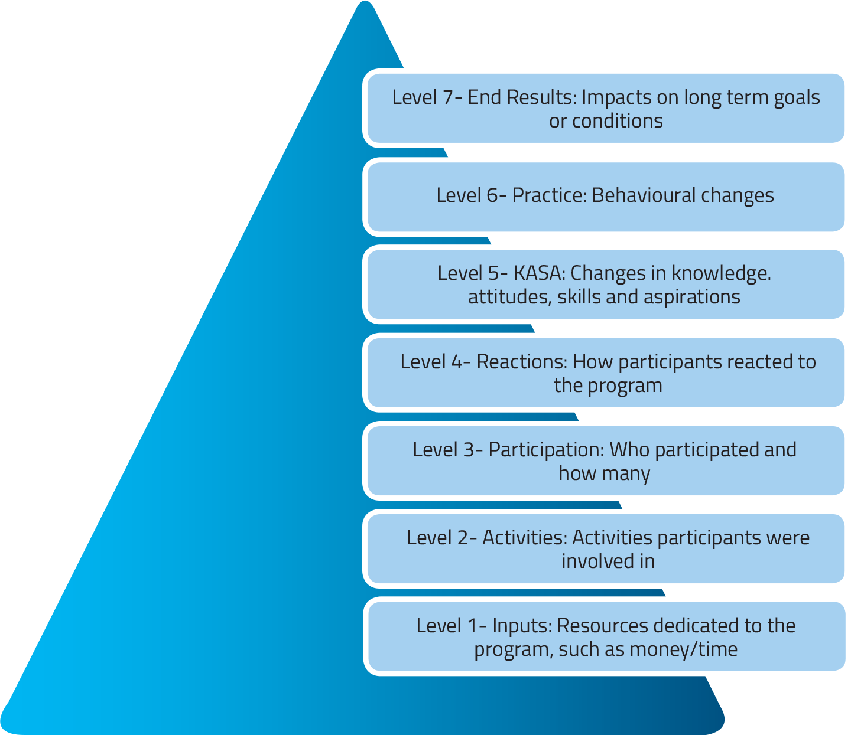

Pipeline/results chain³
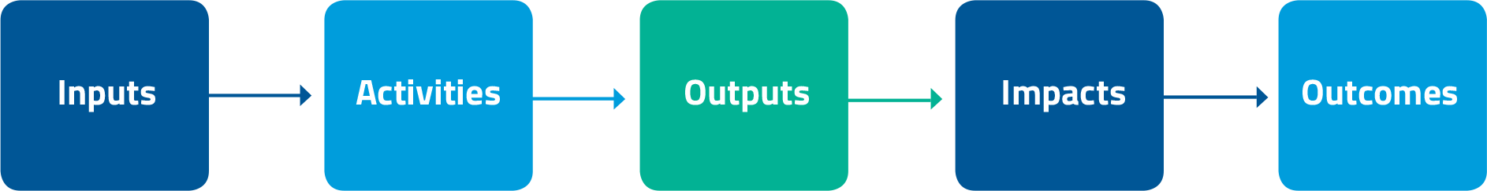

²Bennett, C (1975) Up the hierarchy. Journal of Extension.
³Funnell, S and Rogers, P (2011) Purposeful Program Theory: Effective Use of Theories of Change and Logic Models

Process map/flow chart
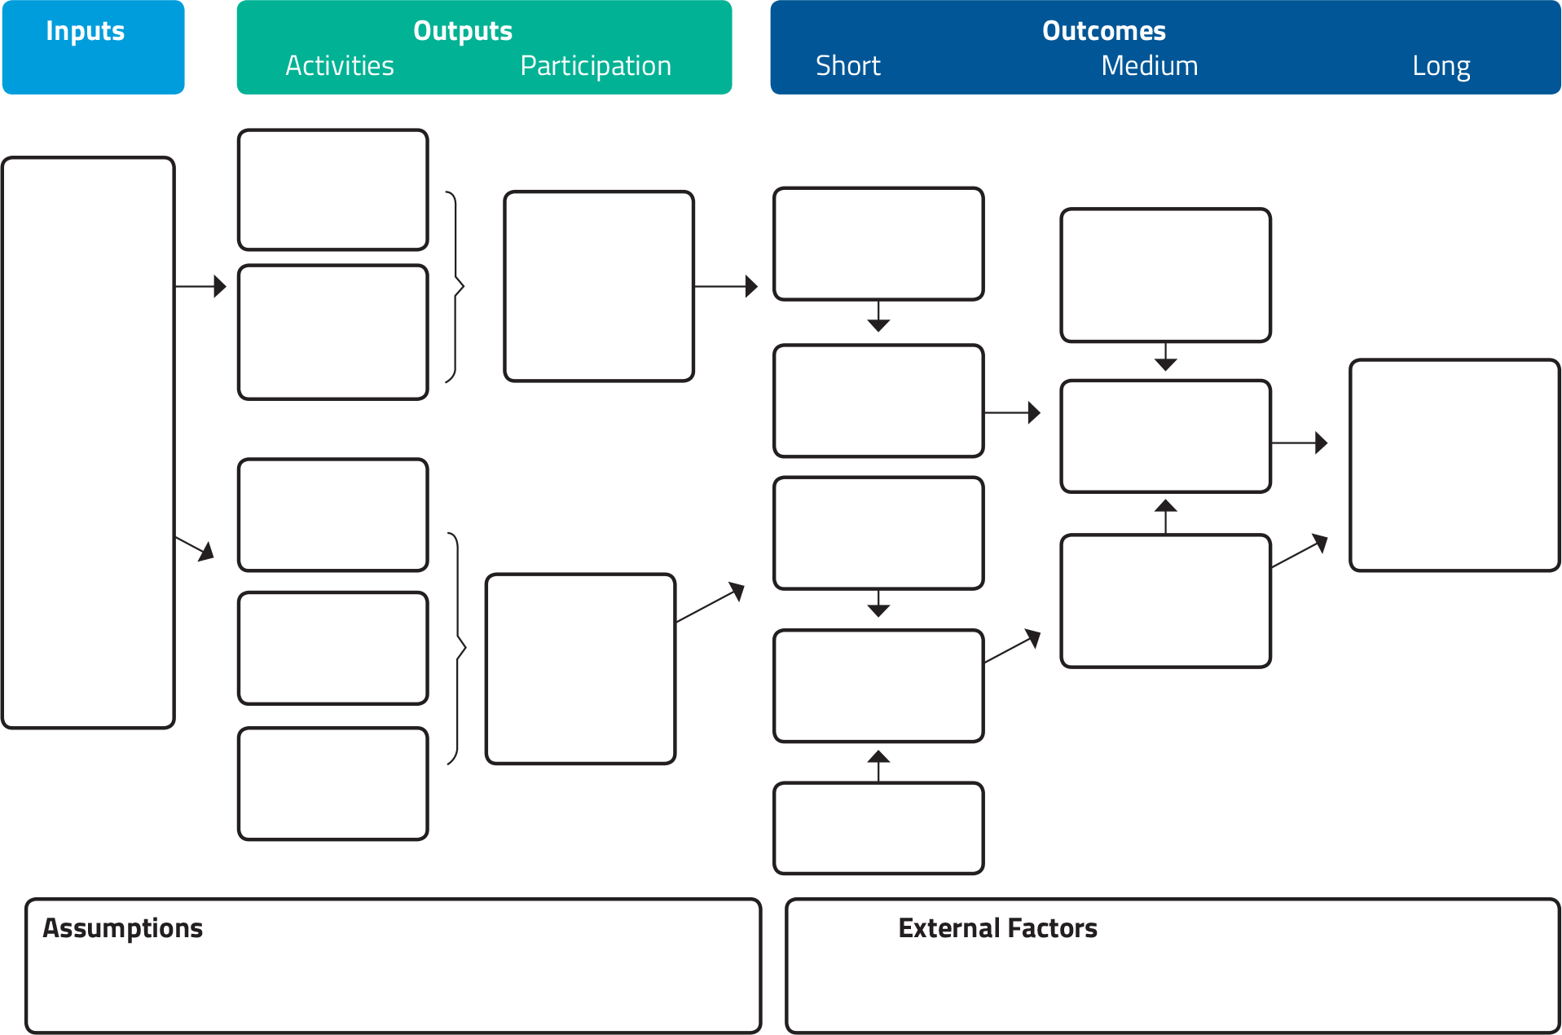

Picture based formats

Rich pictures⁴
Rich pictures⁵ can be used as a way to capture how a program works. They seek to capture relationships, structural elements, motivations and tensions , processes, flows and exchanges.
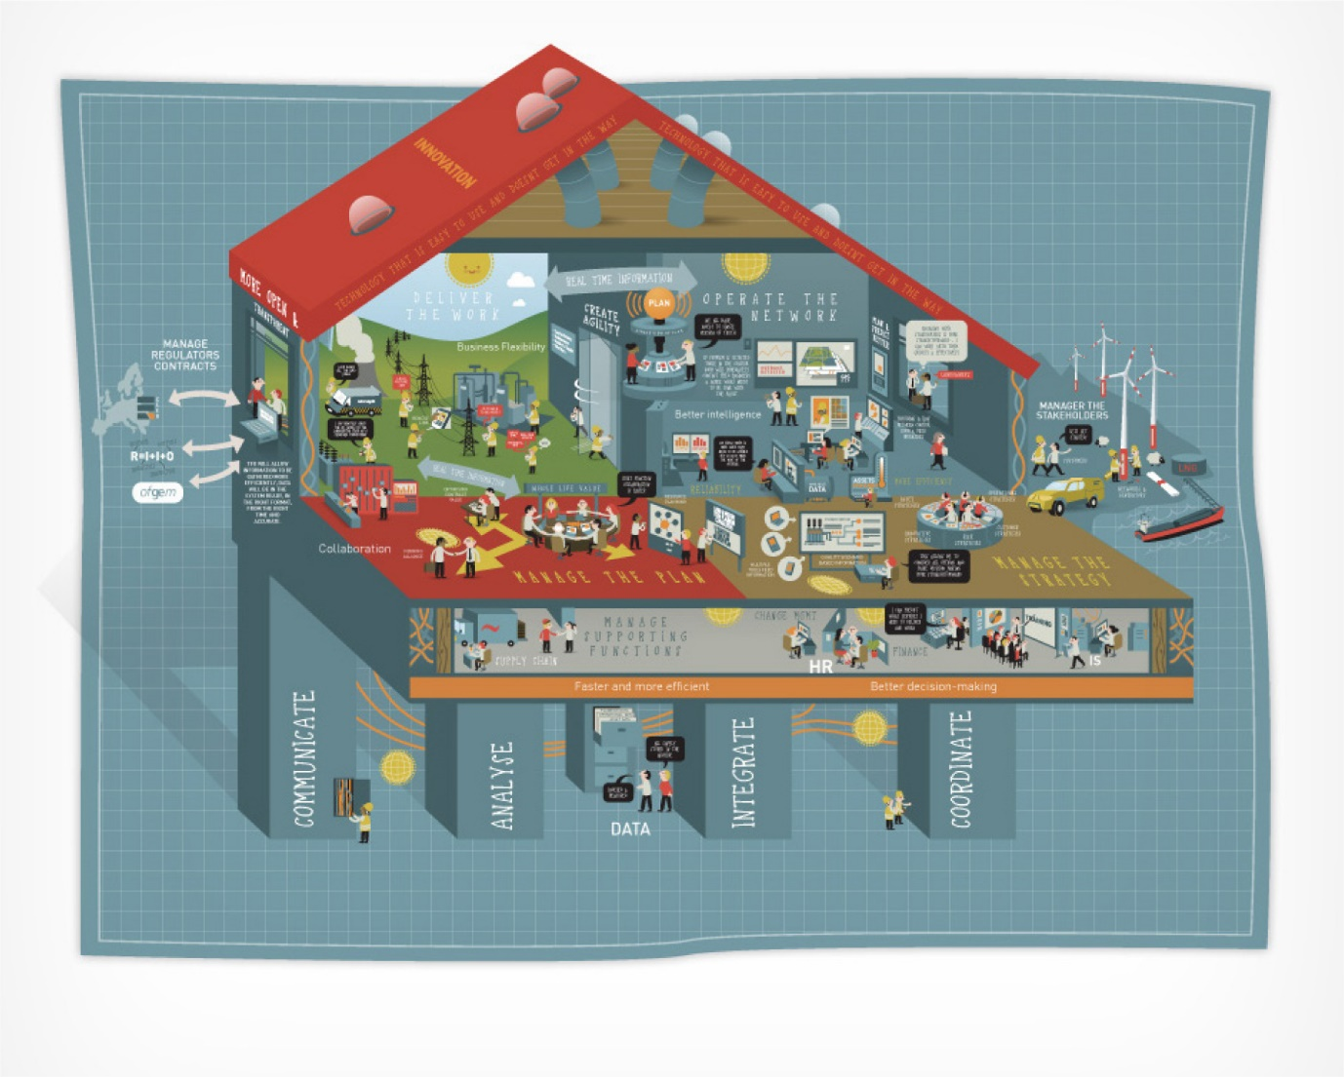

⁴http://www.visualscribing.com/rich_picture/
⁵A tool developed by Peter Checkland and Brian Wilson; Oakden, J (2014) If a picture paints a thousand words.

Place mats
Place mats tend to be one to two pages long and seek to provide a high-level summary of a program through the use of visual elements as well as text.

Example 1⁶
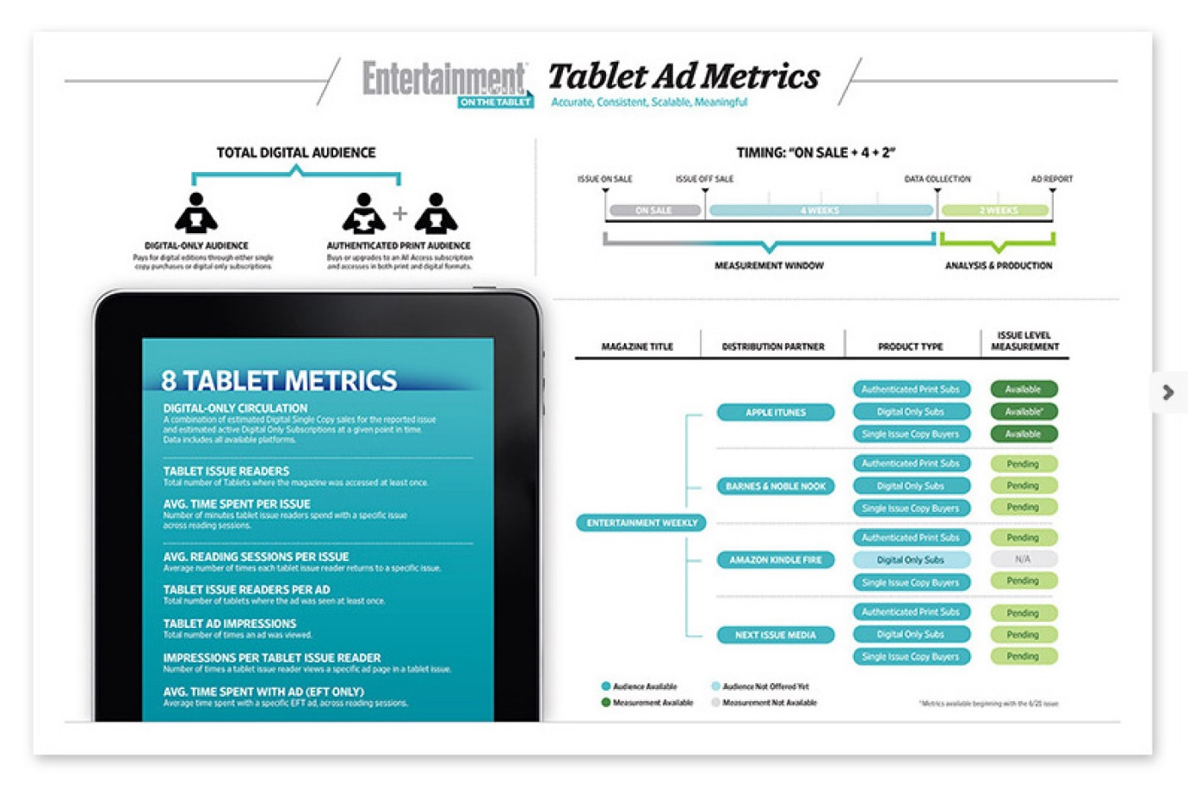
⁶http://www.johnbrandonmiller.com/portfolio.html

Example 2⁷
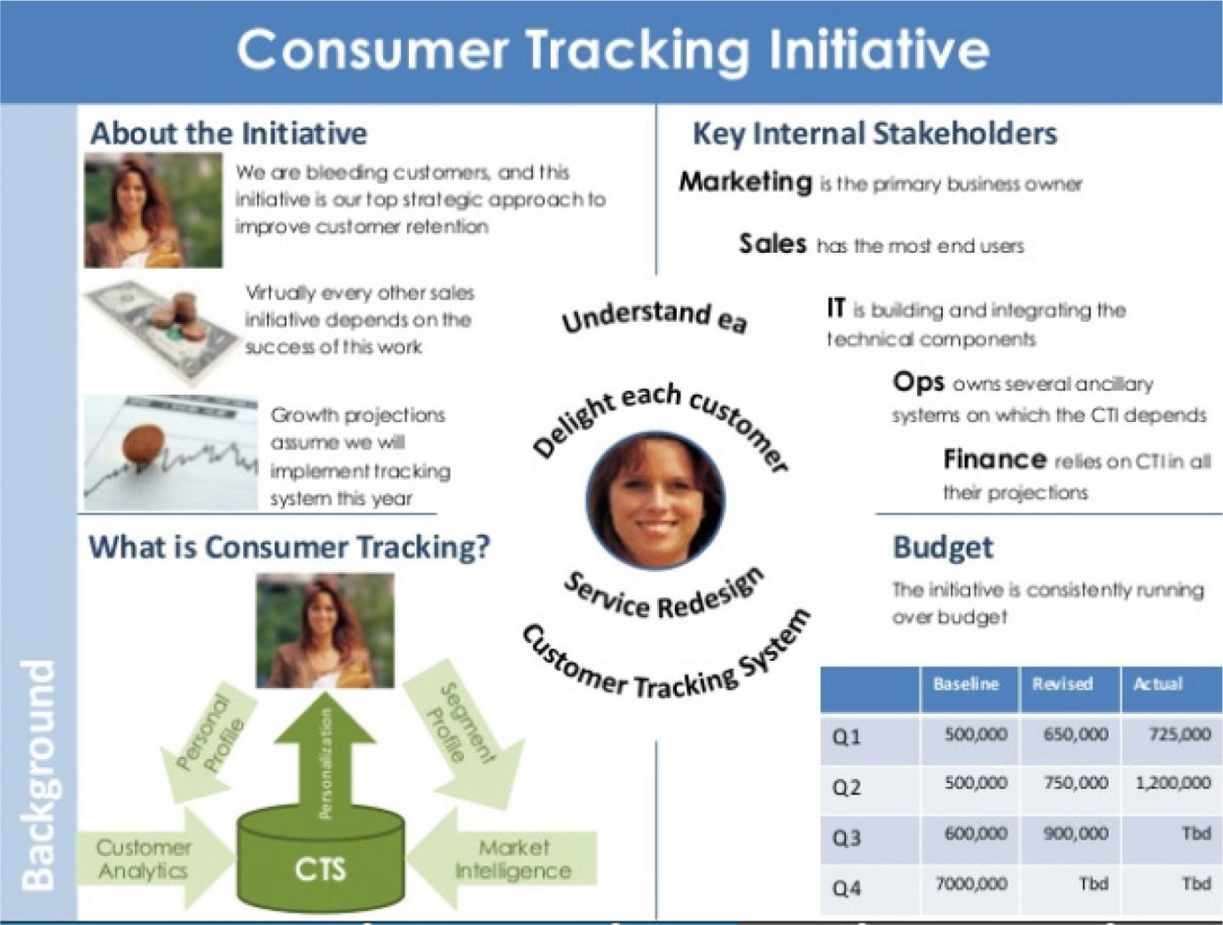
⁷https://www.slideshare.net/timiti/placemat-exercises-in-power-point-style-5

References
¹W.K. Kellogg Foundation (1998)
²Bennett, C (1975) Up the hierarchy. Journal of Extension.
³Funnell, S and Rogers, P (2011) Purposeful Program Theory: Effective Use of Theories of Change and Logic Models
⁴http://www.visualscribing.com/rich_picture/
⁵A tool developed by Peter Checkland and Brian Wilson; Oakden, J (2014) If a picture paints a thousand words.
⁶http://www.johnbrandonmiller.com/portfolio.html
⁷https://www.slideshare.net/timiti/placemat-exercises-in-power-point-style-5

