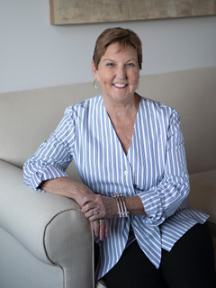
Summary of Qualifications
For over 30 years, I’ve been transforming executives and their teams through soulful coaching and consulting that focuses on the human element. My clients experience personal and professional breakthroughs, creating happier, healthier, more productive work (and home!) environments. They become better leaders, team members, partners, parents and friends. It is a privilege to be a catalyst for this type of life-changing growth and success. A partial list of clients includes the US Government, Abbvie, Compass Group, and BlueCross and Blue Shield, to name a few. Additionally, I have spoken to a variety of groups on the subjects of Leading on Purpose, Transformational Leadership, Executive Presence in the Workplace, Career-Life Fit, and Life Transitions.
Before I launched my coaching and consulting practice, I held leadership roles in talent management at Nestle and Frito-Lay, specializing in the creation of comprehensive strategies for organization and leadership development. I’ve been a part of the Deloitte team for over 15 years (focusing on Partner Development across functions and industries), and have a comprehensive understanding of the challenges and opportunities associated with leading in a fast-paced, matrix environment.
Coach Philosophy
Through my holistic approach, my clients achieve their greatest potential for themselves and those they serve. Sometimes they just need to see things differently. I help them recognize the horizon line for themselves and the organization more clearly. We work together to clarify and align their values and strengths to their purpose and that of the organization, and to identify what is getting in their way of crossing the threshold to the next level of leadership/results. I use a combination of organizational and behavioral best practices as well as personal experience to craft a process of assessment, high gain questions, observations, practical development plans (including identification of their support team and key experiences for immediate application) and accountability. This opens the door to an amplified state of awareness and effectiveness. Clients are ready and excited for the next level of leadership, meaningful and measurable results, and heightened fulfillment in all areas of their lives.
Hobbies and Interests

Peace Building and Reconciliation work in Central and East Africa
Spending time with family
Travel, especially to any place that has great beaches
Personal growth
Writing
Taking on new challenge

