Leader Communication

[YOUR COMPANY NAME] Leadership,

As each of us continues to navigate an unprecedented new reality for [ORGANIZATION] team members, [ORGANIZATION] customers and the communities we serve, this email is a brief reminder to pause and consider the long-term impact of our leadership during this time period. At some unknown date in the future, we will look back on how we chose to lead today and how we reacted during these trying times. We will be either proud or disappointed. But we won’t be neutral. While we are asking a tremendous amount from our team members, we must also ask a tremendous amount from each of you. Below are questions to help guide your thinking as well as resources and tools to navigate the current environment.

1. As you make rapid decisions and communicate with your team members, how can our values continue to be a guidepost?
Now is the time to use our values as a filter for decisions and communications to stakeholders. Before jumping into the tactics of how to mitigate risks, ask, “if we, as an organization, are going to respond in support of our values, how should we act? To each other? To our customers and clients?”

2. Where do the people in our span of care rank?
Our people are equally as important as our customers. As leaders in the organization, by definition, our role is to serve the people in our span of care. If we do our jobs well, our people will take care of the customer. Make decisions that show our people that in a time of need we have their back. Remaining loyal to our people now results in their loyalty to [ORGANIZATION] in the future. What does this look like?
- Communicate in the right order. Make it very clear that you are concerned with the health and well-being of team members first and foremost. Begin all communications with what’s most important, our people and our values.
- Double-down on recognition and celebration. Pointing out what’s “going right” and calling your team to those behaviors is critical. Recognize and celebrate people one-on-one. Also, begin meetings with “what’s working” not just “what needs to be done or fixed.”
- Ask for feedback. While you will have a need to transmit new information at a rapid and changing pace, don’t forget to engage your team. Ask,
  - What have we missed?
  - How can I better support you in your role as your leader?
  - What ideas do you have?
  - How can you make this idea better?
  - What concerns do you have from your perspective?
  - How can our team work better together during this time?
- Assume positive intent. As information will continue to be imperfect (and constantly changing) we all have a responsibility to: 1. Ask Why, and 2. Tell Why. Rather than assume negative intent, speak-up and ask for more information. For information that you have, over-share context and background aligning everyone to why decisions are being made. A small investment of this time on the front end will yield dividends later in the form of reduced confusion.

4. How can you increase transparency in your communication?
Right now, our people are searching for facts. Even if the answer is unknown, be transparent and willing to state what you know and what you don’t. The willingness to not “spin” a message or convolute it with more words will earn us trust at a time when it is needed and appreciated. Consider,
- How often do I need to be communicating with my team?
- What’s the best format? Email is highly effective at communicating facts and information. It’s not ideal for emotional topics. Would a video call be more effective?
- What channel have I established for people to deliver feedback, questions and concerns?

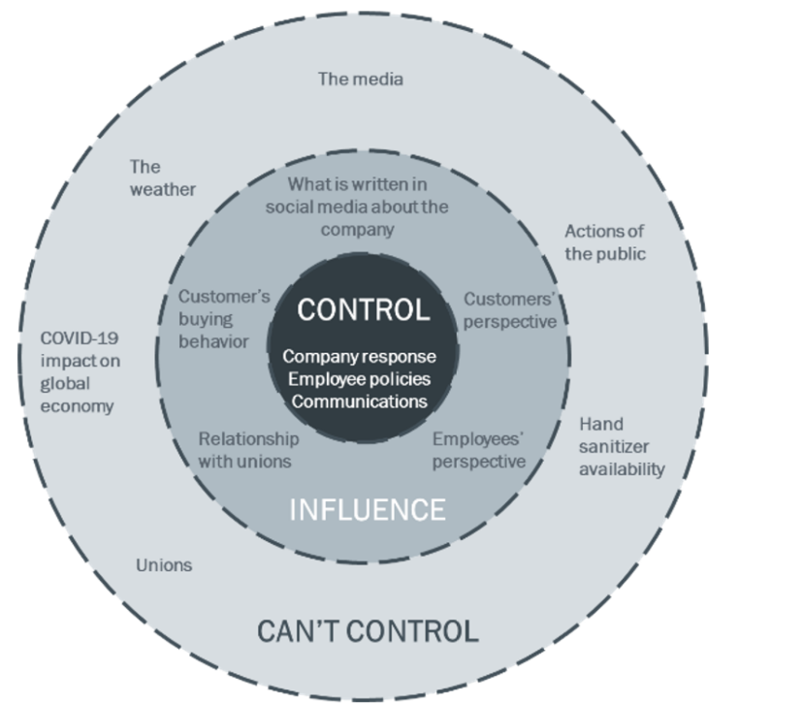
5. What can you personally control and influence?
To facilitate better decision making, use structure to focus your thinking. For example, use the Control – Influence – Can’t Control model to help. Rather than focusing on what you cannot control, list what is in control of the organization and what the organization can influence. This helps you stay in tune with possibilities and allows for creative thinking to be applied in a more productive way. See graphic for an example.

While current business demands can make it difficult to devote time to how we lead our teams, how we lead our teams will make the difference between a world event that strengthens us as a team or results in damage to the [ORGANIZATION] culture. Additional online resources we encourage you to leverage:
- L&D team resources
- Sign-up here for regular online leadership training and resources from Chapman & Co. Leadership Institute

While none of us can predict what tomorrow or the future may hold, we do know that this team will continue to serve and support each other, we will show up in remarkable ways, and we will serve our customers in a way that adds value to their lives and their family’s lives.

