September 12, 2018
Dear Valued Customer,
Sargent and Greenleaf is dedicated to continuous improvement of its product, service and processes. To serve our customers better and to improve electronic lock kit pack accuracy we are moving to a new packing process and packaging. In addition, this change will dramatically decrease the cost of shipping multiple skids of these kit packed electronic kits.
Currently a standard skid shipped internationally will hold 200, 6100 electronic kits, with this improved packaging we will be able to ship, on the same skid, 366 of these same kits. Or an increase of over 60% packing improvement!
This new packing process has passed an ISTA level 1 shipping test.
S&G does recognize that there are some customers that open the current box and manipulate the lock and/or components. To allow customers to do this and keep the kit and its components together, we have included a re-sealable plastic bag in each kit.
The following kits will be included in this change:
6120, 6123, 6124, 6125, 6126, 6128, 6129, 1006, 1007, 2006, 2007, 3006, 3007, 3028, 3029
This change will be implemented in Mid-November 2018.
We sincerely appreciate your support.
Sincerely,
Patrick Cunningham

Patrick Cunningham
Product Manager
Sargent and Greenleaf
One Security Drive
Nicholasville, KY 40356
www.sargentandgreenleaf.com

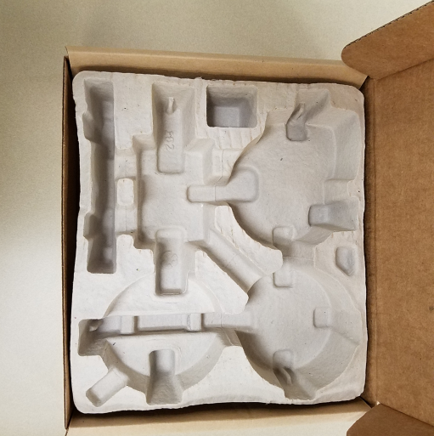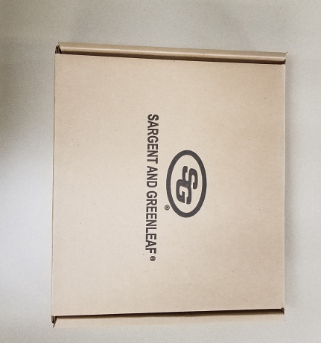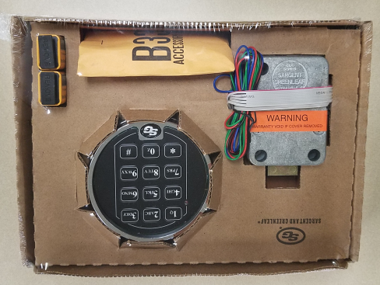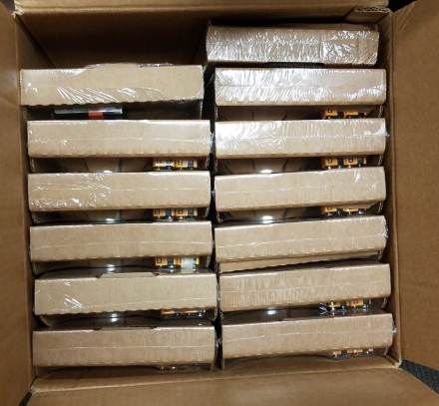
Photo1: Old electronic kit packs
Photo2: New electronic kit packs and Overpack box with room for 14 kits.
The Overpack box is also smaller.

