September 12, 2018
Dear Valued Customer,
Sargent and Greenleaf is dedicated to continuous improvement of its product, service and processes. To serve our customers better and reduce the installation effort S&G will remove the aluminum escutcheon plate from the 6128 kit packs for the following SKUs: 6128-240, 6128-241, 6128-247 and 6128-251.
To provide our customers with a location to attach the included serial number label, we have slightly changed the keypad extension. This change is now integrated into the keypad extension and so reduces the number of components that must be installed for the above listed SKUs.
S&G does recognize this new keypad extension may not be compatible with all of the containers that currently have a 6128/29 installed on them. So please contact your sales representative to assist you in finding the 6128/9 that still has the aluminum escutcheon available. This change will be implemented in December 2018.
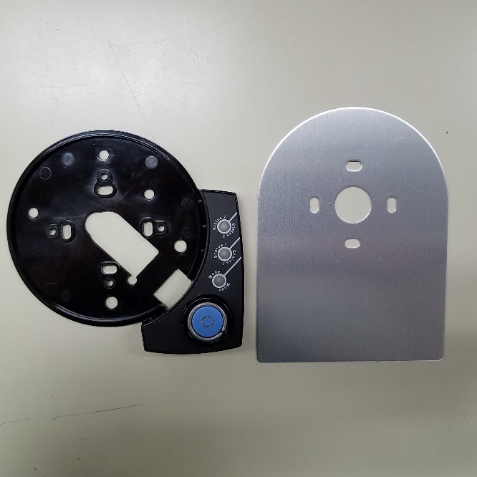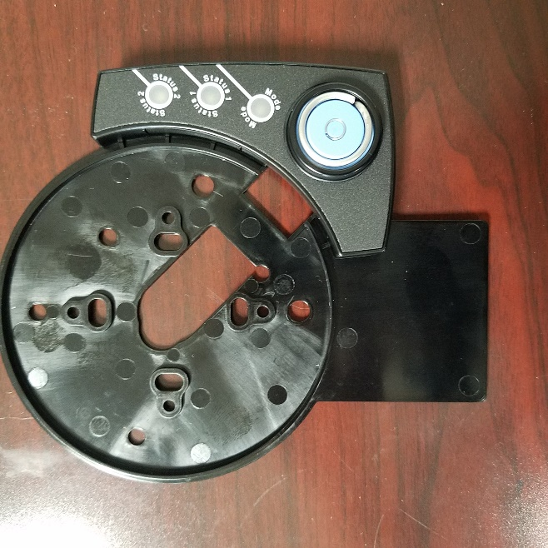
Photo2: New keypad extension with new label location integrated into the extension
Photo1: Current Aluminum Escutcheon Plate with keypad extension

We sincerely appreciate your support.
Sincerely,
Patrick Cunningham

Patrick Cunningham
Product Manager
Sargent and Greenleaf
One Security Drive
Nicholasville, KY 40356
www.sargentandgreenleaf.com

