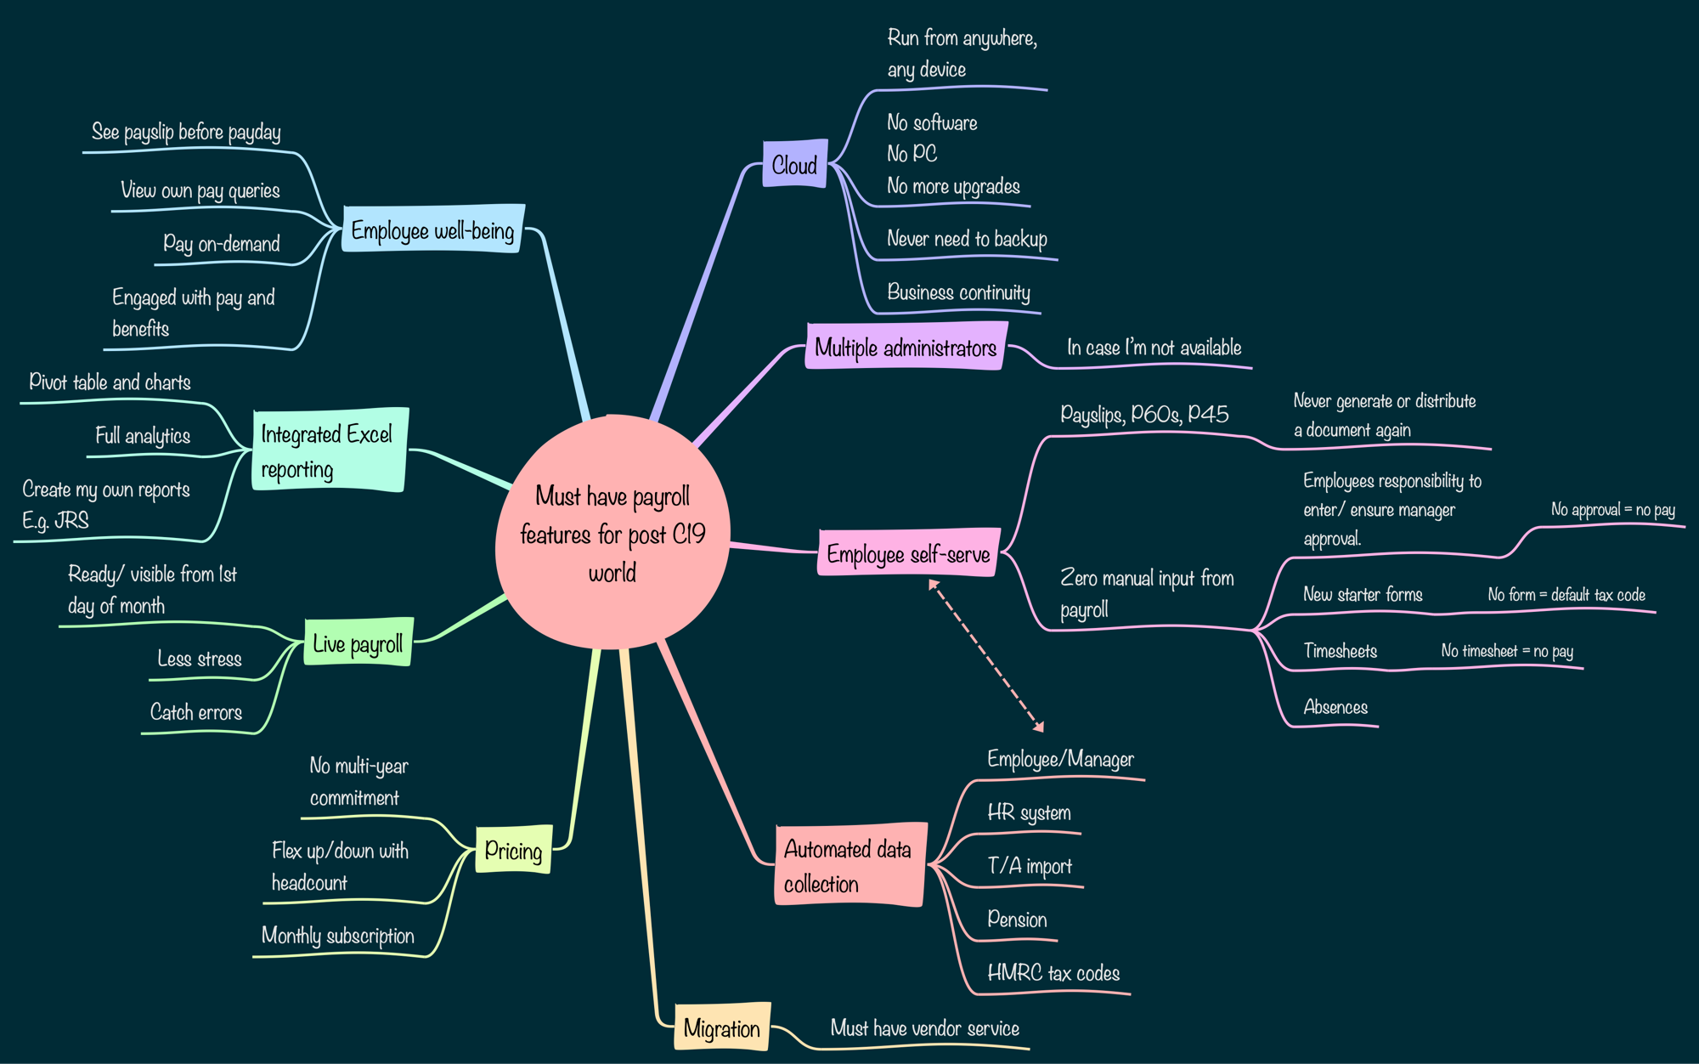

Must have payroll features for post C19 world

Cloud | Run from anywhere,  any device
No software
No PC
No more upgrades
 | Never need to backup
 | Business continuity
Multiple administrators | In case I’m not available
Employee self-serve | Payslips, P60s, P45 | Never generate or distribute a document again
 | Zero manual input from payroll | Employees responsibility to enter/ ensure manager approval. | No approval = no pay
 |  | New starter forms | No form = default tax code
 |  | Timesheets | No timesheet = no pay
 |  | Absences
Automated data collection | Employee/Manager
 | HR system
 | T/A import
 | Pension
 | HMRC tax codes
Migration | Must have vendor service
Pricing | No multi-year commitment
 | Flex up/down with headcount
 | Monthly subscription
Live payroll | Ready/ visible from 1st day of month
 | Less stress
 | Catch errors
Integrated Excel reporting | Pivot table and charts
 | Full analytics
Create my own reports
E.g. JRS
Employee well-being | See payslip before payday
 | View own pay queries
 | Pay on-demand
 | Engaged with pay and benefits

