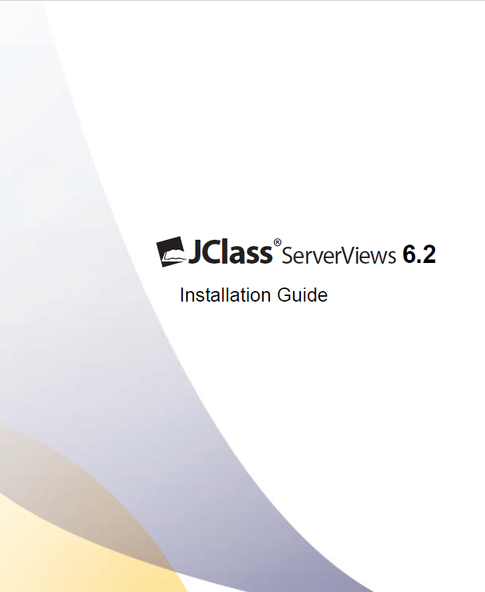

Installation Guide

**© 2013 Quest Software, Inc.**

**ALL RIGHTS RESERVED.**

This guide contains proprietary information protected by copyright. The software described in this guide is furnished under a software license or nondisclosure agreement. This software may be used or copied only in accordance with the terms of the applicable agreement. No part of this guide may be reproduced or transmitted in any form or by any means, electronic or mechanical, including photocopying and recording for any purpose other than the purchaser’s personal use without the written permission of Quest Software, Inc.

The information in this document is provided in connection with Quest products. No license, express or implied, by estoppel or otherwise, to any intellectual property right is granted by this document or in connection with the sale of Quest products. EXCEPT AS SET FORTH IN QUEST'S TERMS AND CONDITIONS AS SPECIFIED IN THE LICENSE AGREEMENT FOR THIS PRODUCT, QUEST ASSUMES NO LIABILITY WHATSOEVER AND DISCLAIMS ANY EXPRESS, IMPLIED OR STATUTORY WARRANTY RELATING TO ITS PRODUCTS INCLUDING, BUT NOT LIMITED TO, THE IMPLIED WARRANTY OF MERCHANTABILITY, FITNESS FOR A PARTICULAR PURPOSE, OR NON-INFRINGEMENT. IN NO EVENT SHALL QUEST BE LIABLE FOR ANY DIRECT, INDIRECT, CONSEQUENTIAL, PUNITIVE, SPECIAL OR INCIDENTAL DAMAGES (INCLUDING, WITHOUT LIMITATION, DAMAGES FOR LOSS OF PROFITS, BUSINESS INTERRUPTION OR LOSS OF INFORMATION) ARISING OUT OF THE USE OR INABILITY TO USE THIS DOCUMENT, EVEN IF QUEST HAS BEEN ADVISED OF THE POSSIBILITY OF SUCH DAMAGES. Quest makes no representations or warranties with respect to the accuracy or completeness of the contents of this document and reserves the right to make changes to specifications and product descriptions at any time without notice. Quest does not make any commitment to update the information contained in this document.

If you have any questions regarding your potential use of this material, contact:

Quest Software World Headquarters

LEGAL Dept

5 Polaris Way

Aliso Viejo, CA 92656

www.quest.com

email: legal@quest.com

Refer to our Web site for regional and international office information.

**Trademarks**

Quest, Quest Software, the Quest Software logo, AccessManager, ActiveRoles, Aelita, Akonix, Benchmark Factory, Big Brother, BridgeAccess, BridgeAutoEscalate, BridgeSearch, BridgeTrak, BusinessInsight, ChangeAuditor, CI Discovery, Defender, DeployDirector, Desktop Authority, Directory Analyzer, Directory Troubleshooter, DS Analyzer, DS Expert, Foglight, GPOADmin, Help Desk Authority, Imceda, IntelliProfile, InTrust, Invirtus, iToken, JClass, JProbe, LeccoTech, LiteSpeed, LiveReorg, LogADmin, MessageStats, Monosphere, NBSpool, NetBase, NetControl, Npulse, NetPro, PassGo, PerformaSure, Point, Click, Done!, Quest vToolkit, Quest vWorkSpace, ReportADmin, RestoreADmin, ScriptLogic, SelfServiceADmin, SharePlex, Sitraka, SmartAlarm, Spotlight, SQL Navigator, SQL Watch, SQLab, Stat, StealthCollect, Storage Horizon, Tag and Follow, Toad, T.O.A.D., Toad World, vAutomator, vConverter, vEcoShell, VESI, vFoglight, vPackager, vRanger, vSpotlight, vStream, vToad, Vintela, Virtual DBA, VizionCore, Vizioncore vAutomation Suite, Vizioncore vEssentials, Vizioncore vWorkflow, WebDefender, Webthority, Xaffire, and XRT are trademarks and registered trademarks of Quest Software, Inc in the United States of America and other countries. For a complete list of Quest Software’s trademarks, see http://www.quest.com/legal/trademark-information.aspx. Other trademarks and registered trademarks used in this guide

are property of their respective owners. Other trademarks and registered trademarks are property of their respective owners.

**Third Party Contributions**

JClass ServerViews contains some third party components (listed below). Copies of their licenses may be found on our website at www.quest.com/legal/third-party-licenses.aspx.

|  |  |
| --- | --- |
| **Component** | **License or Acknowledgement** |
| Apache Tomcat | Apache Foundation License version 2.0 |
| GifEncoder | Copyright 1996 by Jef Poskanzer (www.acme.com). |
| International Components  for Unicode | Copyright 1995–2006 International Business Machines Corporation and others. All rights reserved. |
| JDOM | Copyright 2002–2002 Brett McLaughlin & Jason Hunter, all rights reserved. |

**Installation Guide**

**January 2013**

**Version 6.2**

**Table of Contents**

Welcome to JClass ServerViews 6

Using this Installation Guide 6

Supported Platforms 7

About Quest Software, Inc. 9

Installation and Licensing Overview 10

JClass ServerViews Installation Files 10

Installed Directories 10

Licensing Overview 11

Upgrading a JClass ServerViews Installation 12

Microsoft Windows: Installing and Licensing 13

Installing and Licensing JClass ServerViews in Microsoft Windows 13

UNIX: Installing and Licensing 15

Installing and Licensing JClass ServerViews on UNIX 15

Installing and Licensing in a Headless Environment 16

JClass ServerViews and Your Development Environment 18

JClass ServerViews JAR Files 18

JClass ServerViews and Your CLASSPATH 19

Integrating JClass ServerViews into your Ant Build Scripts 20

Demos and Examples 21

JClass ServerViews Designer Tools 21

# **Welcome to JClass ServerViews**

*Using this Installation Guide* ■ *Supported Platforms Guide* ■ *About Quest Software, Inc*

Thank you for choosing JClass ServerViews. You can use this suite of fully-customizable, 100% Java components to create rich user interfaces for your serverside Java applications.

JClass ServerViews contains three sets of components:

* JClass ServerChart offers advanced chart components, including bar, plot, radar, polar, and financial charts.
* JClass ServerReport enables you to add paginated, formatted, flowed-text, and image output to Java applications.
* JClass ServerGauge offers a variety of gauge components as well as a simple graph component.

## Using this Installation Guide

This JClass ServerViews Installation Guide is organized into the following sections:

* Before installing JClass ServerViews, review the matrices in the Supported Platforms section to verify that your operating system, JDK, J2EE application server, and IDE are supported. You should also read the installation and licensing information in the Installation and Licensing Overview chapter.
* Once you are familiar with the information, continue on to either:
  + Microsoft Windows: Installing and Licensing
  + UNIX: Installing and Licensing
* Once the product is installed and licensed, the steps required to integrate JClass ServerViews within your development environment are outlined in the JClass ServerViews and Your Development Environment chapter.
* Lastly, integrate JClass ServerViews with your J2EE application server. Consult your application server documentation.

If you require information on programming, refer to the programmer’s guides, which can befound in the following locations:

* JClass ServerChart Programmer’s Guide, in *JCLASS_SERVER_HOME/docs/schart*.
* JClass ServerReport Programmer’s Guide, in *JCLASS_SERVER_HOME/docs/sreport*.
* JClass ServerGauge Programmer’s Guide, in *JCLASS_SERVER_HOME/docs/sgauge*.

## Supported Platforms

This section outlines the application servers, operating systems, JDKs, IDEs, and web browsers supported by JClass ServerViews.

**Validated Application Servers by Operating System**

The following table shows the JClass ServerViews support for application servers by operating system. Any restricted application server or OS update levels are shown within the table cells.

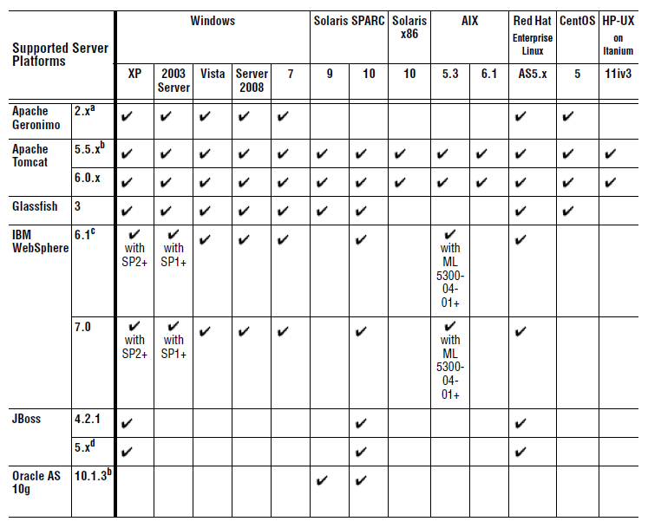

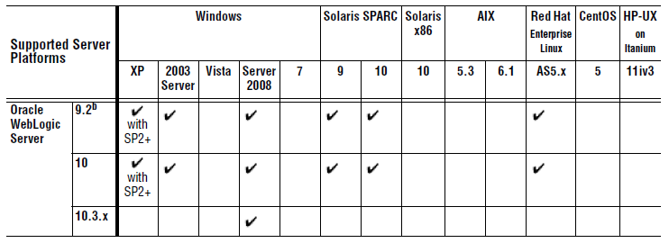

a. To deploy the server-samples web application on Apache Geronimo, you need to remove jstl.jar and standard.jar from the *server-samples.war* file. These JARs conflict with Apache Geronimo's own jstl.jar, resulting in tld validation warnings during deployment.

b. The Facelets examples in the JClass ServerViews server-samples.war require an application server that implements the JSP 2.1 specification (for example, Apache Tomcat 6). To deploy the server-samples.war on JSP 2.0 compliant application servers, add the expression language JARs   
(el-api-1.0.jar and el-impl-1.0.jar) from the Facelets 1.1.15 distribution to your application server’s *WEB-INF/lib* directory and also to the server's classpath. You also need to add the listener class com.sun.faces.application.WebappLifecycleListener to the *web.xml* file.

c. IBM WebSphere Application Server 6.x is supported as noted on Windows XP and Windows Vista only for application design, development, and testing; no support for production use.

d. To use the *server-samples.war* file, some application servers (as noted in the preceding table) require that you remove the following JSP-related JAR files from your application server’s WEB-INF/lib directory: *jsf-api.jar, jsf-impl.jar, jstl.jar, standard.jar, commons-beanutils.jar, commons-collections.jar, commons-digester.jar, and commons-logging-api.jar*.

**Supported JDKs**

**Note**: As of JClass ServerViews 6.1, JVM 1.4.2 is no longer supported.

JClass ServerViews supports the following versions of Java software development kits (JDKs), provided the JDK version is also supported by your application server:

* JDK 1.5
* JDK 1.6
* JDK 1.7
* VMs used by supported application servers and specific updates thereof, which include a JVM and whose vendor specifically supports or recommends its use over any other

**Supported IDEs**

Current versions of the following IDEs are supported:

* IDEA
* Eclipse
* NetBeans

**Supported Web Browsers**

Current versions of the following browsers are supported:

* Apple Safari (Windows only)
* Mozilla Firefox
* Microsoft Internet Explorer

## About Quest Software, Inc.

Quest Software (now a part of Dell) simplifies and reduces the cost of managing IT for more than 100,000 customers worldwide. Our innovative solutions make solving the toughest IT management problems easier, enabling customers to save time and money across physical, virtual and cloud environments. For more information about Quest go to *www.quest.com*.

**Contacting Quest Software**

Email info@quest.com

Mail Quest Software, Inc.

World Headquarters

5 Polaris Way

Aliso Viejo, CA 92656

USA

Web site *www.quest.com*

See our web site for regional and international office information.

**Contacting Quest Support**

Quest Support is available to customers who have a trial version of a Quest product or who have purchased a Quest product and have a valid maintenance contract. Quest Support provides unlimited 24x7 access to Support Portal at *http://support.quest.com*.

From our Support Portal, you can do the following:

* Retrieve thousands of solutions from our online Knowledgebase
* Download the latest releases and service packs
* Create, update and review Support cases

View the Global Support Guide for a detailed explanation of support programs, online services, contact information, policies and procedures. The guide is available at: *http://support.quest.com*.

**Quest Communities**

Get the latest product information, find helpful resources, and join a discussion with the JClass Quest team and other community members. Join the JClass community at *http://jclass.inside.quest.com/*.

# **Installation and Licensing Overview**

*JClass ServerViews Installation Files* ■ *Installed Directories* ■ *Licensing Overview*

*Upgrading a JClass DesktopViews Installation*

The JClass ServerViews installation is comprised of two parts:

* extracting and installing the product
* installing the license file

## JClass ServerViews Installation Files

If you purchased a physical kit, your JClass ServerViews installation CD contains JClass ServerViews packaged for installation on Microsoft Windows, UNIX, and other development platforms; if you purchased the product online, download the appropriate development platform(s) installer(s) for your environment.

|  |  |
| --- | --- |
| **Target Platform** | **JClass ServerViews** |
| Windows | jcserverviews620.exe |
| Red Hat Enterprise Linux | jcserverviews620-lnx.bin |
| AIX | jcserverviews620-aix.bin |
| Solaris SPARC | jcserverviews620-sol.bin |
| HP-UX | jcserverviews620-hp.bin |

## Installed Directories

The following directory structure is created on your system when you install JClass ServerViews.

**Note:** Throughout this document, we use the environment variable JCLASS_SERVER_HOME to represent the directory on your system where you have installed JClass ServerViews.

**JCLASS_SERVER_HOME**

|– **bin/** *Executables, License wizard*

|– **com/** *Source code (optional)*

|– **demos/** *Product demos*

|– **docs/** *API reference (javadoc), tlddocs, online help (html), and guides (pdf)*

|– **examples/** *Product examples (include WAR files)*

|– **jakarta-tomcat/** *Integrated Tomcat distribution*

|– **jre/** *JRE, if installed*

|– **lib/** *JAR files (including Batik JARs for ServerChart)*

|– **licenses/** *License files*

|– **samples/** *Sample XML files*

|– **Uninstall/** *Uninstall files*

|– **xml-dtd/** *XML DTD and TLD files*

|– license.pdf

|– JClassServerViews_6.2.0_ReleaseNotes.htm

## Licensing Overview

In order to use JClass ServerViews, you need a valid license file. If you try to run a JClass ServerViews-based application without a valid license file, a warning message will appear and you will not be able to use the product. JClass ServerViews has three different types of licenses: evaluation, development, and production.

**Evaluation**

An Evaluation license allows you to test JClass ServerViews functionality for a limited period of time. You have access to demos and examples and you can begin prototype level development. An “Evaluation” watermark will overlay any generated output.You can not use evaluation-based JClass ServerViews products in a production environment.

**Development**

The Development license allows you to use the JClass ServerViews products to develop your applications, however any output will have a “development” watermark in the generated output.

**Production**

A Production license allows you full access to the JClass ServerViews products for development and production, eliminating the watermark. There are two different Production licenses: CPU-based and Architecture-based. A CPU-based license will specify system information and the number of CPUs on that system that can be used with the JClass ServerViews software; an architecture-based license specifies the system environment on which JClass ServerViews will be installed.

You can purchase the JClass ServerViews source code as well.

**Multiple Hosts and Multiple CPUs**

JClass ServerViews products are licensed on a node locked basis. Each license is keyed to the hostname and CPU count of the physical machine. Therefore, any changes to the hostname or the CPU count of a machine will cause the license validation to fail (license validation occurs at runtime).

**The License Repository**

This license file (typically named, *jclass-schart.license* or *jclass-sreport.license*) is emailed to you from Quest Software. Once you receive this file, use the JClass License Wizard to install the license file into the JClass ServerViews license repository. The license repository – called *jclass-serverviews.licenses* (located with the *JCLASS_SERVER_HOME/* license directory)–will be created the first time that you add a license with the License Wizard.

**Note:** One license file can cover multiple hosts and multiple CPUs.

**Multi-User Licenses**

Each JClass ServerViews license allows two primary support contacts (individuals in your organization who are responsible for interacting with Quest Software for product support issues) in our licensing system. Once those have been established, no other email contacts can be added. Since a new license request must have an email address and a license key associated with it, to request a new license you must have one of the primary contacts fill out the request form using their email address. Once verified, a new license for the specified host will be mailed to the contact, who can distribute it to the required machine.

Licenses are transferable. To transfer licenses or purchase additional licenses, contact Quest Software. See About Quest Software, Inc. on page 10.

**Using JClass ServerViews and JClass DesktopViews**

JClass DesktopViews is a JFC/Swing-based library that helps you build client-side Java applications quickly and easily, offering Java developers world-class versions of the components required by many standard applications, such as charts, tables, and reporting/printing.

To use both JClass ServerViews and JClass DesktopViews on the same machine, separate classpath settings must exist for each product. Since both products have components in common, which have been optimized for each product, placing them on the same classpath will result in the virtual machine and/or compiler automatically choosing the first class that matches. This may be from the wrong product, and may result in the desired product not working correctly.

## Upgrading a JClass ServerViews Installation

You can run different versions of JClass ServerViews on the same machine. To do so, simply run the installer and, when it asks you where you would like to install the product, select a different folder than the one where the current JClass ServerViews installation resides.

For example, if you already have a previous version of JClass ServerViews installed on your system, and you accepted the default installation, it will be installed in a *JClass ServerViews x.x* folder, where *x.x* represents the version number. When installing the latest version, use a different folder name, such as *JClass ServerViews 6.2*.

If you would like to install the latest version of JClass ServerViews without keeping any past versions, you must first run the uninstaller to remove JClass ServerViews from your system. Proceed with installing JClass ServerViews as outlined in Installing and Licensing JClass ServerViews in Microsoft Windows on page 17 or Installing and Licensing JClass ServerViews on UNIX on page 19.

**Note:** When installing a newer version of JClass ServerViews, it is essential that *the new and old JAR files do not mix*. For that reason, do not install a new version over top of an old version; either uninstall the older version first, or install the new version in a different folder.

# **Microsoft Windows: Installing and Licensing**

*Installing and Licensing JClass ServerViews in Microsoft Windows*

## Installing and Licensing JClass ServerViews in Microsoft Windows

1. **Insert the JClass ServerViews CD or download the installation executable.**

If you have purchased the JClass ServerViews CD and autorun is enabled, the installation process will start automatically. If you downloaded the installation file, or autorun is not enabled, you can simply run the executable file, *jcserverviews620.exe*, by double-clicking it. Once running, follow the instructions given by the installation program.

1. **Install the product files.**
2. **Ensure that JCLASS_SERVER_HOME is set correctly.**

While setting the *JCLASS_SERVER_HOME* is optional, it is highly recommended as it adds a valuable level of platform and file system independence.

*JCLASS_SERVER_HOME* should be set correctly by the installation program. If not, you can set it manually at a command prompt.

For example:

set JCLASS_SERVER_HOME=C:\JClassServerViews

where C:\JClassServerViews is where you installed the JClass ServerViews product(s).

1. **Run the License Wizard to install the JClass ServerViews license.**

The License Wizard automatically launches while you are running the installer.

If you did not install the license at installation time, you must do so before you can successfully use JClass ServerViews.

To run the license again, go to the *JCLASS_SERVER_HOME/bin* directory and doubleclick *license.exe*. Follow the instructions to install the license.

**Adding a License File to JClass JARs**

Once you have selected the product(s) you want to install, the License Wizard allows you to choose whether you want to add your license file to JClass ServerViews JARs and/or WARs.



If you choose not to add your license file to JClass ServerViews JARs and/or WARs with the License Wizard during the installation and later decide to add them, simply run the License Wizard again and add them.

# **UNIX: Installing and Licensing**

*Installing and Licensing JClass ServerViews on UNIX* ■ *Installing and Licensing Headless Environment*

## Installing and Licensing JClass ServerViews on UNIX

**1. Insert the JClass ServerViews CD or download the installation executable.**

**2. Install the product files.**

To determine the appropriate installation file for your UNIX environment, see JClass ServerViews Installation Files on page 13.

You can launch the JClass ServerViews installer from a GUI or from the command line. In

both cases, the installer will be the same.

* **GUI:** Right click the appropriate installation file and select the option to view its properties or change its permissions (the name of this option will vary depending on your platform). Enable the Execute permission for at least the file’s owner, and save your changes. Double-click the file in the file manager to start the installation.
* **Command-line:** First, you must ensure that the installer has execute permissions by typing:

chmod +x jcserverviews6.2-*.bin

where * is the proper platform. Next, execute the installer by typing:

./jcserverviews620-*.bin

**3. Ensure that JCLASS_SERVER_HOME is set correctly.**

While setting the *JCLASS_SERVER_HOME* is optional, it is highly recommended as it adds a valuable level of platform and file system independence.

*JCLASS_SERVER_HOME* should be set correctly by the installation program. If not, you can set it manually at a command prompt.

For example:

setenv JCLASS_SERVER_HOME /opt/JClassServerViews_620

where /opt/JClassServerViews_620 is where you installed the JClass ServerViews product(s).

**Note:** Though we suggest that you set your JCLASS_SERVER_HOME, this step is not required for JClass ServerViews to function properly.

**4. Run the License Wizard to install the JClass ServerViews license.**

The License Wizard automatically launches while you are running the installer. If you did not install the license at that time, you must do so before you can successfully use JClass ServerViews.

To run the license again, go to the *JCLASS_SERVER_HOME/bin* directory and launch *jclicense*. Follow the instructions to install the license.

**Adding a License File to JClass ServerViews JARs and WARs**

Once you have selected the product(s) you want to install, the License Wizard allows you to choose whether you want to add your license file to JClass ServerViews JARs and/or WARs.



If you choose not to add your license file to JClass ServerViews JARs and/or WARs with the License Wizard during the installation and later decide to add them, simply run the License Wizard again and add them.

## Installing and Licensing in a Headless Environment

The JClass ServerViews installation must be performed on a computer with a graphical environment (a keyboard, mouse and monitor, which are either physically attached or remote). If you would like to use JClass ServerViews on a computer that does not have a graphical environment (known as a headless environment), you will need to install it temporarily on a different computer, and then transfer the installation to the headless computer.

The following instructions are a guide for performing such a transfer.

1. Install JClass ServerViews on a computer with a graphical environment (such as a Windows machine, a Linux machine with a local display, or another UNIX machine with a remote DISPLAY). When asked to enter a license, provide the license for the target headless machine.
2. If you execute the bundled Tomcat in the temporary installation, extra directories may be created that should be deleted before transferring the installation.

* In the JClass ServerViews installation directory, go to *jakarta-tomcat/webapps* and delete the following subdirectories: *server-samples*, *ROOT*, *admin*, *examples*, and *test* (if they exist). Do NOT delete the *balancer* subdirectory.
* Delete the *jakarta-tomcat/work* directory, if it exists.

1. Open a command prompt in the ServerViews installation directory.
2. Expand all the files from the temporary JClass ServerViews installation archived into a TAR, JAR, or ZIP file.

**Note:** JAR and ZIP files are compressed using the same algorithm. As such, any compatible tools may be used to archive and extract these types of files. You will need a compatible archive tool on the temporary installation machine, such as **zip**, **Winzip**tm, or JDK’s **JAR** tool. You will also need a compatible extraction tool on the headless machine, such as **unzip** or JDK’s **JAR** tool. **Note:** JDK’s **JAR** tool can be used for both operations.

Using the JDK **JAR** tool:

* Execute jar cf jcsv.jar *

Using **zip**:

* Execute zip –r –q jcsv.zip *

Using **tar**:

* Execute tar cf jcsv.tar *

1. Using ftp, or a similar file transfer tool, transfer the *jcsv.tar* or *jcsv.jar*/*jcsv.zip* file to the headless machine, in binary mode.
2. Log in to the headless machine’s terminal.
3. Create an installation directory (for example, *ServerViews*) and navigate to it in your command prompt.
4. Extract the archive using an appropriate command

Using the JDK **JAR** tool:

* jar xf <path_to_archive>/jcsv.jar

or

* jar xf <path_to_archive>/jcsv.zip

Using **unzip**:

* unzip –a -q <path_to_archive>/jcsv.jar

or

* unzip –a –q <path_to_archive>/jcsv.zip

Using **tar**:

* tar xf <path_to_archive>/jcsv.tar

1. To view the demos and examples using the bundled Tomcat application server, set the *JCLASS_SERVER_HOME* environment variable to your JClass installation directory, and *JAVA_HOME* to your Java installation before executing the following command in the *jakarta-tomcat/bin* directory of your headless ServerViews installation:

/bin/sh runHeadless.sh

Alternatively, edit the *runHeadless.sh* script and set the values for these variables inside the script.

**Note:** As all other JClass executables require a graphical display (ServerChart Designer, ServerReport Designer, ServerGauge Designer, License Wizard), only the bundled Tomcat application server can run in the headless environment.

# **JClass ServerViews and Your Development Environment**

*JClass ServerViews JAR Files* ■ *JClass ServerViews and Your CLASSPATH*

*Integrating JClass ServerViews into your Ant Build Scripts* ■ *Demos and Examples*

*JClass ServerViews Designer Tool*

## JClass ServerViews JAR Files

The following JAR files are located in the *JCLASS_SERVER_HOME/ lib/* subdirectory of your JClass ServerViews installation:

|  |  |
| --- | --- |
| **JAR** | **Usage** |
| jcschart | The core JClass ServerChart JAR. |
| jcschartdesigner | The JClass ServerChart Designer JAR. |
| jcsgauge | The core JClass ServerGauge JAR. |
| jcsgaugedesigner | The JClass ServerGauge Designer JAR. |
| jcsreport | The core JClass ServerReport JAR. |
| jcsreportdesigner | The JClass ServerReport Designer JAR. |
| batik-* | There are various batik JAR files. They all provide SVG support, though you only need a subset of these. Which subset you require depends on your application server; consult your application server’s documentation for more information. |
| jdom | The DOM XML parser. |
| jmgeGif | The classes used to render the animated GIFs that are available with JClass ServerGauge indicator gauge and indicator gauge panel. |
| commons-* jsf-api  jsf-impl jstl  standard | The JAR files required for JavaServer Faces and JavaServer Pages (jstl.jar and standard.jar are used by both). They are used by the JClass ServerChart and JClass ServerGauge JSF components. |

## JClass ServerViews and Your CLASSPATH

The Java Virtual Machine (JVM) and other applications use the CLASSPATH environment variable by default to locate user-defined classes. You should ensure that the CLASSPATH points to the location of the JClass ServerViews JAR files (and any other classes you develop).

The following entries should be part of the CLASSPATH:

■ an entry for each of the JClass ServerViews product JAR files located in the *JCLASS_SERVER_HOME/lib/* directory

■ an entry specifying the JClass ServerViews installation directory, which is required to run the example and demo programs

■ an entry specifying the location of your class files

To determine the current CLASSPATH, enter the following at a command prompt:

Windows — echo %CLASSPATH%

UNIX — echo $CLASSPATH

**JClass ServerViews License Repository and Your Classpath**

In addition to the required JAR files and class files, the license repository file (*jclassserverviews.licenses*) needs to be in your CLASSPATH. For your convenience, the Tomcat distribution that is shipped with JClass ServerViews has been modified to add

*JCLASS_SERVER_HOME/licenses/* to Tomcat’s CLASSPATH. This means that if you run the JClass ServerViews demos and examples with the version of Tomcat that we ship, you are all ready to go once you install your license file.

**Setting the CLASSPATH in Windows**

Open the **Control Panel** and select **System**. Locate the environment variables on the **Advanced** tab. Look for a CLASSPATH environment variable (if it doesn’t exist, create it), and make sure that the JClass ServerViews JAR location and home location are in the variable.

For example, to include the JClass ServerViews JARs in the CLASSPATH, add the following values to the variable:

[*existing-classes*];%JCLASS_SERVER_HOME%\lib\jcschart.jar;

%JCLASS_SERVER_HOME%\lib\jcsreport.jar;

%JCLASS_SERVER_HOME%\lib\jcsgauge.jar;

C:\JCLASS_SERVER_HOME;

**Setting the CLASSPATH in UNIX**

In UNIX, you must manually configure the CLASSPATH environment variable before you can start using any JClass ServerViews product. The CLASSPATH must point to the location of the classes and installation directory.

For example, to set the CLASSPATH for JClass ServerViews when using the C-Shell, add a *setenv* command to your startup file (*.cshrc*) to set CLASSPATH to point to the classes:

setenv CLASSPATH $CLASSPATH ${JCLASS_SERVER_HOME}/lib/jcschart.jar:

${JCLASS_SERVER_HOME}/lib/jcsreport.jar:

${JCLASS_SERVER_HOME}/lib/jcsgauge.jar:

${JCLASS_SERVER_HOME}

If you are using the Bourne Shell, the commands for installing JClass ServerViews are:

CLASSPATH=$CLASSPATH:

${JCLASS_SERVER_HOME}/lib/jcschart.jar:

${JCLASS_SERVER_HOME}/lib/jcsreport.jar:

${JCLASS_SERVER_HOME}/lib/jcsgauge.jar:

${JCLASS_SERVER_HOME}

export CLASSPATH

## Integrating JClass ServerViews into your Ant Build Scripts

In order to compile your JClass ServerViews application using the popular Ant build tool, you must ensure that the JClass ServerViews JAR files you are using are specified in the CLASSPATH of the <javac> task that performs the compilation. If your environment's CLASSPATH setting includes the JClass ServerViews JARs, then they will automatically be available for any <javac> task you use. However, we recommend that you specify explicitly the JClass ServerViews JAR files to be used via a nested <fileset>. For example:

<project name="JClassApp">

<!-- Enable the prefix env for accessing environment variables -->

<property environment="env" />

<!-- Set a property, jcee_home, to be used throughout the build file when

referring to your JClass installation -->

<property name="jcee_home" value="env.JCLASS_SERVER_HOME" />

<!-- Set some properties specific to our application -->

<property name="srcdir" value="src" />

<property name="builddir" value="build" />

<!-- Create a path containing the required JClass JAR files -->

<path id="jclass_jars">

<fileset dir="${jcee_home}/lib">

<include name="*.jar" />

</fileset>

</path>

<target name="compile" description="Compiles all .java files in our

JClass application src directory">

<javac srcdir="${srcdir}"

sourcepath=""

includeAntRuntime="no"

includeJavaRuntime="no"

fork="yes">

<!-- Make sure to fork a new process to ensure your

explicit settings are used -->

<classpath refid="jclass_jars" />

<!-- Specify the JClass jars on the 'CLASSPATH' -->

<patternset refid="**/*.java" />

</javac>

</target>

</project>

## Demos and Examples

JClass ServerViews ships with demos and examples for each of the products. Examples show you how to create and customize a JClass ServerViews component. Demos demonstrate how to use one or more JClass ServerViews components within the context of a larger application. Many of the examples and demos are referenced in the JClass ServerViews Programmer Guides.

The quickest way to run a demo or example is to use the Jakarta Tomcat application server that is installed with JClass ServerViews. It is already configured to run the demos and examples.

1. Start the server by launching *tomcat-startup* from the *JCLASS_SERVER_HOME/bin/* directory.

**Note:** Microsoft Windows users can launch the Tomcat server from the JClass ServerViews program group off the Start menu.

1. In a web browser, go to: *http://localhost:8686/server-samples/*
2. Select the link for one of the JClass ServerViews products. A list of examples and demos is displayed.
3. Click the name of an example or demo to run it.

Most examples and demos provide a direct link to their source code. The source code is installed with the compiled classes in the *JCLASS_SERVER_HOME/examples/* and *JCLASS_SERVER_HOME/demos/* directories.

For your convenience, the examples are also packaged as WAR files. The WAR files are located in *JCLASS_SERVER_HOME/examples/war* directory. To learn how to add WAR files to your application server, consult your application server’s documentation.

## JClass ServerViews Designer Tools

JClass ServerViews ships with a set of WYSIWYG Designer tools that enable you to design and customize a JClass ServerViews component within a GUI environment. The properties that you set in a Designer are saved as XML tags in an XML file. You can then use this file in your program, rather than specifying the properties individually in your application.

**To install the Designers**

When you install JClass ServerViews, the installation wizard gives you the opportunity to select the Designers that you want to install. By default, all are selected. When you finish the installation, the selected JClass ServerViews Designers are installed to the same location as JClass ServerViews.

**To launch a JClass ServerViews Designer**

On Windows systems, from the Start menu, navigate to the JClass ServerViews program group, select a JClass ServerViews product, and then select its Designer. The Designers require JDK 1.4 or later to run.

Alternatively, you can launch a Designer using the executables that are located in the *JCLASS_SERVER_HOME/bin* directory.



*Figure 1 ServerChart Designer*



*Figure 2 ServerGauge Designer*



*Figure 3 ServerReport Designer*