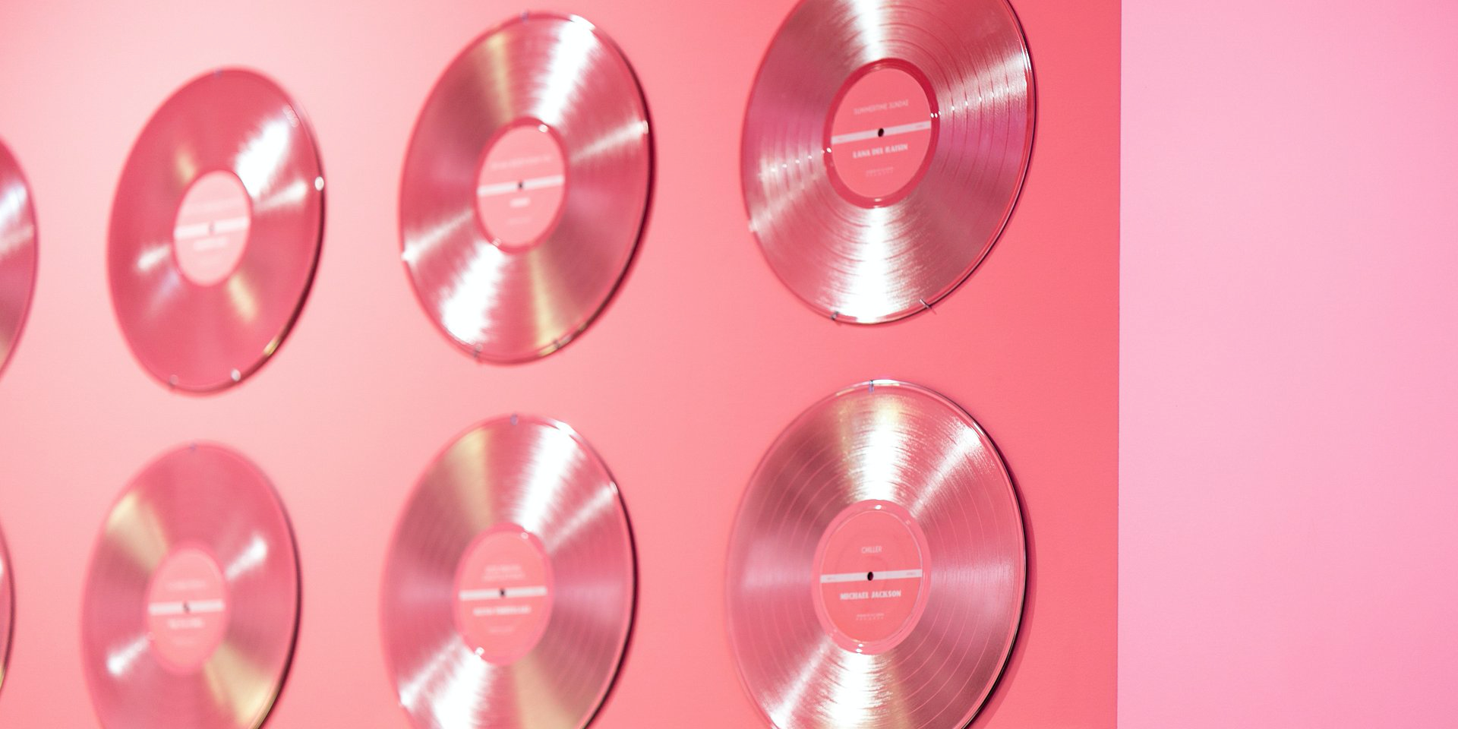

{Record Company} Announces the New Album {Title of Album} from {Name of Artist/Band}

{City, Date} - {Record Company} is thrilled to announce the release of the {latest, debut, etc.} album from {Artist/Band}. {Title of Album} will be available {Where} on {Date}.

{Album title} is {description of the album, including genre and any other relevant details}.
- Add more details about the artist or the band, including their relationship with the label.
- Reveal how it was received by both critics and the audience that received early copies of the album.

{Quotes from the artist, label representative, and/or any critics that received early copies of the album}.
- Person being quoted: name, surname, position

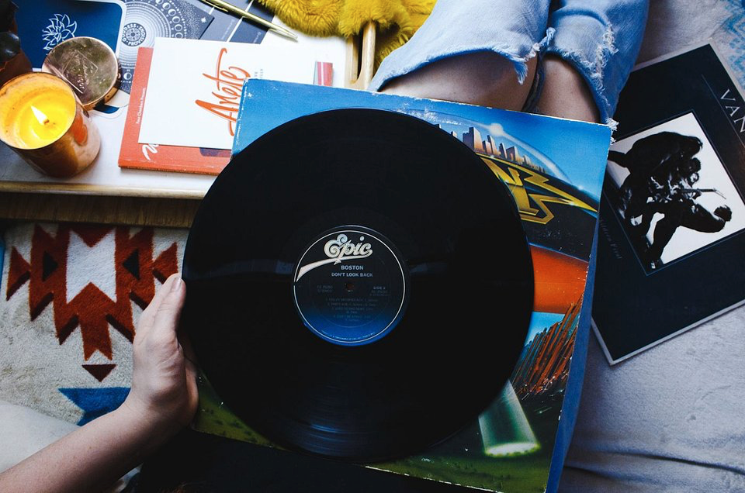

Add images (Source: Unsplash)
Add any further details that the audience might find relevant—i.e. how to support the artists, where to purchase the album, where to find more information about the band.

{Boilerplate about the record company and/or artist}.

Contact Information: {Contact person and his/her info}

Name
Position at Company
name@email.com
Social media handles

