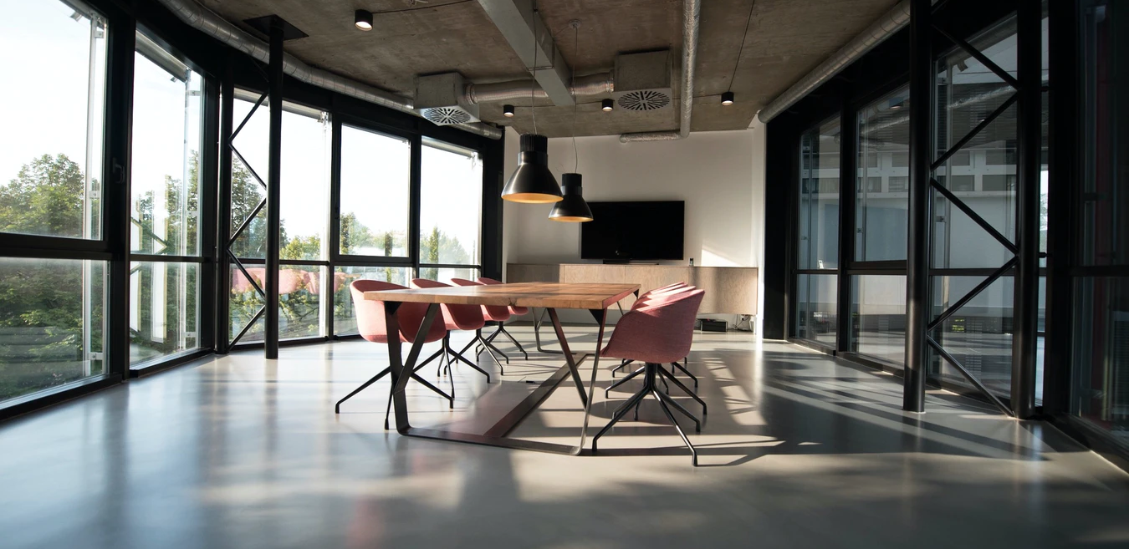

{Company} opens a new office in {City}

{City, Date} - {Company}, the leading provider of {Product/Service}, is proud to announce the official opening of its brand new office in {Location}. The {City} office will serve as {specific function, i.e. sales & marketing} center.

Plans to develop operations in {City} OR simply change the location came from {Specific need/event}. The new office will allow the company to {...}.

{Quote from the office manager/CEO}.
- Person being quoted: name, surname, position

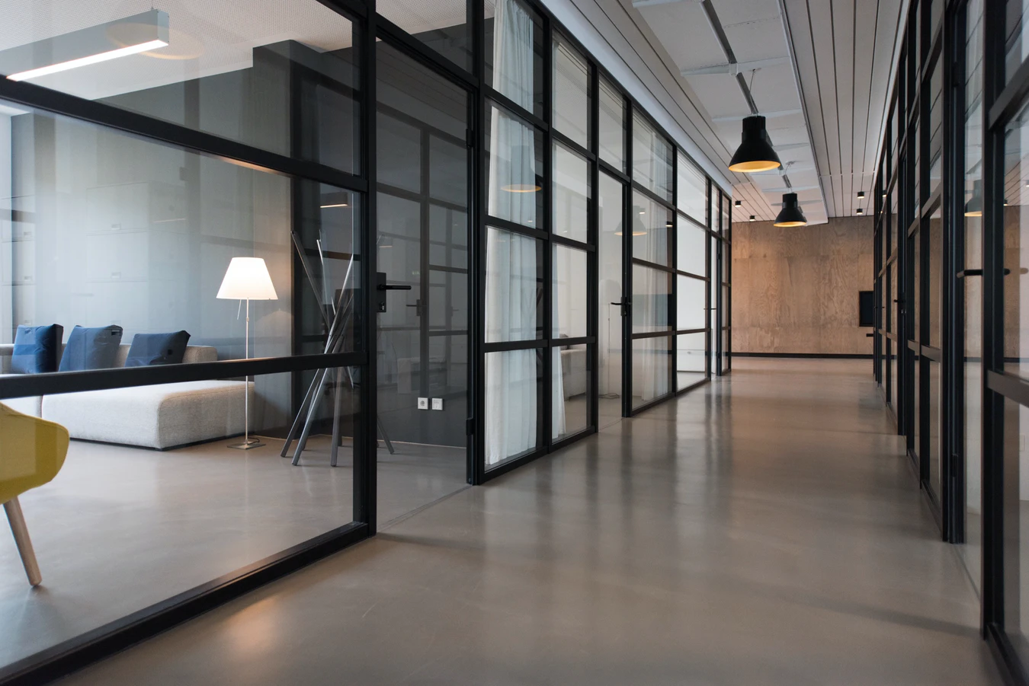
Add images (Source: Unsplash)
- Consider adding a video tour.

- Reveal plans for new offices (if any).

{Boilerplate about the company}.

Contact Information: {Contact person and his/her info}

Name
Position at Company
name@email.com
Social media handles

