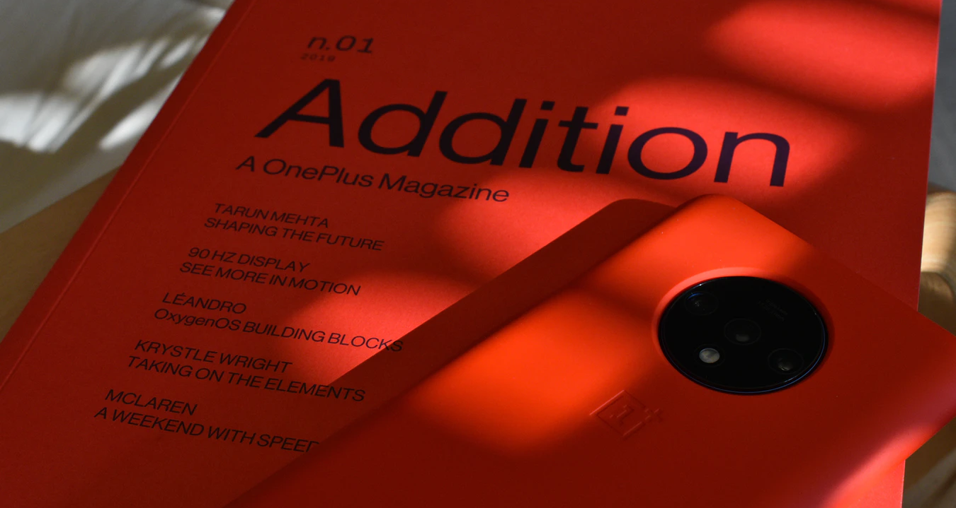

{Company} Announces Major Rebranding

{City, Date} - {Company}, a leading provider of {Product/Service}, is proud to reveal a major rebranding that reflects {company goals/changes}.
The need for rebranding originated from {reason}. The rebranding has solidified the company’s stance as {an industry leader} offering {more about the offer}.
The rebranding includes {a redesign of the company’s website, logo, visuals, etc.}.
- Give more details about the rebranding and its importance for the company.
- Specify who was involved in the rebranding.
{Include relevant quotes}.
- Person being quoted: name, surname, position
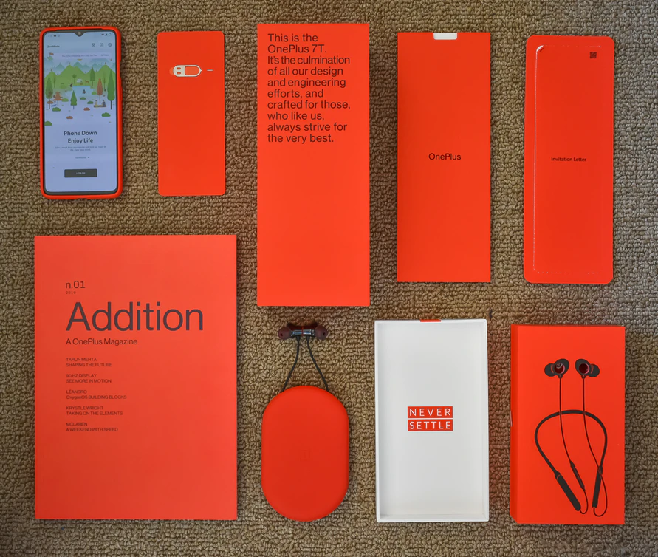
Add images (Source: Unsplash)
Add any further details and links that the audience might find relevant—i.e. where to find more information about rebranding and any recent changes in the company.
{Boilerplate about your company}.

Contact Information: {Contact person and his/her info}

Name
Position at Company
name@email.com
Social media handles

