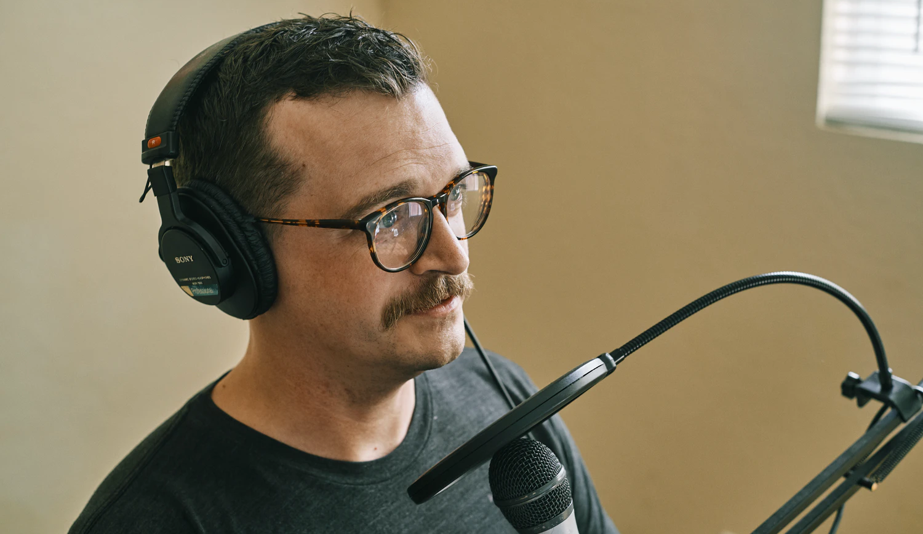

Statement by {Name} about {an issue, event, etc.}

{A sneak peek of what’s inside that will grab the reader's attention and encourage them to continue reading the statement}
Cover the statement in a few paragraphs. Statements from you personally should always be written in the first person.
Add any further details and links to other sources that the audience might find relevant.
For interviews/more information, please contact:

{Contact person and his/her info}

Name
Position at Company
name@email.com
Social media handles

