Multimedia Press Release Templates – Made with Prowly's Press Release Creator
templates.prowly.com

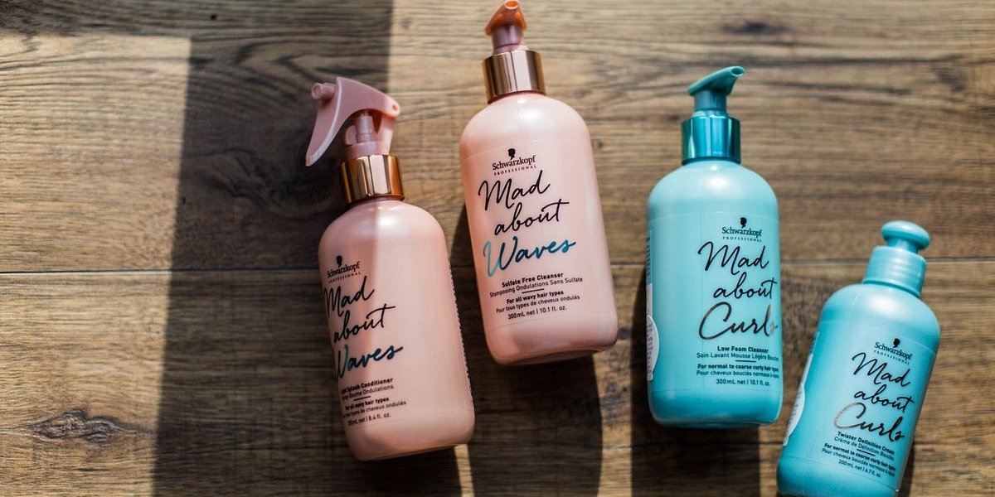

{Image caption}
New Product Press Release Template

This new product press release template can be used to let everyone know of the launch of your new product.

{Create a Great ‘Hook’ as Your Headline}

Lead/Subhead: {City, State} - {Company/Corporation} is excited to announce the launch of {product}, a {description of product} that will {basics of what this product will do}. The official launch date for {product} is {Date}.

First paragraph (it needs to be as impactful and engaging as possible): {Company/Corporation} believes {product} will {more details about what this product will do, maybe compared to what its predecessors and/or competitors already do}.{More details about product launch, such as what kinds of marketing will be employed, if there is to be a formal launch ceremony, etc.}.

{Caption}

{Comparative table}

Product A | Product B

{Quote about your new product}
{Person being quoted – Name, surname, position}

{Boilerplate about company and any prominent individuals involved in this product launch}.

Name
Position at Company
email@email.com
Twitter
Facebook
Linkedin

