Rock Point
PARTNERS AND FRIENDS
Celebration!
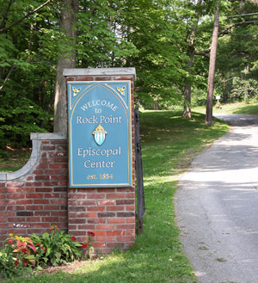

SATURDAY, APRIL 30
Rock Point, Burlington
9:30 AM to 3:00 PM
Please register by April 25, here.

Come for all or part of the day
Bring your family and friends

Learn about Rock Point and Explore how you can become a part of the Rock!
All Activities at Rock Point School unless otherwise noted.

9:30 Registration
Individual Adults - $5.00 per person or $10 with lunch
Two Adults - $10.00 or $15 with lunch
Additional Adults $5.00 per person or $10 with lunch
Children under 18 $5.00 with lunch
10:00 Welcome and Overview
10:15 Activities: Wildflower Walk, Primitive Outdoor Skills, Nature Crafts, Garden Service Project
11:15 Activities: History Walk, Primitive Outdoor Skills, Crazy Games, Garden Service Project
Noon Lunch
1:00 Large Group Presentations followed by Small Group Conversations, including land use plan elements of caring for the trails, rare plants and invasives; developing spiritual/nature retreats and pilgrimages; and information about Energy Coop, Bishop Booth Conference Center, and Summer Camp.
2:00 Large Group Presentations followed by Small Group conversations: including Homeward Bound Gardening, Beekeeping and Sugaring, Partnerships, and a Rock Point Partners Campaign.
1:00-3:00 Additional on-site activities for children (5 and older)

