Customer Journey Map Template

Step 1: Use the interviews you conducted to produce the Customer Interview Questions Template.
Step 2: Use the Interview Findings Document to determine buyer roles and create buyer personas.
Step 3: Identify common actions among the interviewees that you used to make each persona. For example, if you find that some of your customers do research online, make this action a step in your Customer Journey.
Step 4: Place each action into the appropriate stage of the customer journey (Awareness, Consideration or Decision) in the blank Customer Journey Template at the end of this document. Pay special attention to how personas interact with and influence each other. There are two examples of Customer Journeys in this document for you to use as models (B2B and B2C).
Step 5: Reread the Customer Journey to make sure it is consistent with the Interview Findings Document. Your final Customer Journey should read like a timeline from the beginning of the journey, when the persona is just becoming aware of the problem, to the end of the journey, when the persona purchases your product or service.

Need Help?
Visit: www.intechnic.com or call +1 (847) 970-6190

Overview of the Customer Journey
The Customer Journey is a tool to understand how your prospects go through the buying process. There are three stages of the Customer Journey:
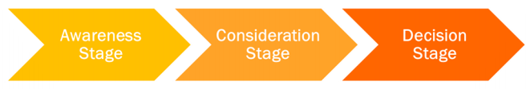
Awareness: The stage in which the prospect experiences and expresses symptoms of a problem or opportunity. Example: Sarah realizes that her phone is getting old. It becomes frustrating to use because apps load so slowly.
Consideration: The stage in which the prospect clearly defines and gives a name to their problem or opportunity. Example: Sarah searches online for “smartphone with best camera” and “fast smartphone” in Google.
Decision: The stage in which the prospect decides on the solution strategy, method, or approach. Example: Sarah goes to her local phone store and meets a salesperson who shows her the smartphones from her shortlist.

Persona Buying Roles and the Customer Journey
Understanding your personas and the actions they take is a critical step in defining your Customer Journey. Personas help you understand how buyers make purchasing decisions and what affects these decisions. When creating personas, it is important to understand their role in the buying process: are they a decision maker - someone who has the power to make the final decision? Or are they an influencer - someone who will make a recommendation to a decision maker? It's important to identify these roles when interviewing customers (so you can ask the right questions) as well as capture and record this information when creating personas. The following are the main roles you want to keep in mind:

Decision Makers
- These personas typically make the final purchasing decision.
- They sometimes rely on feedback / input provided by others (influencers).
- They often have control over money and budgets.
- Securing their confidence is a must.
- You need to know how the decision maker makes his/her decision by understanding their decision process and their selection criteria. This is how you will learn how to get the decision maker to make a decision in your favor.

Influencers
- These personas typically don't have the power of making purchasing decisions.
- In B2B, they are often tasked with doing research or vetting potential vendors.
- Their feedback is often taken into consideration by the decision maker. Influencers act as advisors to decision-makers.
- They could be a powerful ally or an even more powerful adversary.
- Winning the influencer’s vote will get you closer to winning the decision-maker’s vote.
Knowing how your personas’ roles in the decision process will help you know how they influence your Customer Journey.

Finalizing the Customer Journey
You may need to revisit your Customer Journey several times to get it right. Ask your marketing staff, sales staff and / or customer service staff to review the Customer Journey to ensure that it accurately reflects the path that prospects travel to become customers. They are good resources to use because they interact regularly with your customers.
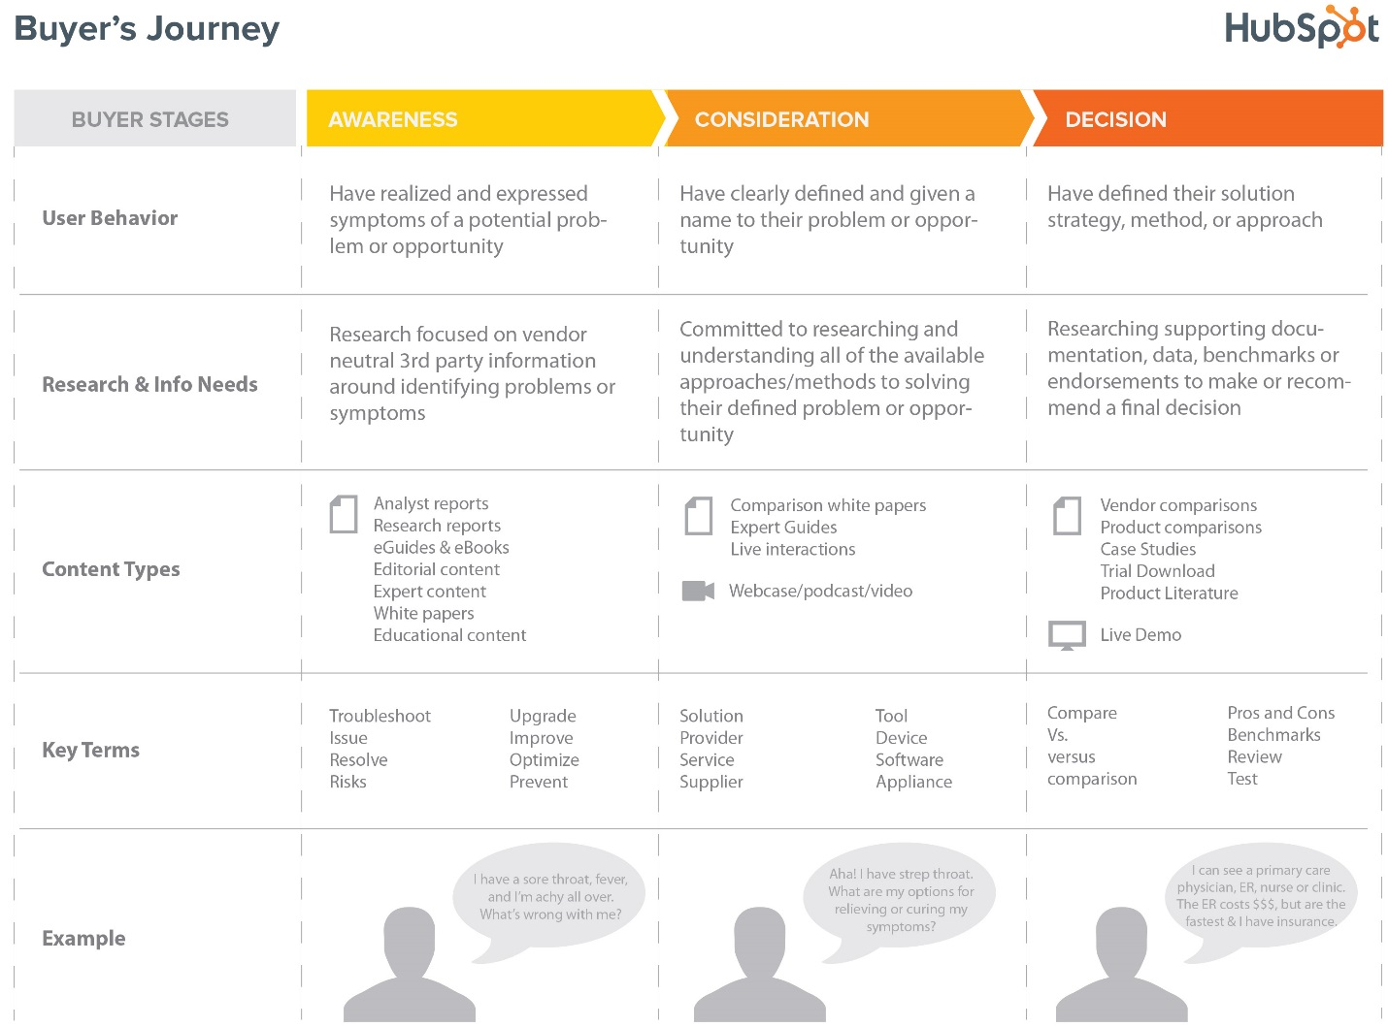

B2C Personas

It is important to consider the dynamic of decision making in business-to-consumer situations – how personas interact with each other (decision makers vs. influencers) and how consumers make their decisions.

Consider the following:

  - Decisions about small purchases and personal-use items or services (clothing, food, personal electronics, beauty salons, gym memberships, etc.) are usually made by a single decision maker. Influencers (friends or family) often play a lesser role, usually in the form of a recommendation that may influence the decision.

  - Decisions about large purchases that affect multiple people, whether they are items or services (houses, cars, vacations, babysitters, etc.), are almost always made by multiple decisions makers. In these cases, you will have multiple people making decisions or strongly influencing them (for example: everyone living in a house wants to have a say in choosing the house). You will need to create personas for all decision makers and understand what affects their individual decisions in order to secure their vote.

  - Impulse purchases are more common in a B2C environment and consumers are more likely to be influenced by their feelings, emotions and instincts. Personality traits play an important role in their decisions. Consumers often buy something they "want" but not something they necessarily "need". A good example of this is clothing; people don’t always necessarily need new clothes, they just like how new clothes make them feel.

  - Typical influencers: friends, family members, colleagues, celebrity endorsements.

B2C Customer Journey Example
Awareness Stage
AWARENESS STAGE NOTES
- Sarah realizes that her phone is getting old. It becomes frustrating to use because apps load so slowly.

- Sarah accidentally dropped the phone, cracking the screen.

- Sarah’s phone dies, so she borrows her friend’s phone to make a call and realizes how nice her it is compared to hers. She describes it as "sleek and shiny". She asks her friend to take a closer look at the phone. Same applications Sarah has on her phone are extremely fast on her friend’s phone and it also takes awesome pictures.

- Sarah decides she has had enough and it is time to start looking for a new smartphone.
>>> PROCEED TO CONSIDERATION STAGE

Consideration Stage
CONSIDERATION STAGE NOTES
- That weekend, Sarah searches online for “smartphone with best camera” and “fast smartphone” in Google.
- Sarah finds many websites from her search. A side by side comparison on tomsguide.com showed prices, expert reviews, and all the technical specs.
She is overwhelmed by the search engine results; there are a lot of different models and styles to choose from. She didn't trust customer reviews because there were so many and they contradicted each other.
Most online pictures are too small, so she can’t judge the appearance, size or user experience. She feels like she should look at the phones in person.

- Sarah makes a shortlist of possible smartphones based on her research.
>>> PROCEED TO DECISION STAGE

Decision Stage
DECISION STAGE NOTES
- Sarah trusts the opinion of her friends when making big purchases. She asked 3 female friends and 2 male friends how they enjoy their phones, what they like and don't like. 3 of her friends recommended Samsung X and 2 friends recommended iPhone. She notes that most friends recommended Samsung X.

- Sarah realizes that she needs to see both phones in person to make a final decision, so she decides to go to the store to select a phone from her shortlist.

- Sarah then goes to her local phone store and meets a salesperson who shows her the smartphones from her shortlist.

- Sarah reviews each phone the salesperson presents based on her criteria: camera quality, speed, durability, battery life and price. She also evaluates each phone’s user experience and warranty package.

- Sarah selects Samsung X smartphone to purchase that she believes will best meet her needs.
SALE

B2B Personas
The dynamics in a decision making process in the B2B environment can be very different from B2C. It is important to understand how decisions are made and how personas interact with each other (decision makers vs. influencers).

Consider the following:
  - Decisions that fit within the spending ability of a business professional (within their "preapproved" or allocated budget) are often made directly by that decision maker. This typically includes inexpensive products or services that service the individual's need or those of a small group (inexpensive software, office supplies, professional consultations, etc.).
  - Sometimes, business professionals ask for recommendations from their colleagues/associates who are subject matter experts before making a purchase. For example, asking IT for an opinion on a new software purchase. Consider creating influencer personas for such colleagues.
  - Large purchases might require "a second signature" or the approval of a "boss" for purchases made outside of an individual's spending ability. In this case, you should have a persona for the supervisor and understand how they will go about making their decision. This is why it is important to ask about the individual's supervisor and their role in the decision making process.
  - Decisions on large purchases or items/services that affect a team or the entire company are often made by committees, where each member has a vote and decisions are made collectively. Examples of this scenario include new company websites, ERP software and new office spaces. It is very important to understand who is on the committee, how they make the decisions and what influences their decisions, then create a persona for each member.
  - Business professionals don't typically like taking risks and making a "decision by committee" is a form of hedging risk. That way, a single individual does not assume full responsibility if something goes terribly wrong.
  - Business purchases often impact business results and smart business professionals set expectations for ROI or some sort of measurable KPI (Key Performance Indicator). It is important to know how a persona's results are measured so that, in the case that your solution helps them with their job, objective KPIs can be used to measure it.
  - Impulse purchases are less common in a B2B environment. Business professionals tend to make business purchases more objectively while looking at ROI, risks vs. benefits, KPIs, etc.
  - Typical influencers: colleagues, management/supervisors, peers.

B2B Customer Journey Example
Awareness Stage
AWARENESS STAGE NOTES
- John has too much on his plate and not enough hours in his day. He is a one-person marketing team doing everything: blog management, email distribution, social media management and a lot more. He is constantly behind on marketing campaigns and therefore, his efforts don’t produce as many leads as the company needs.

- His boss, Stacey, is not happy with marketing results. Stacey mentions in the weekly meeting that he needs to bring in more leads. In order for John to bring in more leads, he needs to catch up on his marketing campaigns. This will require him, however, to produce even more marketing efforts and run more marketing campaigns. He believes the problem is that he has too much for one person to handle, but the company can’t hire more people.

- John times himself and realizes that half his day is dedicated to performing manual tasks and switching between multiple marketing tools. His backlog keeps growing large despite him putting in long hours.

- He feels that there must be a better way to streamline his work and cover more ground, so he begins to look for solutions.
>>> PROCEED TO CONSIDERATION STAGE

Consideration Stage
CONSIDERATION STAGE NOTES
- John searches for “time saving marketing tools” in Google to look for ways to optimize his time and automate his marketing tasks. He is hoping to learn from other one-person marketing teams about how they manage their loads.

- He comes across a blog post written by a fellow marketer who is also a one-person marketing team. This post gives recommendations about using “marketing automation software” to automate tasks and provides a list of many of them. Unfortunately, the post does not compare them. John realizes that marketing automation software can streamline a lot of his manual tasks. He had heard about some of the services, but knew they were expensive, so he hadn’t considered getting one before.

- John then does another (secondary) search for “how to automate marketing” in Google. He finds many software providers in the search results—many of the ones listed in the initial list—so he visits each company’s website to figure out which one is the best fit for his needs. Each of the software websites gives a lengthy list of product features grouped in various packages, which is overwhelming to John.

- John decides to take another approach and writes down his criteria for the “ideal” marketing automation software. He thinks that the ideal software should replace as much existing software as possible, be easy to use and learn, be affordable, support his future needs, and have good customer service.
>>> PROCEED TO DECISION STAGE

Decision Stage
DECISION STAGE NOTES
- John begins comparing the different providers. There are several different options ranging from more basic, less expensive options to very advanced and costly ones. There is one in particular that seems to do everything he needs, but it is also the most expensive one and has a confusing package and pricing model.
- Since the price of all of the software options is outside his budget, John needs to get approval from Stacey (his boss).
He approaches Stacey with the solution to his problem: to purchase marketing automation software.
He presents two options to Stacey, including the more expensive product that he felt was the best fit.

- Stacey likes the idea of marketing automation software but she needs proof that it will actually result in more leads. She wants to see an ROI.
Stacey notices that the more expensive option has a free monthly trial, so she suggests that they try it out for a month before purchasing it.

- At the end of the one-month trial, John completes several more marketing campaigns and the company generates more leads. Stacey is convinced that this will be a good investment and she approves the purchase.
SALE

Your Customer Journey
Awareness Stage
AWARENESS STAGE NOTES
- Include all of the steps that your persona goes through in the Awareness Stage. You may need to add some steps.
>>> PROCEED TO CONSIDERATION STAGE

Consideration Stage
CONSIDERATION STAGE NOTES
- Include all of the steps that your persona goes through in the Consideration Stage. You may need to add some steps.

>>> PROCEED TO DECISION STAGE

Decision Stage
DECISION STAGE NOTES
- Include all of the steps that your persona goes through in the Decision Stage. You may need to add some steps.
SALE

