APPLYING THE MINOR & INFREQUENT BENEFITS EXEMPTIONS
COMMON MISTAKE

Many employers are unknowingly falling foul of the FBT regime through an incorrect interpretation of the minor and infrequent exemption allowed for benefits that cost less than $300.

The most prevalent area where employers find themselves in trouble when applying the minor and infrequent exemption is in relation to the provision of ‘Meal Entertainment’.

Meal Entertainment applies predominantly to the provision of food or drink to employees that are not consumed on the employer’s business premises. Where the value of the food or drink is less than $300 per person the exemption can be claimed, provided the employee only receives this benefit infrequently throughout the year.

Working out whether a meal entertainment benefit is minor is straightforward – you just need to check the receipt. Where employers find themselves in trouble is working out if the benefit is infrequent enough to satisfy that condition.

As a rule of thumb, we recommend that you only provide meal entertainment benefits for an employee no more than 10 times in a given FBT year. Once the benefit you are providing exceeds the infrequent condition, all benefits of that type for that employee become subject to FBT.

Please note, taking employees out of the office to enjoy a coffee is a form of Meal Entertainment. Do this too often throughout the year and an employer may find themselves subject to FBT on all the Meal Entertainment benefits they provide to that employee (including any year end social functions). Failure to maintain an appropriate register of exactly which employees are receiving benefits could result in all meal entertainment benefits becoming subject to FBT.

The ATO has signalled that there will be an increased focus on FBT this year so if you would like to ensure your business is compliant please contact your advisor at HTA as soon as possible.

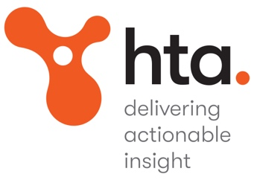
a 10-12 Adolph Street
Cremorne, Victoria 3121

p (03) 9810 3666

e info@htaadvisory.com.au

