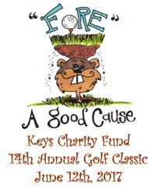

Cocktail & Dinner Reservation

4:00 PM: Cocktail Hour/Silent Auction
5:30 PM: Dinner

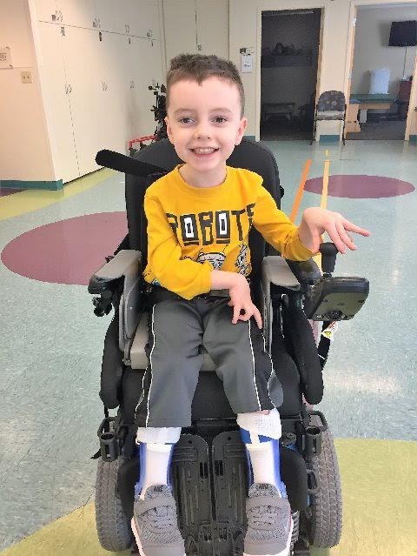
Mikey was diagnosed with Cerebral Palsy and a brain disorder called Schizencephaly that affects body movement, muscle coordination, and causes developmental delays. He is classified as GMFCS level IV and Triplegic, which means it is unlikely he will ever walk without assistance or specialized equipment. Mikey is an amazing kid with an infectious spirit and can put a smile on anyone’s face! As Mikey gets older, it is harder and harder for him to move around.

All proceeds will go toward Mikey's financial burdens associated with medical equipment needed for sustaining his independence as he gets older.

Help Mikey on his quest for independence -- Save the Date!

Dinner - $30 per person
Children under 15 - $10.00

Name(s): ______________________

Amount: ____ Check Credit Card

Card Number: ______________ Expiration Date: ___ /___ Zip_____

Email: ______ Phone: _____ cvv code____

