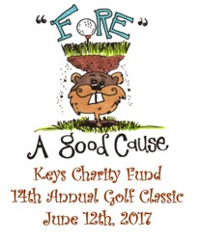
Keys Charity Fund
14th Annual Golf Classic Registration Form
Midland Hills Country Club
Monday, June 12th 2017
Registration & Luncheon @ 11:30 - Tee Time: 12:30 pm- Dinner: 5:30

Please fill out & send to: jean@keyscharity.com or fax to: 651.487.7865

Name ______________________________________________________________

Phone___________________________Company____________________________

Email_______________________________________________________________

_____ X $170. =__________
Golfers

______ X $680. =__________
foursome

______ X $1000. =_________ send logo info to Jean@keyscafe.com
foursome w/ Hole Sponsorship

______ X $500. =_________
Hole Sponsorship only

Credit Card #___________________________________________________________
exp____/____ security code_____ Bill to zip:____________

Names in your Foursome

_______________________________________________________________________
Name Email
_______________________________________________________________________

_______________________________________________________________________

_______________________________________________________________________

Make checks payable to Keys Charity Fund and send to: Keys Café
1682 N Lexington, Roseville Mn. 55113 for more information call Jean @ 651-488-1828
Keys Charity Fund is a nonprofit, tax-exempt 501(c) (3) organization, ID #27-4759727

