PROJECT PLAN

Senior LinkedIn Ambassador Program in partnership with Riipen

May-2019

Project Team:
- Gabriela Castro – Senior
- Alvaro Galicia – Junior
- Carlos Sanchez – Junior
- Luciano J. Gomes Jr – Junior

Authors Note: The following project plan was prepared by using Algonquin College as an example for implementation. However; the authors believe, it can be replicable to any other academic institution involved in the scope of the project.

Executive Summary
This project plan refers to migration from Lynda.com platform to LinkedIn Learning. At the same time, it will be used to create awareness in the Algonquin College community, about the use of LinkedIn Learning as a complementary tool to gain knowledge and skills.
The project requires previous activities to take place before the start of the 2019 fall term. These activities will involve the students, the program coordinators and the college administrative staff. LinkedIn will provide the advertising, presentations and details as well as a representative to talk with the program coordinators. Algonquin College IT staff will support by including LinkedIn Learning requirements in the welcoming package (e-mail check list), LinkedIn will provide presentations about LinkedIn Learning for students and the Career Centre, will include LinkedIn learning content in their services.
The following image, summarize the project plan proposal created to accomplish the goals and requirements established:

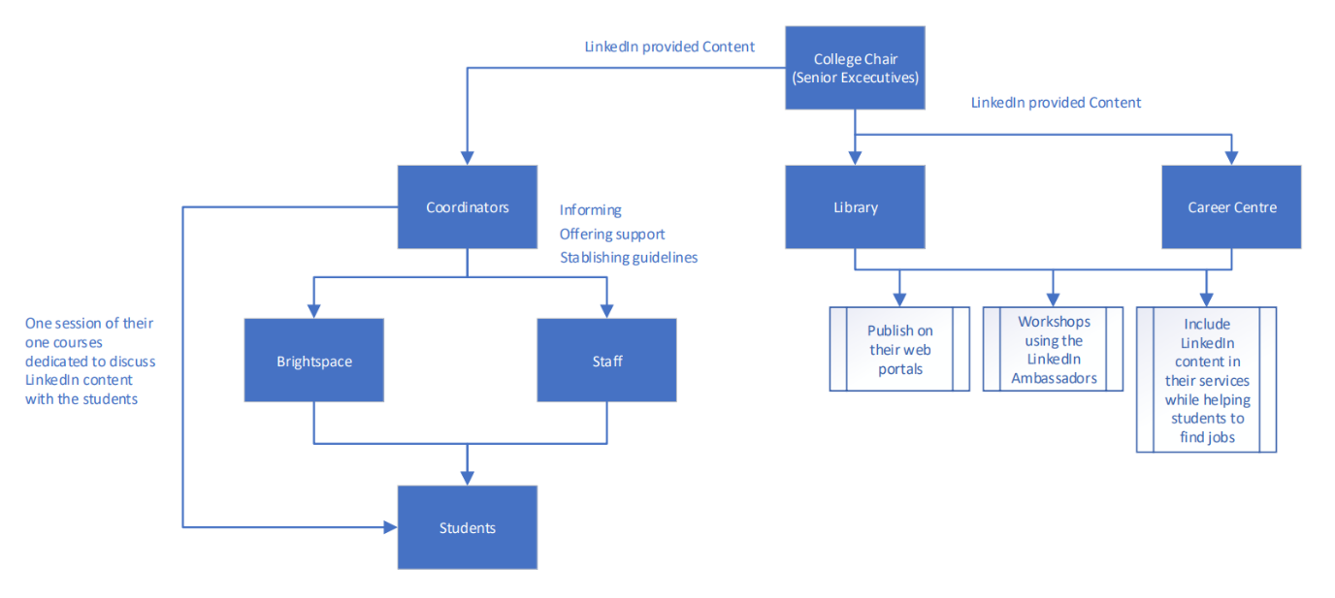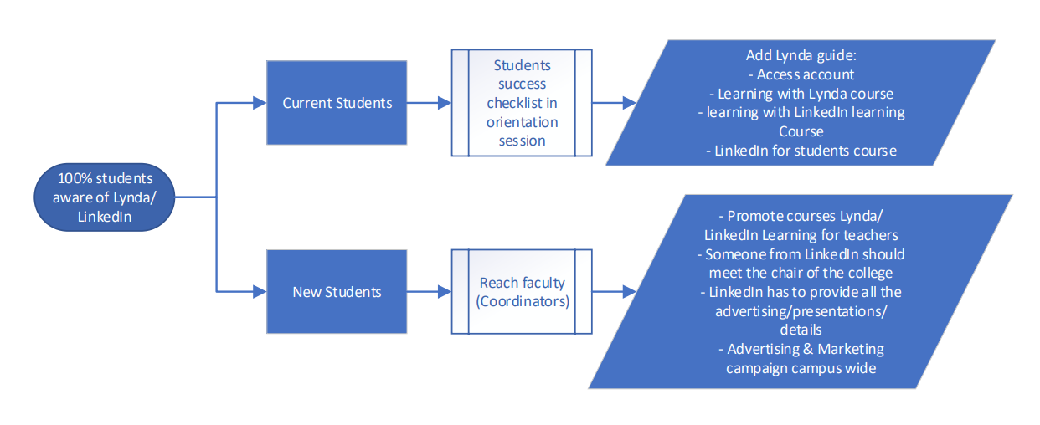
Project Plan
The following requirements and actions were identified as essential to guarantee and measure the success of the plan:
- Identify program coordinators that could be impacted by the migration and/or could act as communicators of this change for new students (all the faculties to be included)
- Create a transition plan/communication strategy (key milestones, communication channels, frequency, target audience)
- Transition set up (meeting with the faculty, IT staff and LSLA team)
- Prepare a specific content for the welcoming package and the communication strategy (ex.: LinkedIn student course on LinkedIn Learning)
- Include a measurement point in the next LSLA Cohort aiming to measure how many students started using LinkedIn Learning x Lynda.com per College
- Provide a transition plan to aid stakeholders involved (program coordinators, students, IT staff and LinkedIn representative)
- Proper communication through email to students (What they need to do, how to do it and where to find help if required.) Alternative communication channels (text, posters, banners, billboards.) As a backup plan, a class session from the program coordinators dedicated to discussing LinkedIn content with students will be requested, using the platform as support for the course content
- Notifications inside of Lynda.com inviting students to migrate to LinkedIn Learning (segregating invite by college email alias x other users)
- Organize LinkedIn presentations about LinkedIn Learning content and with focus on creating curiosity in the student community about the advantages of LinkedIn Learning
- Organize Career Centre content for job search
- Lessons learned, recommendations, close out report
- Prepare survey forms for the end of the project to be filled by project sponsors.
To minimize any potential issue and risk during the transition, the following potential risks were defined as well as their risk strategy mitigation:
Potential Risk | Mitigation Strategy
Technical issues, problems during the upgrading process | Run a pilot (small migration) and after data/information validation, start the migration.
Lack of commitment from stakeholders (ex. program coordinators.) | LinkedIn representative, to engage with key stakeholders and create awareness about the benefits of the platform for the student community.
Miscommunication and poor advertising could result in low interest. | Create a detailed Communication plan that includes backup strategies.
IT issues (poor communication, missing important information in the checklist.) | Identify and gain the support of an internal technical expert (Algonquin College staff member) to validate the integration as appropriate.
Students fail to attend LinkedIn presentations. | Request support from the Programs coordinators to include student’s assistance to the workshops as part of their academic curriculums.
Lack of use of LinkedIn Learning for the Career Centre. | Involve the Career Centre employees in the use of LinkedIn Learning tools to create awareness of the benefits for their work execution.
Project Support
The following support was identified as essential to guarantee the success of the plan.
From LinkedIn:
- Physical LinkedIn representative to introduce the project and plan to Algonquin College key stakeholders (Program coordinators, IT Staff, LSLA and Career Centre staff)
- Team leader to create, promote and execute the project’s presentation and prepare the close out and lessons learned report at the closing phase of the project.
- Printing materials regarding exclusively LinkedIn Learning focusing all marketing on this tool (posters, banners and billboards)
- LinkedIn Learning course about how to use and maximize the benefits of LinkedIn Learning for students
- Focused training for LSLA Mentors and Seniors in order to support new Ambassadors on the LinkedIn Learning migration
- Incentives to Ambassadors and Colleges with high migration rates (prizes, money, recognition)
From Algonquin College:
- Time availability from key stakeholders (Program coordinators, IT Staff and Career Centre staff) to promote and guarantee success of the project
- Assure that all pages and documents are changed to introduce LinkedIn Learning and no more Lynda.com (website, resources page, Library webpage, Day 1 Orientation material)
Appendix: Lessons Learned from Brightspace migration
While preparing this Project Plan, a research about similar projects implemented in the past was executed. Learnings from a previous project was provided from a project manager who participate in the project’s planning and execution and incorporated in this project plan. Highlights:
- Subject of matter experts (IT Staff) essential for the success of the project (pilot trial and backup plan recommended prior the official migration.)
- Training and promotion required to engage stakeholders and improve success possibilities.
- Stakeholder management (identification and assessment of needs and expectations will maximize the benefits of the resources invested.)
- Scope management will eliminate scope creep that could affect the efforts and time/resources assigned.
- Communication and Change management plan to be produced to provide adequate and timely manner information to specific stakeholders during the lifetime of the project.

